**News…….Students past and present**

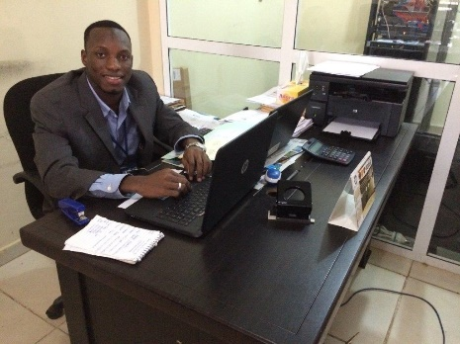**Lamin Njie** has now been promoted to Micro Finance Executive, a well deserved promotion. We were invited to his place of work and made most welcome, it was very obvious that he is extremely well thought of. Lamin has now also started a charity of his own, called ‘Parachute’. It is primarily to help the youths in the Bakau area on the coast. We are sure that with Lamin’s determination that Parachute will be a success.

**Abdou Jammeh -** We have just heard that Abdou has managed to obtain 7 credits in his end of year examinations. Excellent news, we wish him well on his route to university, we are very proud of him!

**[http://www.friendsofsikunda.org/images/photos/Fundraising/easyfund_logo.jpg](http://www.easyfundraising.org.uk/)**

*If you shop online, use EasyFundraising where you can shop at over 500 well known retailers including Amazon, eBay, Next and WHSmith, and for every purchase a donation will go to this charity. Just follow the instructions on the website..*

**For more Information about our charity, please contact anyone listed below:**

Chairperson - Sue Jones: 07717 821604 [sjones@friendsofsikunda.org](mailto:sjones@friendsofsikunda.org)

Treasurer - Marje Jones: 01933 387323 marje.jones25@gmail.com

Sponsor Secretary - Gloz: 01844 274047 [gkeen@btconnect.com](mailto:gkeen@btconnect.com)

Secretary - Anne Seckington: [anneseckington@btinternet.com](mailto:anneseckington@btinternet.com)

Fundraising – Kate Jones 07921 151711 & Danny Jones 07737 457431

**Copyright: Friends of Si-Kunda July 2017**



**Charity UK Registration No.1097750**

**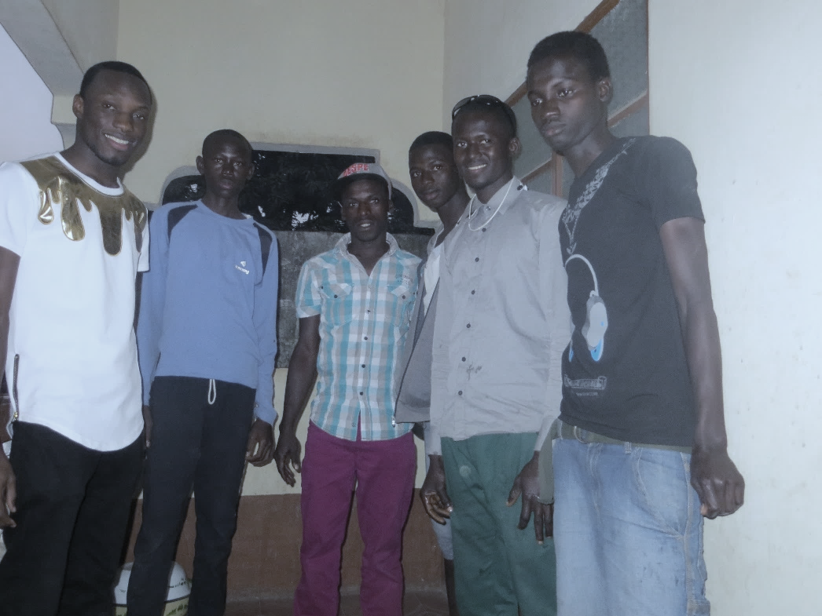*Gambia Registration No. 581/2005***

**July 26th 2017 Issue no: 28**

[www.friendsofsikunda.org](http://www.friendsofsikunda.org)

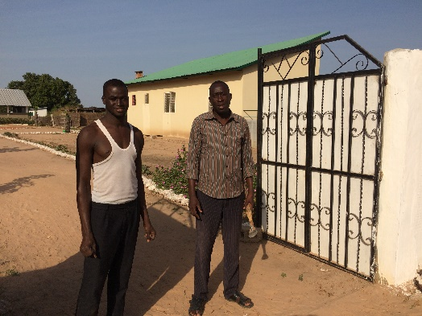**Badumeh Kuta Lower Basic School**

This year we have provided some books and boxes of stationary, and last term they received exercise books as well. Mr Cham sends his thanks and is very grateful.

**Transport**

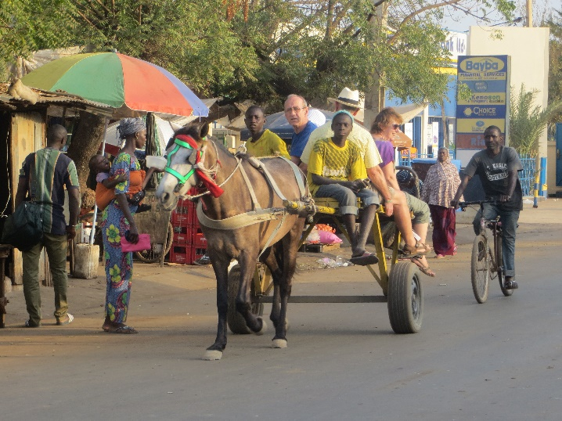While based in Si-Kunda village we have various ways of travelling to the outlying areas to visit the schools and projects we support. We have a motorbike which Sankung uses all the time, and we make use of it a lot when we are there. In the past we have used donkey and carts, but there are not quite so many of them available in the village now so we sometimes use a local geli geli from the nearby town of Soma, (like a mini-bus, with many occupants squashed in and livestock if need be (chickens\goats), or we get a taxi if we have to. A couple of the taxi drivers have got to know us, and we usually get a very good price with them, they are happy to wait until we have finished at whatever place we have been taken too, so it’s not too much of a problem. The vehicles are not in exactly ‘good condition’, and one did have a fire in the boot one day on our return to the village, and they do break down sometimes, but we manage well enough, and of course we walk if it isn’t toooo far to go!

This was our mode of transport in February to visit one of the schools, fine on the road through Soma town, but extremely bumpy “off-road”. The horse would get into quite a gallop at times, and at one point we nearly lost Frances when we un-expectantly took a right!

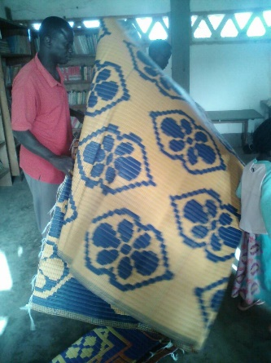**Fonkoi Kunda Lower Basic School**

The nursery class needed some mats for the younger ones, so we purchased 4 large ones for them. There are currently 167 pupils in the school, and another 37 in the nursery class. The headmaster is trying to increase the attendance, and was very pleased the rating for this school in the district is much improved.

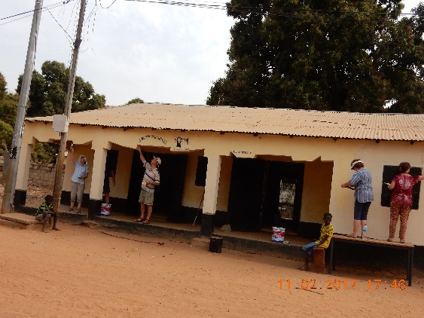**Si-Kunda Community & Skills Centre**

In February, we repainted the outside of the centre, which has really brightened it up. We had lots of willing children wanting to help… a few of them looked

like they had painted themselves rather than the building! It it was all good fun, and a job well done.

One room is now being used for a Health clinic and has had a window installed, a new ceiling, a tiled floor, and a metal door. Hadim and two of the young women who work in the sewing room will be making the school uniforms for Sikunda Nursery School. It’s great to give them some work, Hadim will make the boys shirts and shorts, and the ladies will make the girls dresses.

We have applied for an electricity meter. The cost was approximately £100 for the application. This will provide the meter and the ability to buy the credit for it when needed. This can take some time in-between applying and actually getting it, so we haven’t got it yet! To have electricity installed in the building will be a huge benefit for the many activities that take place there, and will also be great for the sewing team in particular as they are often there until late into the evening. Working by lamps and candlelight is not ideal. The wiring, sockets and link to the pole in the street will all have to be quoted for, once we have the meter we will ask Seedy Dembo to quote for the installation.

**Latest update ..**

Modou’s home is in now having the walls plastered and then painted, also a tiled floor is being laid.

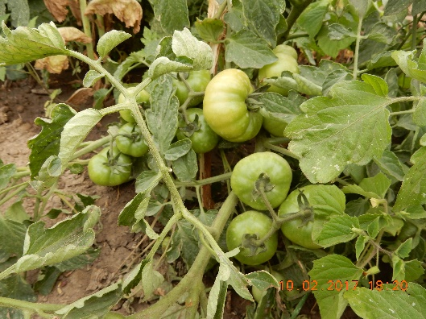**The Friendship Gardens**

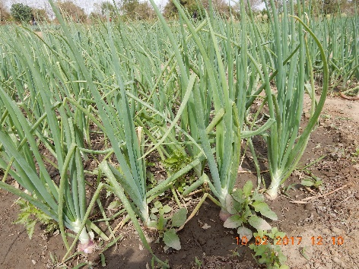

The gardens\allotments are continuing to be very productive! We are always so impressed as to how the women have managed to improve the gardens each year. It is now over 10 years since we started the project, and we are so very pleased we did.

**Soma Medical Centre**

Since our February visit we have provided the centre with some chairs, adjustable swivel chairs on wheels. These were much needed, particularly in the laboratory. They have recently got a new Chief Nursing officer, Sainey Manneh.

**Our Weekly Bonus Ball continues to bring up weekly winners……**

**We still have a few numbers spare! For just £1 a week you will have the chance to win £25 and every penny profit will help our students and the schools we supportPlease contact *Marje –*** marje.jones25@gmail.com ***or, telephone 01933 387323***

As always, we need all the support we can get to be able to continue and do our projects, and support our students, thank you so much to all of you have supported us in the past, and everyone that continues to do so - your contributions make such a difference!

**Chairperson’s report**

We had a very enjoyable productive trip to The Gambia in February. Gary, Marje, Andrew, Frances and I went for two weeks. First of all, staying in Sankung’s compound in Busumbala. We managed to get quite a few of the past and present students together for an afternoon, they are the ones who now live in the coastal area of the country, either for their work or for further education.

It was great to see them all and to hear from them how they are getting on. The picture of them is on the front of this newsletter.. from the left … Lamin who gained his degree in accountancy and has just gained promotion, Sulayman is in Grade 10 and got excellent results in his last exams, Seedy trained as an electrician, Lamin Banda works in Brikama as a welder, Abdou who has just graduated from Grade 12, he was head boy and was the first to give a speech at his school’s graduation ceremony. He is hoping to be accepted in medical school later in the year, and is currently doing an IT course to fill the time. And then there is Ousman on the right has also graduated after completing Grade 12, he said he wants to go to the GTTI (Gambian Technical Training Institute) to do an Electrical Mechanical Engineering course. Needless to say, we are very proud of them all!

We then travelled up country to Si-Kunda village where we stayed for most of our time in The Gambia. Most of our projects have been and still are in this area.

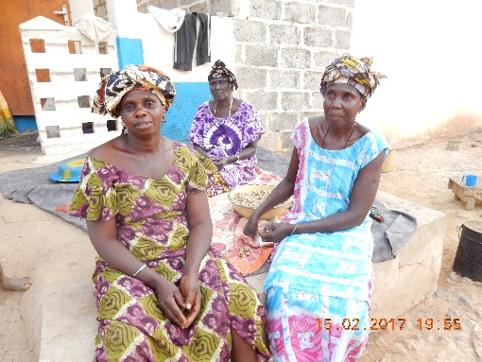Our home there (which we have always, and I have no idea why, called The Lodge) has had a remarkable transformation, the floors are now tiled, (our hut has two rooms) and we now have electricity, it has all made an enormous difference to our comfort there. We are now able to use a fan, and that is just wonderful to get back to after a scorching day outside where it is impossible to get away from the heat. And we also now have an electric light in both rooms. We have put off tiling the floors ever since it was built, but the floors had got into a pretty poor state, so as there is often quite a few of us staying there it really does help. Not sure how much longer the beds will hold up, one of them is **very** unstable, but ok for a bit longer perhaps. Electricity isn’t on all the time, but very welcome when it is. I never thought I wanted it, but now it’s there I must admit I noticed the benefit! We have two more visits planned this year, November and December.

With Kind Regards, Sue

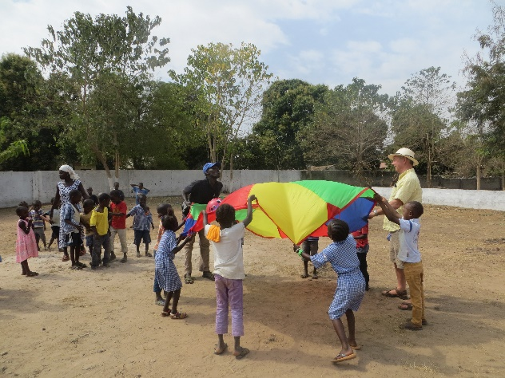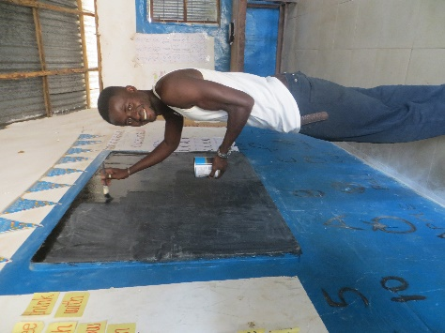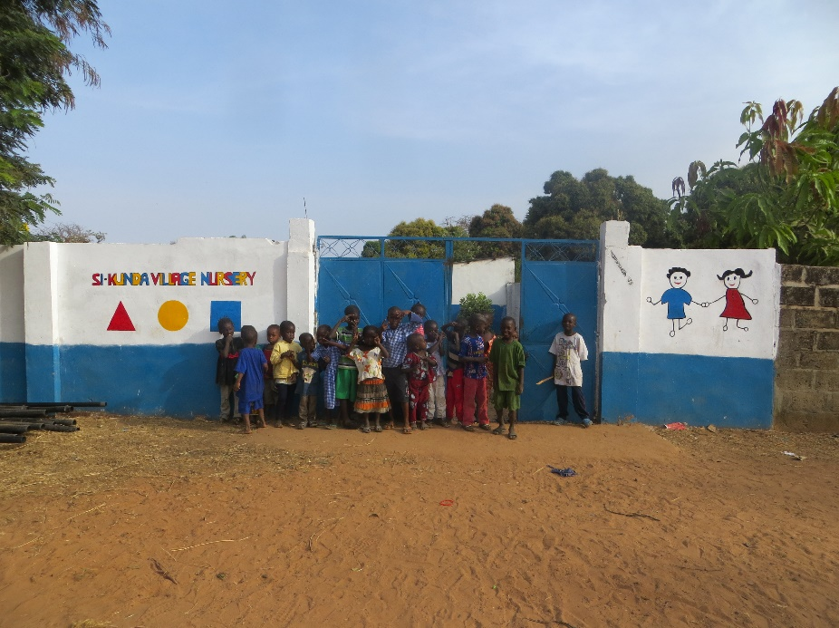**Si-Kunda Nursery School**.

The school is progressing well, Marje painted the front of the school wall, which now looks very colourful and much improved. Bakary who was once one of our students was in Si-Kunda at the same time, so he helped Andrew paint all the individual and classroom blackboards with the blackboard paint that we had taken with us from UK. They had been done previously in local paint which doesn’t really do very much to improve them. We brought some footballs and sorted out books for the school library. We have since had the school roof renovated, repaired some parts of the buildings walls, and replaced the timbers and uprights on the veranda. The teachers have sorted out the storeroom as there were a lot of items that were no longer required. The garden will be started in earnest in the next term, though there was cassava and bananas growing well and being used to supplement the school lunches.

Forty chairs and twenty tables have been purchased and delivered to the school, and we have some more being sent in a shipment in September – most of the existing furniture was really beyond repair. But considering the age of them and repairs done in the past I guess they haven’t done too badly! We have purchased more mats for the little ones and for some to be used in the outside classroom.

We do need to obtain some outside play equipment. We will see if we can source some in Gambia …..

Bakary busy painting blackboards, and fun & games in the playground!

**Modou’s Home**

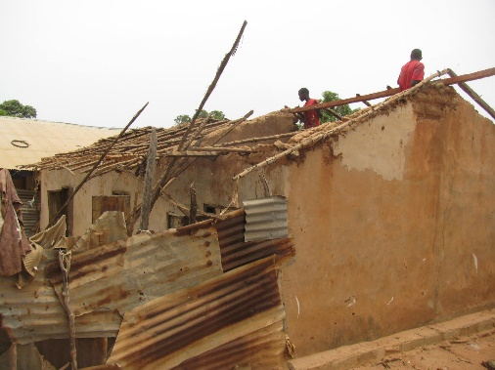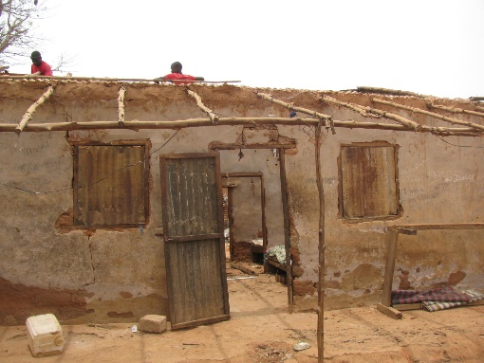There is a man in Si-Kunda called Modou, whom we have known ever since we first visited the village many years ago. He is disabled and in a wheelchair. During our last visit we found that the roof of his home had holes in it allowing rain to get in. Obviously a huge problem anyway, but even more so for Modou as he cannot just get up and walk or move his bed out of the way. The rainy season started end of June\July, so a builder has now replaced the roof of Modou’s home, also his mothers and their neighbours. It had to all be done because as soon as the work started the whole lot caved in as their accommodation is joined. The roof has now been replaced and repairs done. It is now safe and secure from the rains.

Pictures of work in progress!