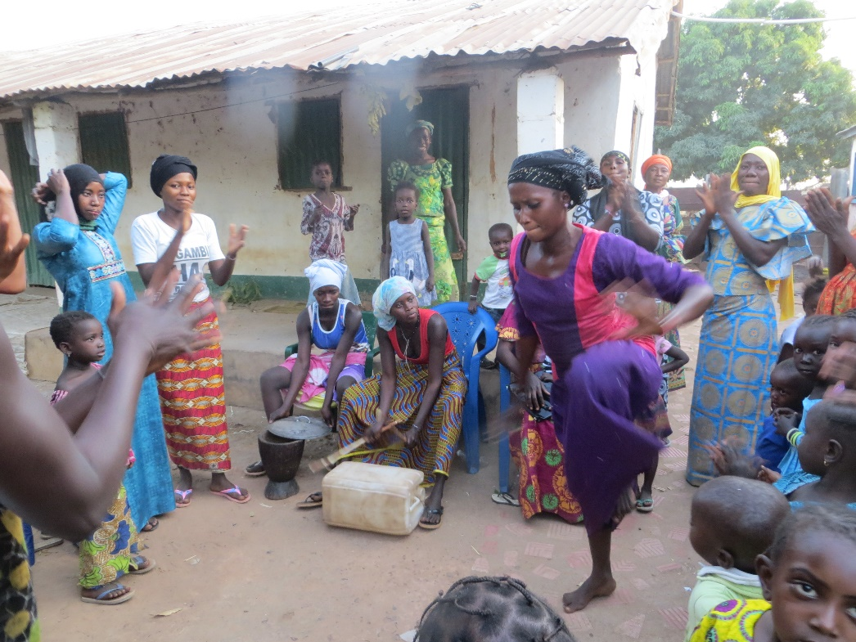 **A baby naming ceremony, always a lively affair!**

[http://www.friendsofsikunda.org/images/photos/Fundraising/easyfund_logo.jpg](http://www.easyfundraising.org.uk/)

*If you shop online, use EasyFundraising where you can shop at over 500 well known retailers including Amazon, eBay, Next and WHSmith, and for every purchase a donation will go to this charity. Just follow the instructions on the website..*

www.friendsofsikunda.org

**For more Information about our charity, please contact anyone listed below:**

Chairperson - Sue Jones: 07717 821604 [sjones@friendsofsikunda.org](mailto:sjones@friendsofsikunda.org)

Treasurer - Marje Jones: 25 Church Hall Road, Rushden, NN10 9PA - 01933 387323 marje.jones25@gmail.com

Sponsor Secretary - Gloz: 01844 274047 [gkeen@btconnect.com](mailto:gkeen@btconnect.com)

Secretary - Anne Seckington: [anneseckington@btinternet.com](mailto:anneseckington@btinternet.com)

Fundraising – Kate Jones 07921 151711 & Danny Jones 07737 457431

**Copyright: Friends of Si-Kunda January 2018**



**January 2018 Newsletter No: 29**

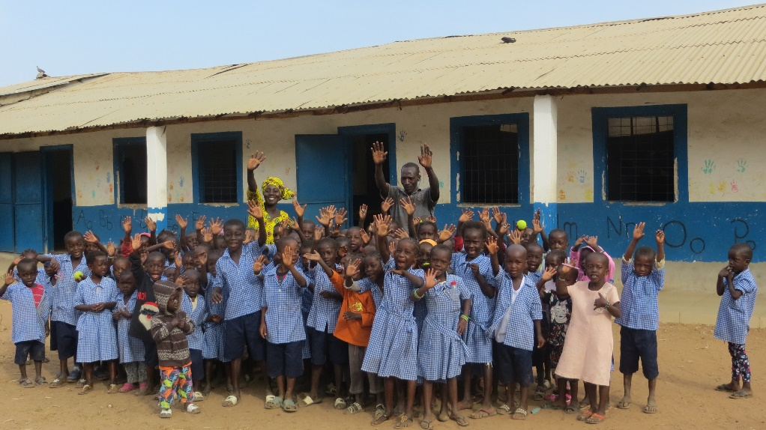

**Si-Kunda Nursery School**

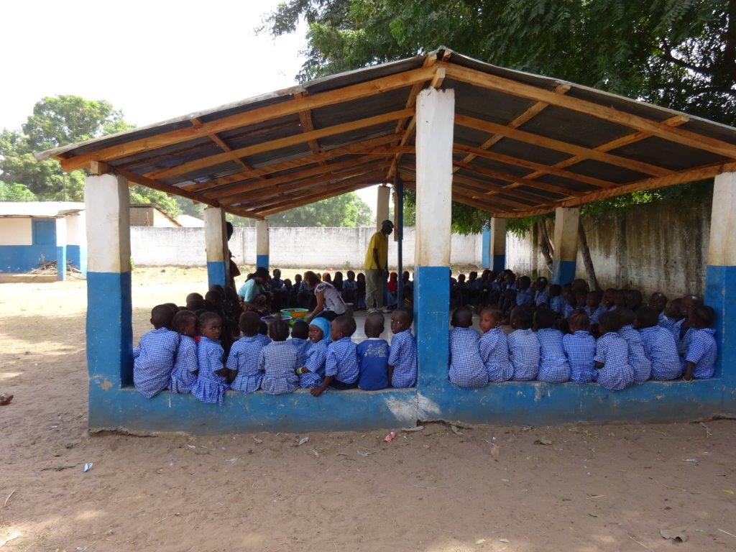

**Charity UK Registration No.1097750  *Gambia Registration No. 581/2005***

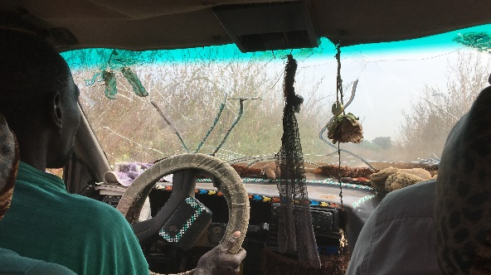 **Fonkoi Kunda Lower Basic School**

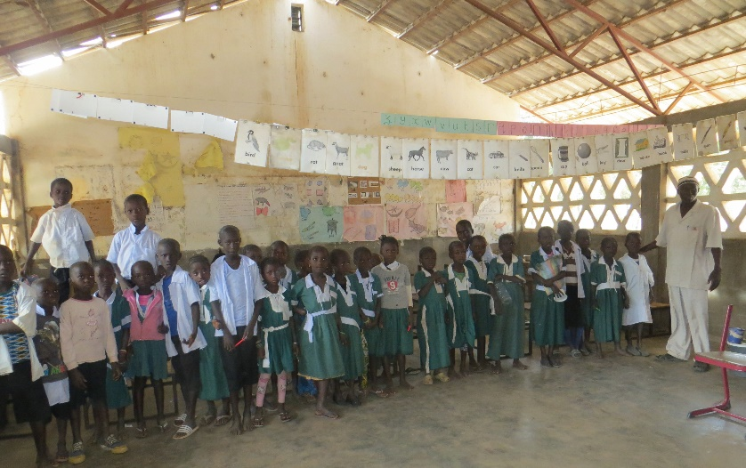

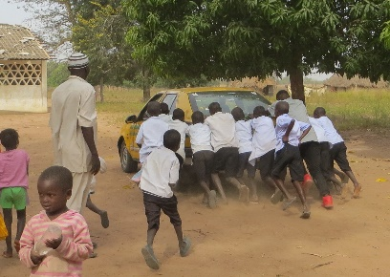

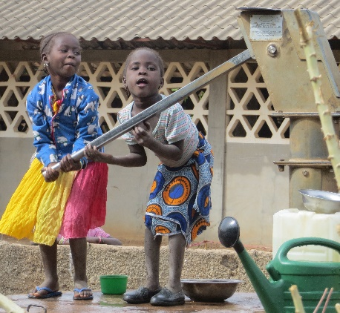

as much as we have been able to, and have recently made repairs to the borehole in the school. It hasn’t been there very long, but the cylinder needed replacing as they could not get to the water, which obviously is crucial for the school.

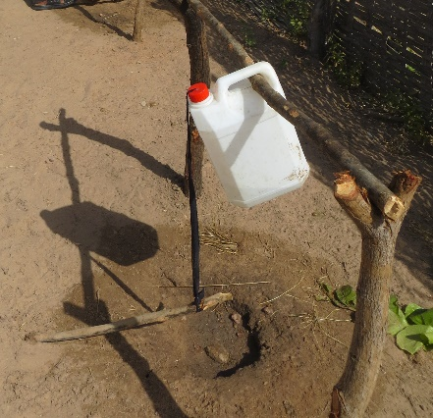They have an ingenious way of providing easy access to a drink of water for the pupils as seen in this photograph. Step on the stick (which is attached by string to the top of the water container), the container tips and lo and behold you have a drink!

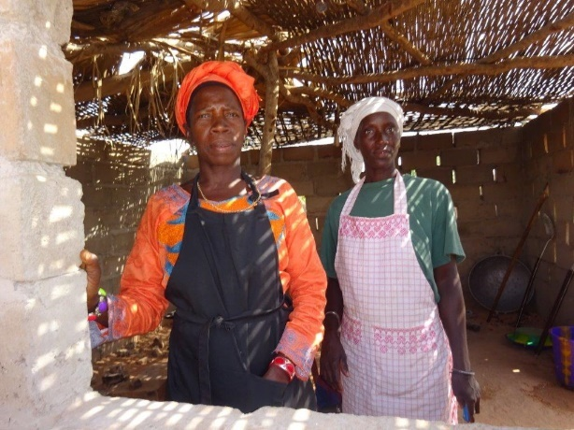

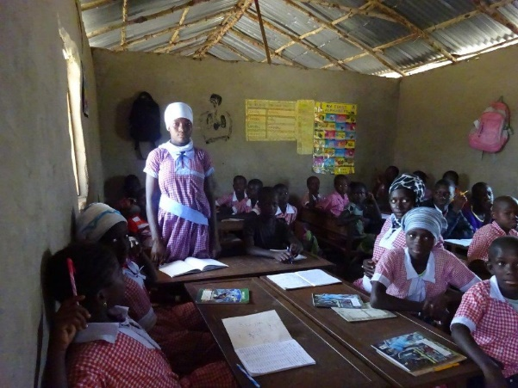

**Soma Medical Centre and Kiaf Health Centre**

Both have received some supplies from us during the last few months, they both need so much more. But the little we can supply really does help.

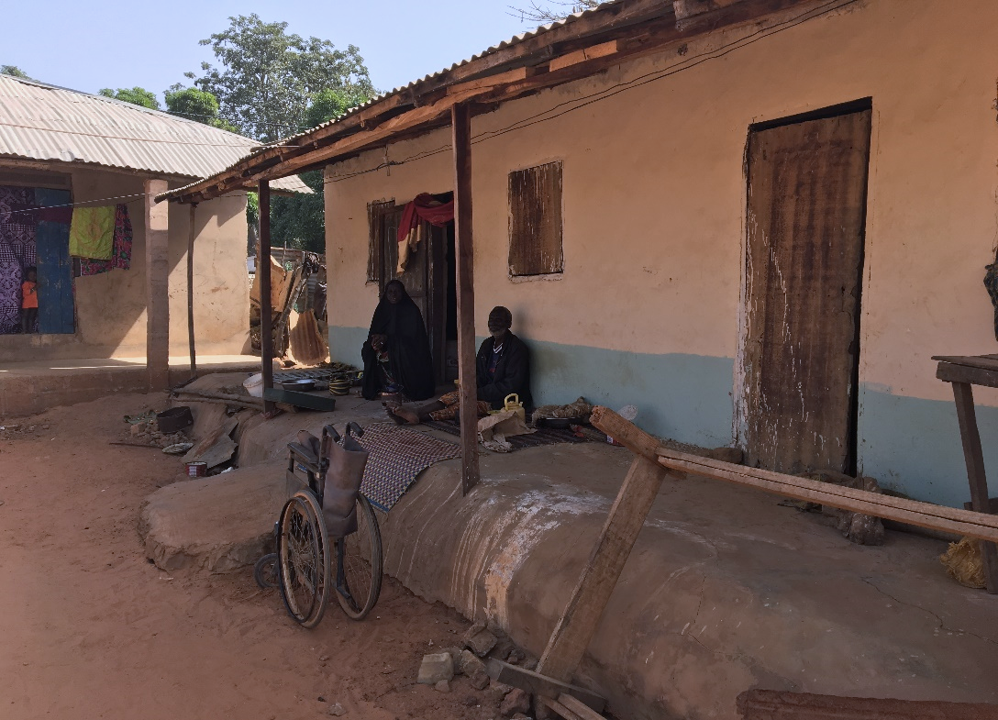**Modou’s Home..**

We have now completed the renovations to this home, including the new roof. It will now thankfully keep dry inside in the rainy seasons. Modou, who is disabled, and his elderly mother are unable to work, and have to rely on others for everything they have.

**Badumeh Kuta Lower Basic School**

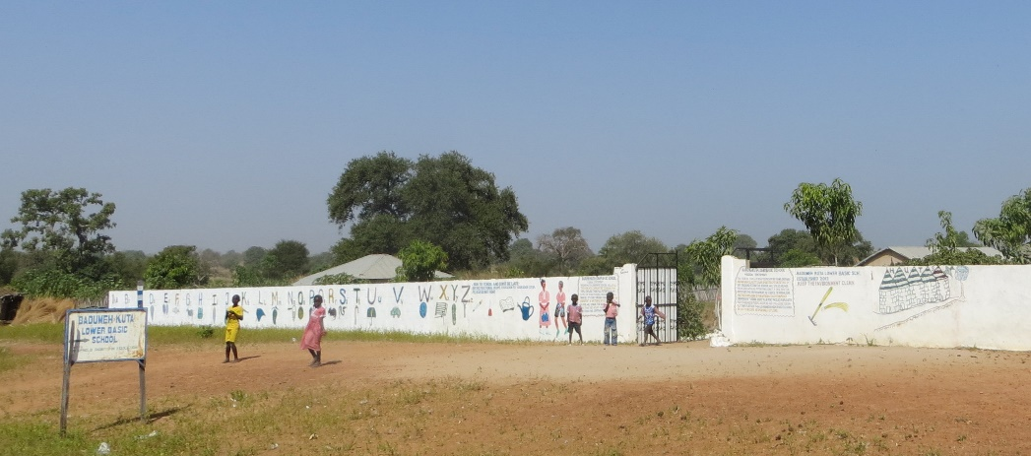

Badumeh School continues to have Mr Cham as its headmaster, he had thought of moving last term, but was persuaded to stay. He has made improvement after improvement at this school, which only opened 4 years ago with a straw classroom and no facilities at all. Since then through his perserverance it is beyond recognition, it just shows what can be done with the right person leading the way. We have helped

**Chairperson’s report**

Since February we have had two trips to The Gambia, which have been necessary as we have had quite a lot going on this year! Marje and Liz went in November, and Gloz and I went in December. Sankung our project manager has been kept very busy with all the demands of the projects we have had and also keeping close contact with our remaining students who are still being sponsored. Sankung also keeps in contact, as we do, with our students who have left education. There are still times when we have helped them with further studies, ie: computer courses since leaving mainstream education. Abdou is now in university; if all goes well, and we have no reason to doubt it, Abdou will in seven year’s time qualify as a doctor. At the very least qualify to work in the health sector.

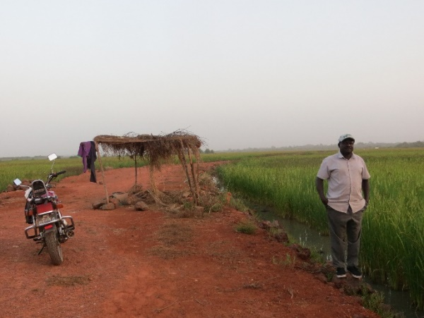

The picture here is of the rice fields outside of Si-Kunda and of the track that is in the process of being widened and built up higher to enable easier access to the area.

The women’s garden project continues to thrive. We have recently made some repairs to the fence surrounding the gardens, as although the agricultural department had put in some new fencing, some had already been battered by some goats trying to get access to the vegetables. The borehole and wells have needed some attention too, and we have now completed all the repairs needed and replaced the taps, the gardens\allotments have plenty of water available. The ladies have formed a new committee to manage the rent they collect to help maintain the area, they have asked Sankung to continue to oversee it all, which he will do with our support.

I have taken this opportunity to enclose a Gift Aid form, so that any of you reading this who donate to FoS could, if any of your details have changed, please fill in accordingly and either email or post to Marje. Her details are on the back page of this newsletter. This is to ensure that when we claim Gift Aid we have all the correct information. Many thanks.

Thank you again for supporting us, with your help we are able to help towards improving the education and lives of so many in the Si-Kunda area of The Gambia. We wish you all a very Happy and Prosperous New Year!! With best regards, Sue

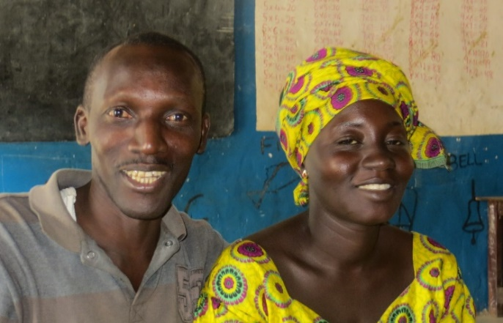**Si-Kunda Nursery School**.

Anna and Modou our teachers at the school, have been joined by a new caretaker, who is helping them to build a better much improved school in the village. They are proving to be very enthusiastic, and there are now many improvements made.

. 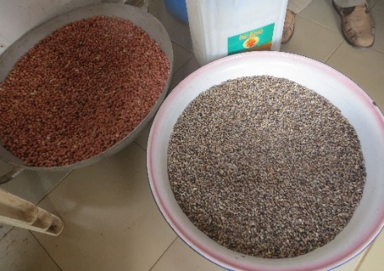

Tombolou is the cook, and here is some of the produce from the school garden, peanuts and beans, there are more vegetables and some fruit planned to supplement the rice at lunchtime.

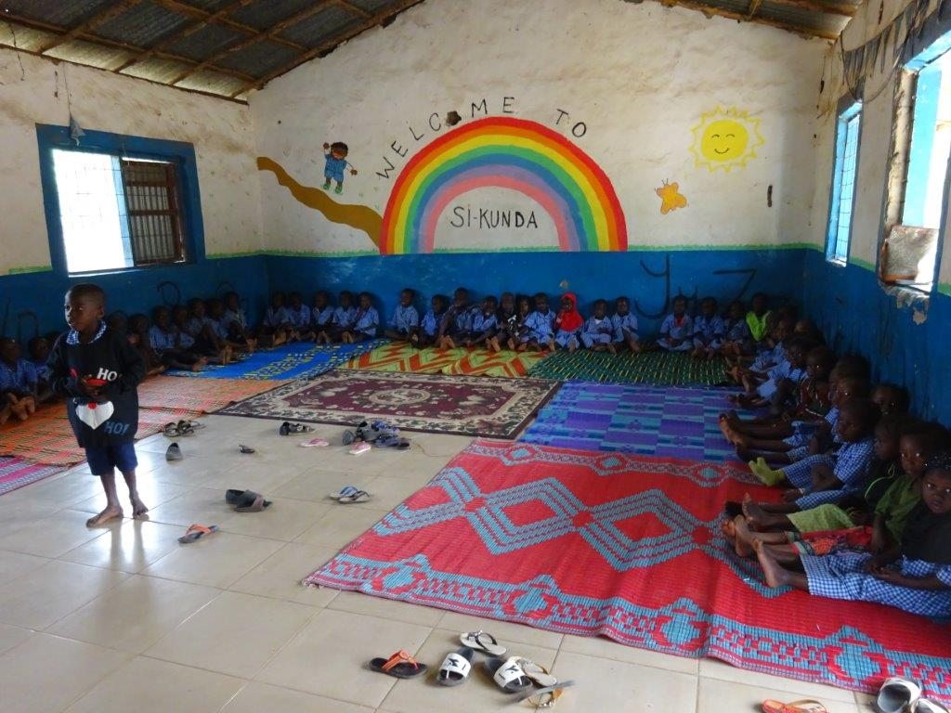The pavilion now has a new roof, and repairs to the school wall and gates have been done. We are in the process of making a veranda with a roof to connect to the school kitchen, which will make for a better cooking area. We have purchased further bowls for the lunches, the children all have a school uniform now, and we have some spare in case they are needed.

For the older children there are new tables and chairs for them, which were sourced in Gambia, we are really pleased with them, they are strong and should last for a considerable time. Further supplies of the everyday needs have been catered for, though we could do with more lego! And of course it is ongoing to supply paper, chalk, crayons, etc., If anyone can help us with pencils and colouring crayons (not wax), then we would be very grateful!

