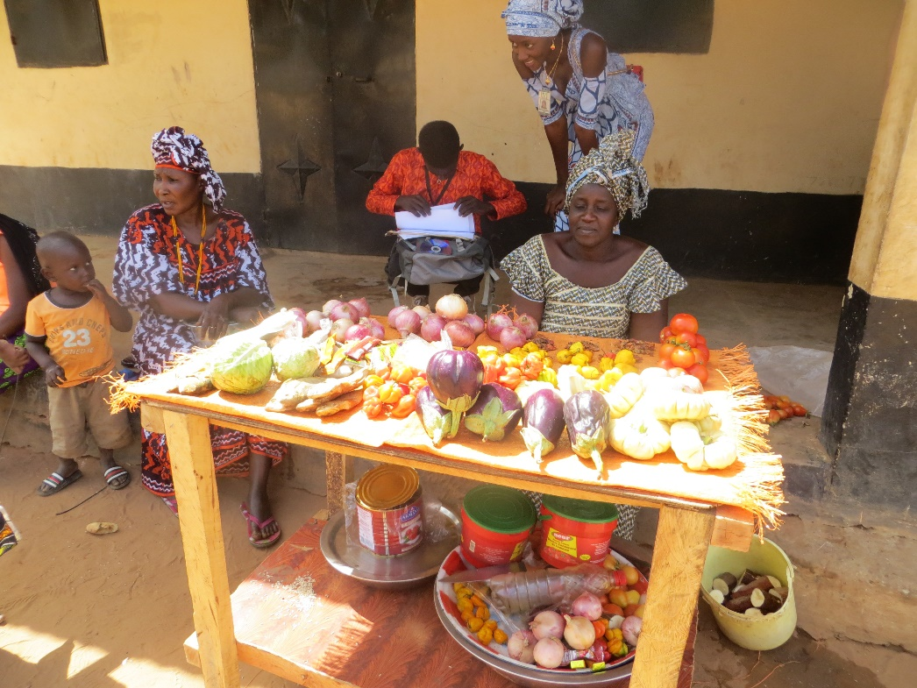

Si-Kunda ladies selling some of their produce from the Women’s Gardens

www.friendsofsikunda.org
Charity UK Reg No.1097750 - Gambia Registration No. 581/2005

For more Information about our charity, please contact anyone listed below:
Chairperson - Sue Jones: 07717 821604 sjones@friendsofsikunda.org
Treasurer - Marje Jones: 25 Church Hall Road, Rushden, NN10 9PA - 01933 387323 marje.jones25@gmail.com
Sponsor Secretary - Gloz: 01844 274047 gkeen@btconnect.com
Secretary - Anne Seckington: anneseckington@btinternet.com
Fundraising – Kate Jones 07921 151711 & Danny Jones 07737 457431

Copyright: Friends of Si-Kunda JULY 2018

July 2018
Newsletter no.30
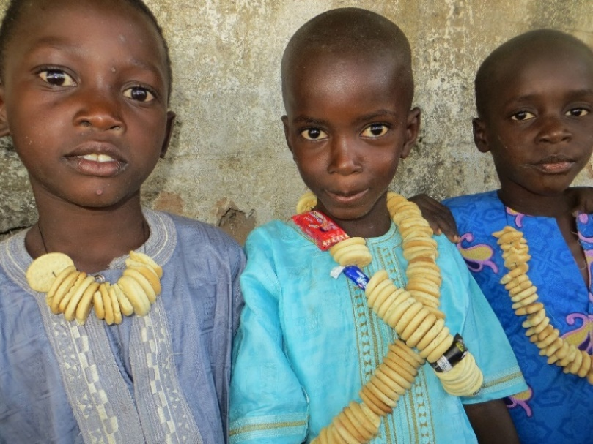

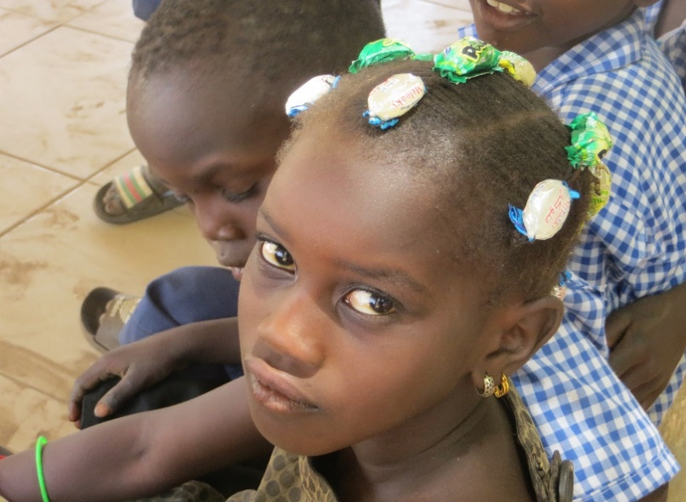

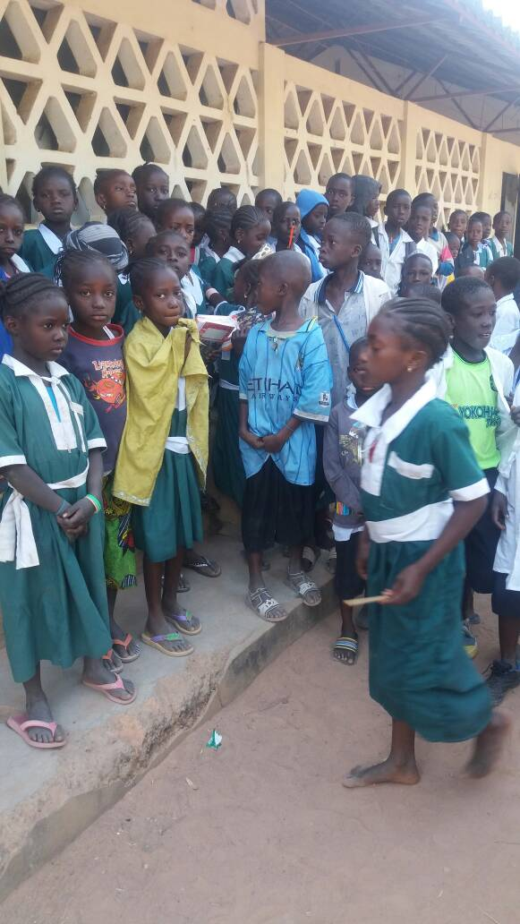
Fonkoi Kunda Lower Basic School

Further exercise books, pens and pencils have been provided for the children at Fonkoi Kunda Lower Basic School.

SMC

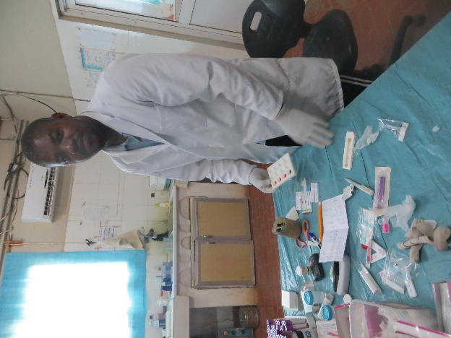
The picture on the right is of Lamarama one of our ex-students, currently working in the laboratory at Soma Medical Centre

Our Data Policy
To conform with General Data Protection Regulation (GDPR), which came into effect on May 25 2018, we have reviewed our procedures and updated our Data Protection and Privacy Policies which can be found on our website. Here is a short summary of the most important parts.
Your personal information is always held securely and will never be passed on to a third party. We only keep your personal information so we can keep you informed of the Charity’s news and activities and for accounting purposes, as and when appropriate. You can unsubscribe at any time if you no longer wish to receive information from us.
Badumeh school
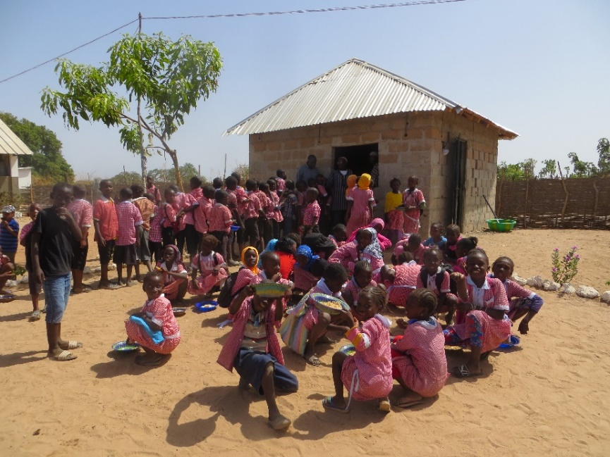
Mr Cham, the school’s headmaster greeted us when we arrived to see the kitchen that has recently been rebuilt. This is a project we had been asked to do as the previous one was not adequate

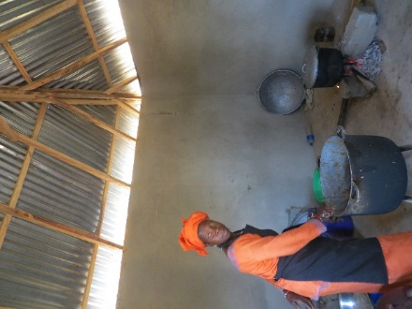
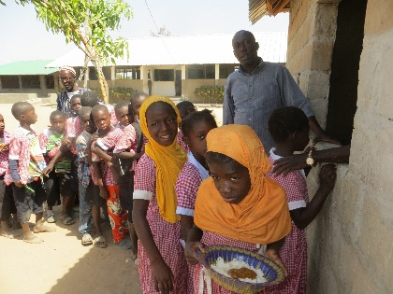
A leaflet has been included with this newsletter, please take time to read it. These are great ways of fundraising for us, which help with all the projects, schools and students we support……and two of them don’t cost anything!

Si-Kunda Community & Skills Centre
We now have electricity installed into the Community & Skills Centre in Si-Kunda. One of our ex-students who is now an electrician was employed to do the work for us, and it is proving to be a real benefit for all the activities that the building is now used for.
Since April one room is being used as a hair dressing salon. Two girls from the village are employed there, and it is managed by Anna and Sankung. The charity gave a small loan to enable the setup, which is being repaid. The salon is doing very well and a is now making a profit.
A new venture
We are always trying to think of new ways of raising funds, and also to create work and self-sufficiency. An idea which has been discussed for some time was the idea of a taxi working in The Gambia to raise funds. Money was given to the Charity specifically for this reason, and earlier this year a Mercedes Benz 190 was purchased. A strong economical car, in very good condition which has been registered etc & painted in taxi colours. A driver is now employed and is working from Busumbala and in the coastal area. A bank account has been opened, and the taxi is now creating funds for the charity as well as giving some employment. We are really pleased how this is currently working, and hope that more enterprises alongside this and the one above can be started and continued by people in The Gambia, to help towards the running of Sikunda school as well as providing some employment.
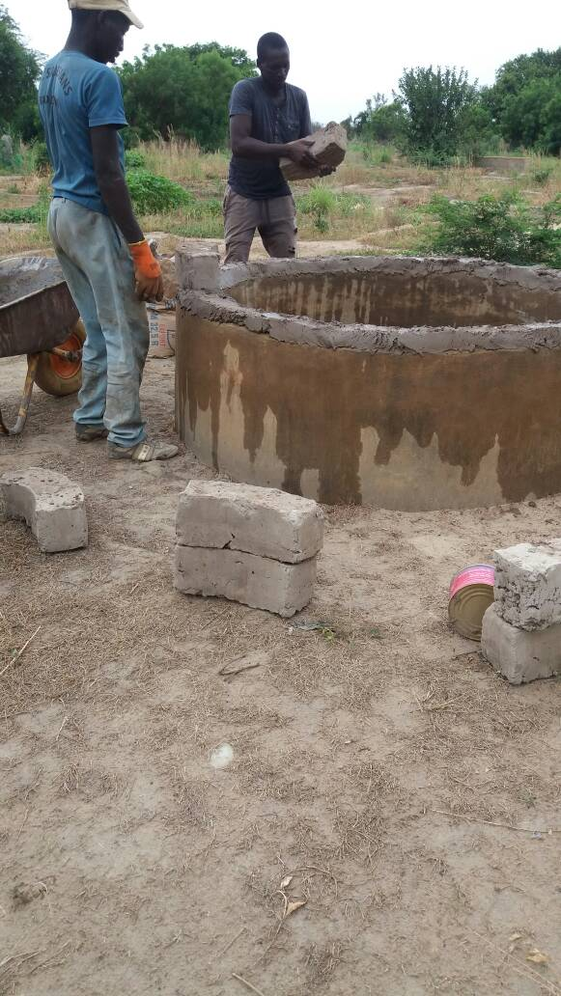
Womens Friendship Gardens
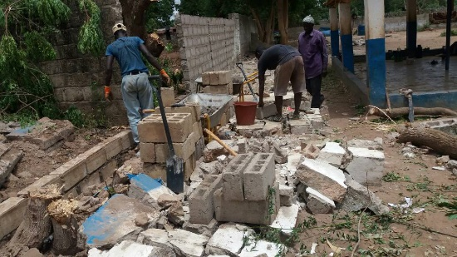
Two extra wells were dug by the Agricultural ministry when they installed the borehole, but they were too low and therefore dangerous for small children, so we have had them made higher to the recommended height. All the wells have taps, and repairs have been made to some that needed it. The produce has been amazing this year, and the women have said they would like a designated market place in the village to sell surplus produce.

Chairperson’s Report
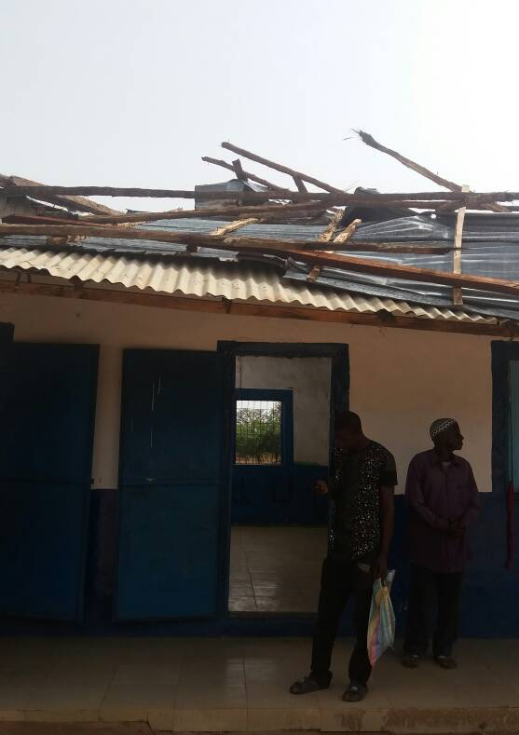
Since the last newsletter, Gwyn and I last went to The Gambia in March. It is always a pleasure to meet our current and past sponsored students which we always endeavour to do on every visit. We are so impressed by how dedicated some of them are, and how hard they work to ensure a future as good as it can be. Even if nothing else had been done all these years that the charity has existed, to see what some of the students have achieved as young men and women makes it all worthwhile.
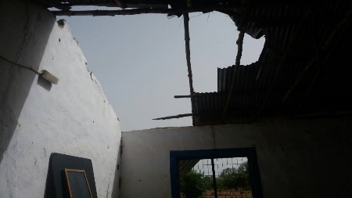
Sadly, since our last visit, on the 28th June (incidentally just after Si-Kunda village school had been decorated and minor repairs completed), there was a violent storm in the Si-Kunda area. The nearby town of Soma was worst hit, with many homes and 19 schools in the area sustaining damage of varying degrees or destroyed. Si-Kunda school had roof damage, making the storeroom and one of the three classrooms unusable. Parts of the school wall came down, and some supplies destroyed. Sankung contacted us straightaway and got working immediately to get help to move the school equipment to a safer place but was very concerned that with the rains imminent there would be a lot more damage while the remaining roof was in such an unstable state – further storms were forecast. Also, the school wall being down meant that animals could wander in at will.
School had to be closed until repairs were completed, but they are now done and the children back at school. This was an expense we hadn’t foreseen, so a bit of a chunk out of our budget, but it had to be done and done quickly. Sankung did a great job managing it and getting a lot done in a relatively short time.
Ironically, they now haven’t had rain for the last 10 days or so and are in desperate need of it, although they continue to get the strong winds. Hopefully the rains will come, and soon. Best regards, Sue
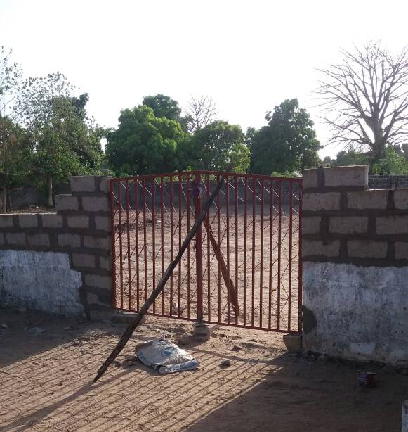
Sikunda school……. Well this newsletter does seem to be mostly about this school! There have been a lot of improvements there over the past year, and although there was a bit of a setback end of June, we have overcome it and school is back up and running.
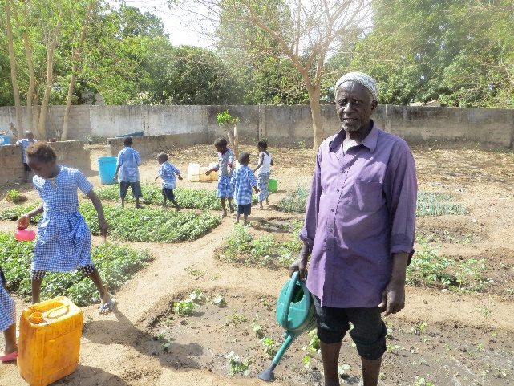
The garden area now has a dividing wall and gates to separate it from the school playing areas, and to stop any goats getting in – they tend to sneak in whenever the school main gates are open! Fadarbo has been growing lots of vegetables and fruit to be used to supplement the lunch together with the rice. The children help with the watering!
Fadarbo has proved to be a great asset to the school.
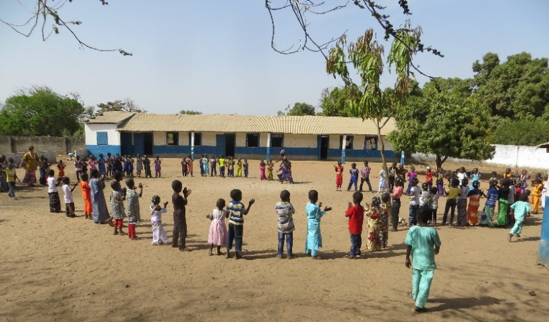
Second week of July the garden area was ploughed, and the ground will be made ready to grow beans, alongside some other produce. Beans are used a lot in the school meals, and there will also be extra grown to sell - creating some funds for the school. Blackboard slates have been donated to the school from another charity in Gambia. We contacted them as they had provided them once before, and straightaway Simon offered to help. We are very grateful for that, as he has also said more can be provided at the start of the next school year in September. We have made shutters for windows to stop the dust getting in, or at least help to reduce it! There have been over 90 children attending the school this school year, some will be moving on to Toniataba Lower Basic school in September, but I am sure there will be more coming into the first class as others move up.
While we were at the school in March, we had an end of term party, well it seemed a good idea! It was exhausting! But great fun was had by all.
The day of the party started at 8am. Well actually it started the evening before when Anna and I went to the market in Soma to buy some supplies for making lunch and whatever else we thought would be needed for the school party.
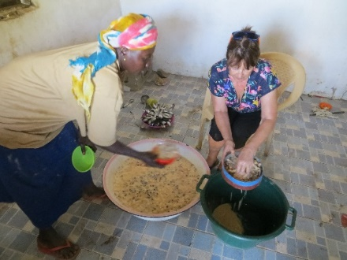
We calculated on there being 100 children (word would get out … there would bound to be extras). I gave Anna the budget and it was managed to the last dalasi. (Gambian dalasi is £1 – 65dalasi, at the time). Arriving at the school we set about the food preparations, which took all morning with 5 of us hard at it! We made a huge bowl of baobab juice, a lengthy process but very tasty. A huge bowl of baobab, including the seeds and some added water, we had to swirl it around with our hands for a very long time, then strain it several times– it was very sticky and gloopy, then about 3.5 kilos of sugar was added, (yes it really was a very big bowl) tiny bottle of banana essence, quite a few chopped up bananas, more water, coconut, and a large tin of condensed milk… kept stirring for a long time. I ended up covered in the stuff which I later found out was almost impossible to get out of black trousers! But it was all done, and there was plenty to drink for the 108 children plus everyone else who had come to help. Chicken Benechin was made for lunch, and then spicy beans for tea. And last but not least at the end of the day, “minty” (otherwise known as sweets). After morning school, the children all went home to change from school uniform into traditional dress, most had necklaces of biscuits around their necks and the girls had boiled sweets tied in their hair. (Photos of front of newsletter). Lots of games were played, with music supplied from a cassette player. We were given traditional clothing to put on as a gift for the occasion from Anna which was very much appreciated by us, and we were each instructed to wear a necklace of biscuits each… the little boys were trying to eat Gwyn’s while he still had them around his neck. Everyone had great fun – how they kept going in the 40+ heat goodness knows, but they did. The teachers, cooks and Fadarbo did a fantastic job, it was a very memorable day for us all. We thought it would never end… we finally left about 7pm!

