Some children in Si-Kunda doing some homework!

A link to this newsletter and a few from the past can be downloaded from our website

For more Information about our charity, please contact anyone listed below:
Chairperson - Sue Jones: 07717 821604 sjones@friendsofsikunda.org
Treasurer - Marje Jones: 01933 387323 marje.jones25@gmail.com
Sponsor Secretary - Gloz: 01844 274047 gkeen@btconnect.com
Secretary - Anne Seckington: anneseckington@btinternet.com
Fundraising – Kate Jones 07921 151711 & Danny Jones 07737 457431

Our Data Protection and Privacy Policies can be found on our website
www.friendsofsikunda.org

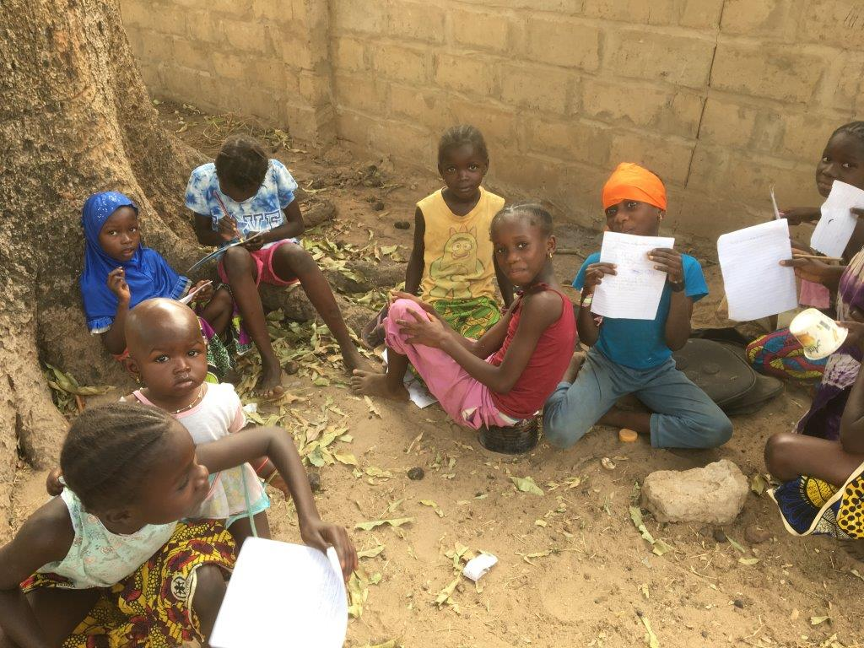
Copyright: Friends of Si-Kunda JANUARY 2019

January 2019
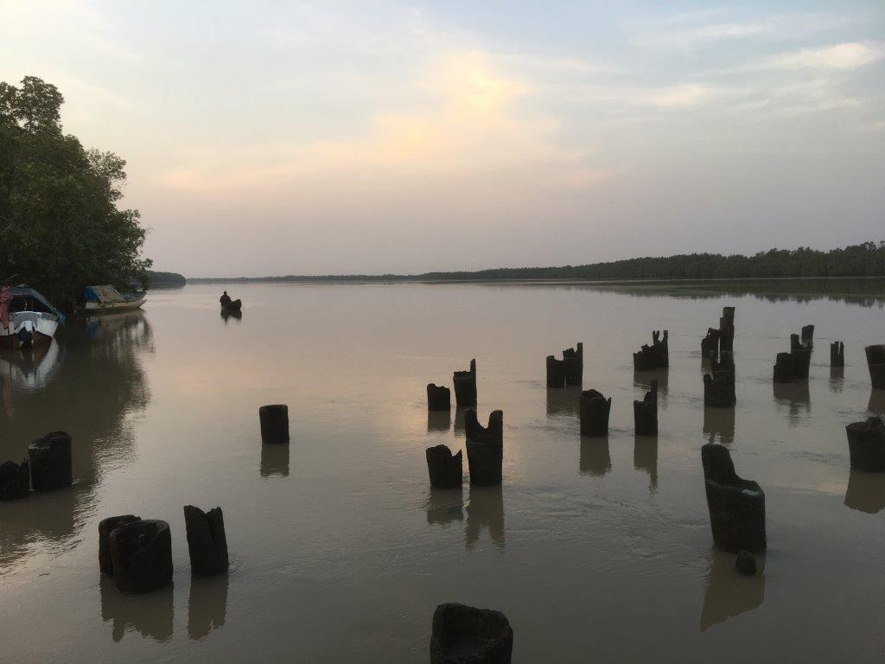
Newsletter no.31
We work with the community of Si-Kunda village and the surrounding areas to help provide education, employment and basic medical care
Friends of Si-Kunda try wherever possible to create projects that can be passed on to, and sustained by the community. We use local labour with all our projects

Charity UK Reg No.1097750 - Gambia Registration No. 581/2005
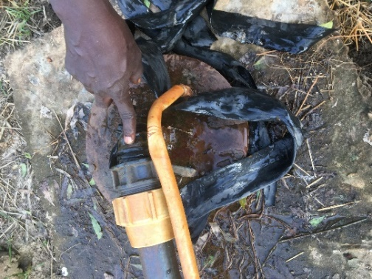
The Women’s Friendship Gardens/Allotments – Si-Kunda
Early morning and evenings are the best times to visit the gardens to either help out or observe the hive of activity, the children all help with the watering and there is always a good social atmosphere
In December there was a problem with this pump connection leaking which came from the borehole. At the beginning of January we had a quote for the repairs, and have since had those repairs completed, along with replacing a broken tap in one of the wells. There are some small repairs to be done to a part of the fencing, so that will be done next.

If you, or someone you know, would like to become involved with fundraising for our charity, we would love to hear from you!
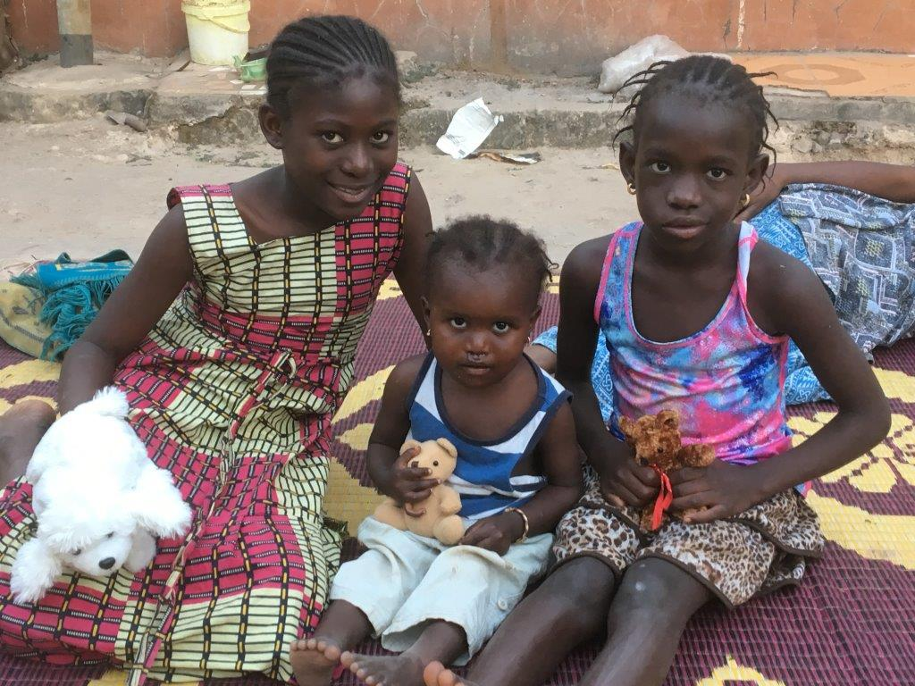
Or, if you would be interested in helping to sponsor one of our teachers, or help to sponsor exercise books and stationary then again, we would love to hear from you. We buy exercise books in The Gambia as it is cheaper than shipping them from here, so we would really welcome some help as any donation no matter how small goes a long way. Either as a one off, or a regular monthly donation – we really appreciate all the help we can get! £1 will buy 4 good exercise books, which means four very happy children!
The results we have seen over the years make it all very worthwhile.

If you would like to see the history of our projects and work in The Gambia since 2003, please go to our website www.friendsofsikunda.org and checkout the Projects section
Si-Kunda Nursery School

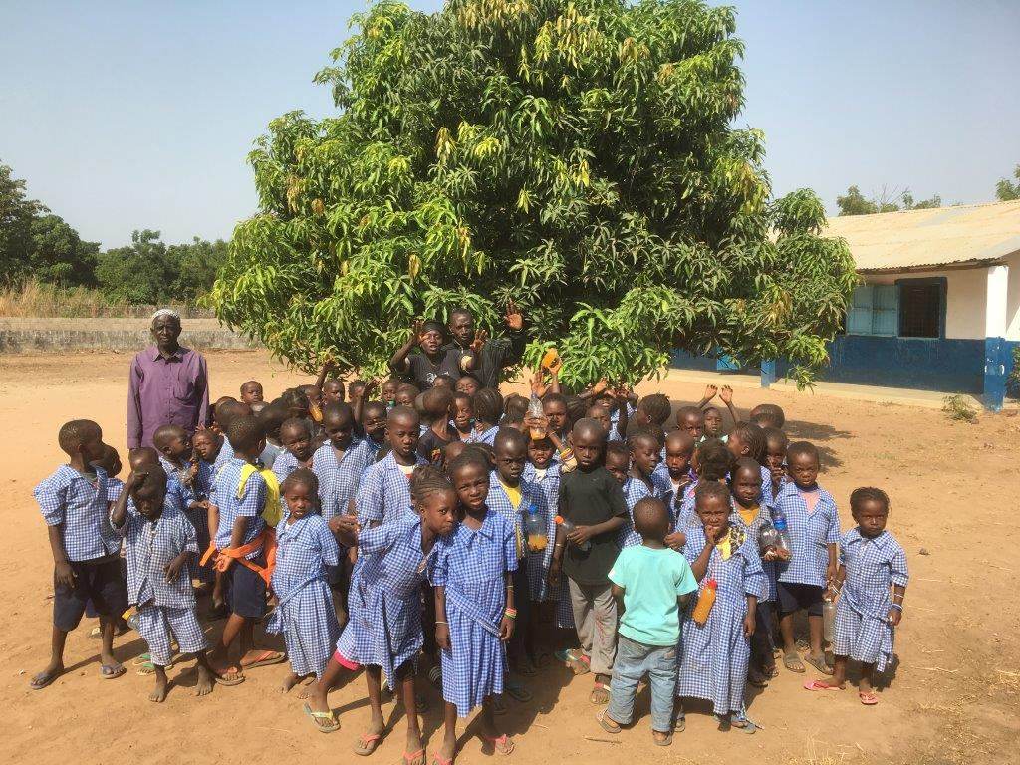
The numbers of students are increasing, over 90 every day. Each year the older students move onto the school in the next village, Toniataba Lower Basic School. Much has been done over the past year with renovations and improvements to the school. We are currently having more individual blackboard slates made in the nearby town of Soma, and we need to source more Lego! Our teachers, cook and caretaker are all working well together, the school is a happy place!

Si-Kunda Community & Skills Centre
The hairdressing project in the Centre worked well for a few months during 2018. It provided employment and also made a profit which paid for the rice and oil needed at Si-Kunda Nursery School for a month. The young lady working there has now left the village as she has married, so we are currently hoping to resume as soon as possible.

Soma Medical Centre
The purpose for this visit was to take some biros which they have been asking for, and to see the swivel chairs purchased for them
Our ‘new venture’ update:
As explained in our last newsletter, we now have a taxi currently working in The Gambia to raise funds for the charity’s projects and school supplies. We are very pleased to report that this is working very well so far, and considering it started in the rainy season when the conditions can be difficult, we are more than happy with the results. Long may it continue…. And maybe at some stage have another, a tourist taxi perhaps!! Now that would be good…..

Fonkoi Kunda Lower Basic School
We have just supplied another 800 exercise books, along with pens, pencils, colouring pencils, erasers, sharpeners, scissors, etc etc, for the start of school term. The headmaster of the school Mr Sanneh is on the right of the picture below. There are currently 153 pupils in grades 1 – 6, and another 40 in the nursery class.
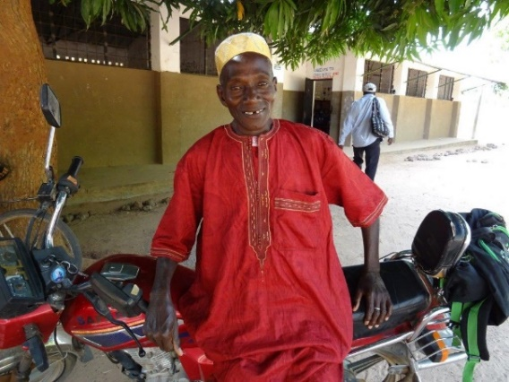
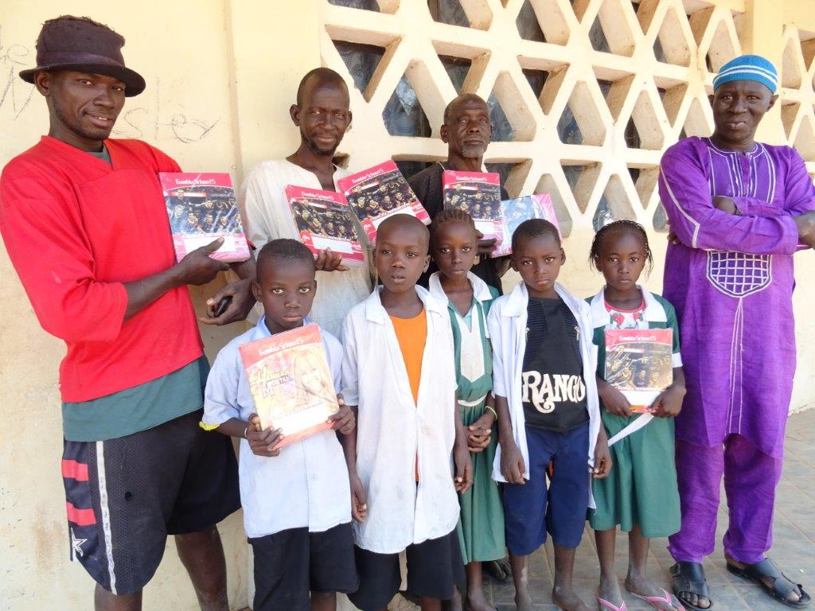
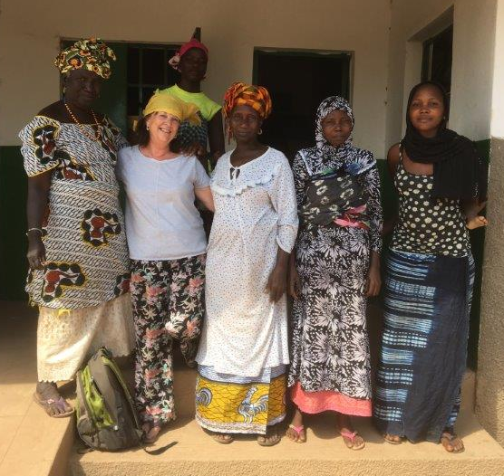
Chairperson’s Report The last visit to Gambia was in December. A very busy week, but having little time focuses the mind and a lot can be achieved! This included a first (and second) visit to a small remote village called Jabisa. We tried to take the taxi the first time but the track to get there proved to be only suitable for donkey carts and bikes. So, to supply 800 exercise books we hired a donkey cart to take them, and off we went on the motorbike, 20km later, hot, weary and aching ribs from trying to hang on over the rough tracks through the bush, we arrived. I dismissed all ideas of falling off, punctures, Sankungs helmet flying off and hitting me in the face as he had one hand hanging on to it and the other steering, avoiding collisions with donkeys, goats or the occasional cow, my “sensible” side would not have allowed it! We were laden with stationary supplies, but managed, and of course it was great fun! We eventually arrive at the school with shouts of welcome coming from all directions. Some ladies then arrived from the school and village committees. The headmaster was taken aback when he saw all the exercise books, pencils etc., I don’t think they expected to see us again so soon after our initial visit the day before. We walked to the women’s gardens afterwards, the gardens were quite large, outside of the village, growing mainly peppers and bananas, they said they rotate the crops, though there did seem to be a huge amount of peppers! The gardens were very neat and orderly and very well tended. There are 3 wells in the gardens, with very low walls which concerned them of the safety aspect and it is so hard for the older women pulling up the water in the plastic containers. The fencing was almost non-existent, and cows and goats often get in. They need help, and this could be a project for us, but at the moment water in the village and school is the main priority. More about the school on the next page.
Here is one of the teachers from Toniataba school, he has been there for many years, he does like to have his photograph taken, so we have quite a collection now! Best regards, Sue
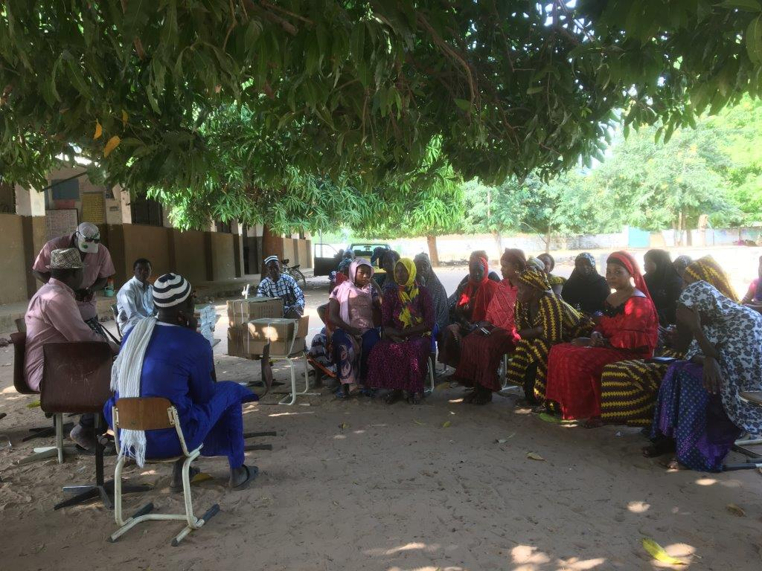
Toniataba Lower Basic School
The school now has a new headmaster, Mr Colley. We took 800 exercise books for the new school term, plus writing materials. We met the chairman of the School committee and all the Women’s committee. There are currently 435 pupils in Grades 1 – 6, with 83 in the two nursery classes. The school has expanded quite a lot in the last couple of years. They currently have an issue with water. We installed a water tap a couple of years ago but it is dependent on how much the village is using along the line, and they don’t always have enough, especially now that the school has expanded.
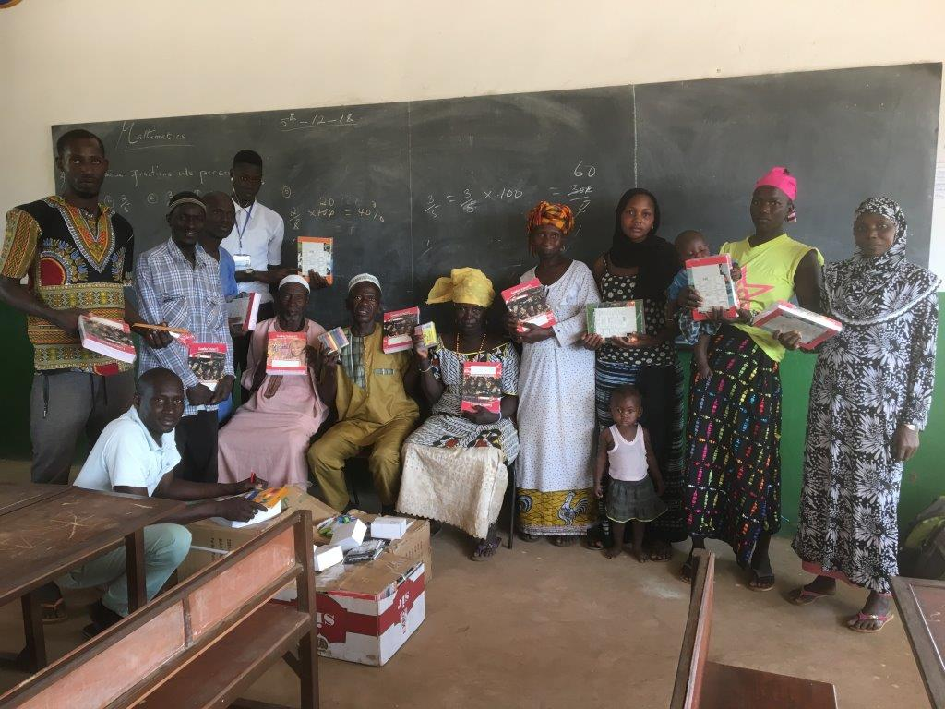
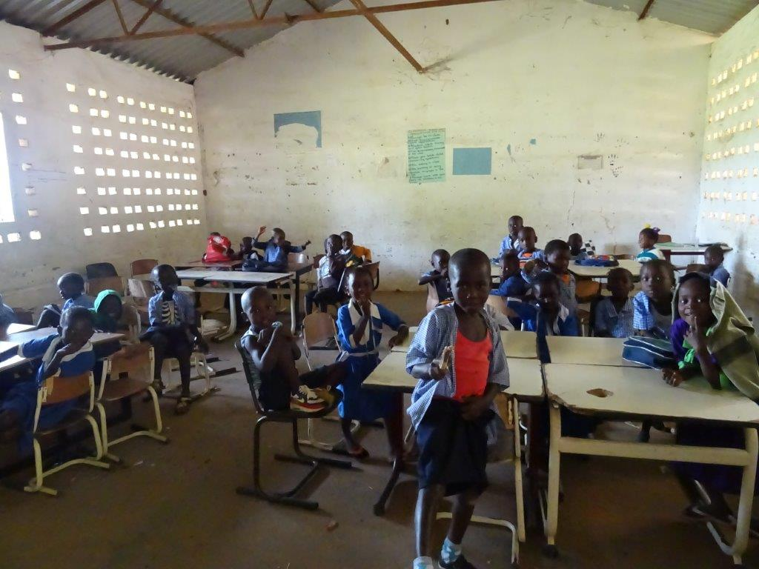
A borehole has since been put in for them, but is currently unusable as the pump is broken. So, we are going to ensure the pump is replaced with a better quality one and get the supply up and running as it should be, then along with the water tap they will have plenty for their needs.

We do seem to go in cycles, at one time we had a run of building lots of toilets, at the moment it seems to be water access!
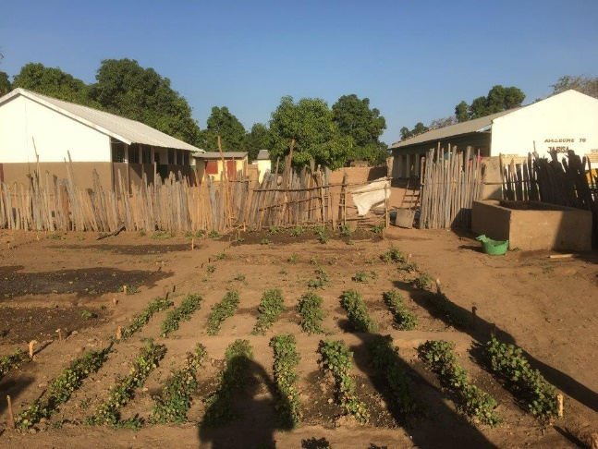
Jabisa Village and Lower Basic School
The school and village are remote, much like Fonkoi Kunda though much further from Soma town. And once off-road the 5km track to the village is good for only donkey carts and bikes (if you are careful), otherwise it’s a very long walk! The village has a population of 400. The school was first opened in 2011. It was made of straw, then an English charity built them a classroom, the government then 3 years ago built more classrooms and teachers living quarters. The villagers have been asking us to visit, in case we could help in some way. On first impressions it is very well looked after, with a school garden, and very enthusiastic staff. There were text books in the school, which the government supplies, but no exercise books. Parents are expected to supply them, but as so often is the case in the rural areas in particular, they cannot afford them especially if they have more than one child at the school. The villagers themselves were as friendly as we have ever met, with school and village committees formed. We have now provided exercise books and stationary. While there I saw one water tap in the school grounds, but all the villagers were having to use it as well as the school, which is obviously not ideal nor convenient. So, after checking it out, it was apparent that the borehole in the village needed a new pump and handle (yes, another one!). So, we will take this on as a project to get done as soon as possible. There are a few more smaller items the school would make good use of that we will source in Gambia including garden tools and a First Aid Kit.

