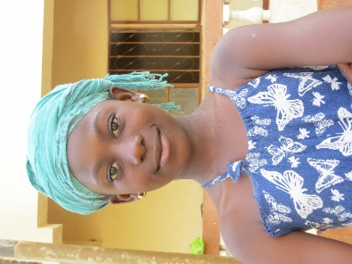

Toniataba Lower Basic School – we have repaired the well pump in the school grounds, they were struggling to get enough water, so this has helped them enormously.

A link to this newsletter, and a few from the past can be downloaded from our website

For more Information about our charity, please contact anyone listed below:
Chairperson - Sue Jones: 07717 821604 sjones@friendsofsikunda.org
Treasurer - Marje Jones: 01933 387323 marje.jones25@gmail.com
Sponsor Secretary - Gloz: 01844 274047 gkeen@btconnect.com
Secretary - Anne Seckington: anneseckington@btinternet.com
Fundraising – Kate Jones 07921 151711 & Danny Jones 07737 457431

Our Data Protection and Privacy Policies can be found on our website
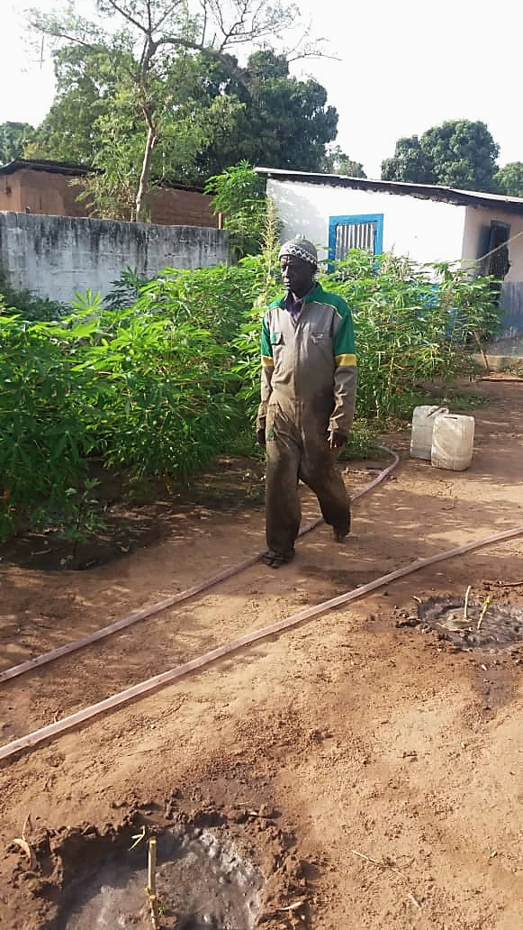
www.friendsofsikunda.org Copyright: Friends of Si-Kunda July 2019
Fadarbo, the Si-Kunda school caretaker and gardener…. showing some of the cassava growing in the school gardens

July 2019
Newsletter no.32
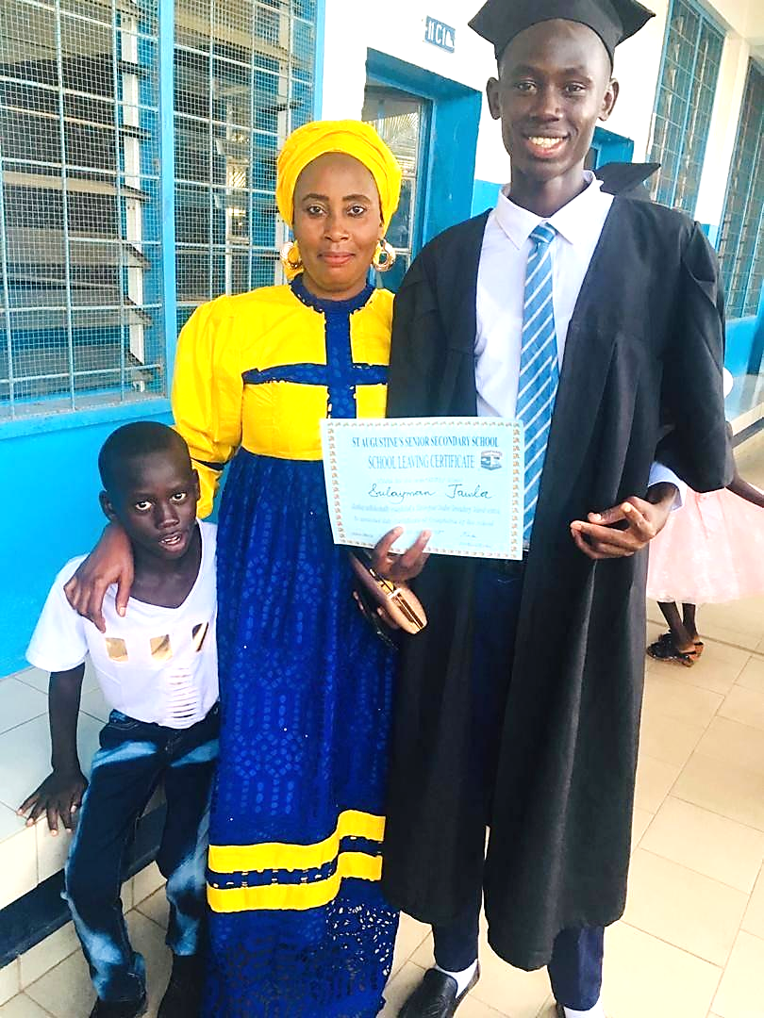

Sulayman and his mother

Friends of Si-Kunda try wherever possible to create projects that can be passed on to, and sustained by the community. We use local labour with all our projects
Charity UK Reg No.1097750 - Gambia Registration No. 581/2005
Another School Year Ends
As another school year comes to a close, two more of our students have graduated from Year 12. These are Sulayman Jowler & Paseedy Jammeh. And Fatau Jammeh has completed her three-year Primary Teaching Course
Sulayman (who’s photo is on the front page) is an avid football fan and a very good player he has loved receiving any books on the subject since he was young. He has always done very well at school, with consistent results. He has not had an easy life, his father died a few years ago, leaving his mother struggling to educate him. Both are so grateful for the chance he has had. He is chatty and lively and hoping his hard work has paid off when his results arrive so he can pursue his Further Education for a career in IT
Paseedy is very athletic and in 2018 he attended a four-day sports camp, having come first in all of his races at his school. He then went on to represent this school in Brikama and won all of those races too, then competed at National Level at the Independence Stadium, where he took part in two relay races and thoroughly enjoyed it all, he was delighted that it was covered by Gambian T.V. he is still enjoying his sport when he can. He has studied well to achieve some good grades over the years to enable him to take the next step to work in the Health Sector – in his own words: “I work hard as I expect to be taking on the health of the public and I also love to be a guy who will be working at the hospital – I hope my grades are good”. He would like a career in Nursing, and is also interested in Public Health, where there are sanitation issues.
Fatau is a very lively young woman, full of confidence and was always writing stories while growing up. Her ambitions and imagination know no bounds. She has completed her three-year Primary Teachers Course and during the past year she was also a member of the College Government as one of its ‘Ministers’ she has earned respect and is capable of giving a very lively debate. As well as teaching she has always had an interest in Currant Affairs and Journalism.
We wish all of our students the best of luck with their forthcoming results, and will follow Fatau’s chosen path with interest. Gloz
Si-Kunda Nursery School
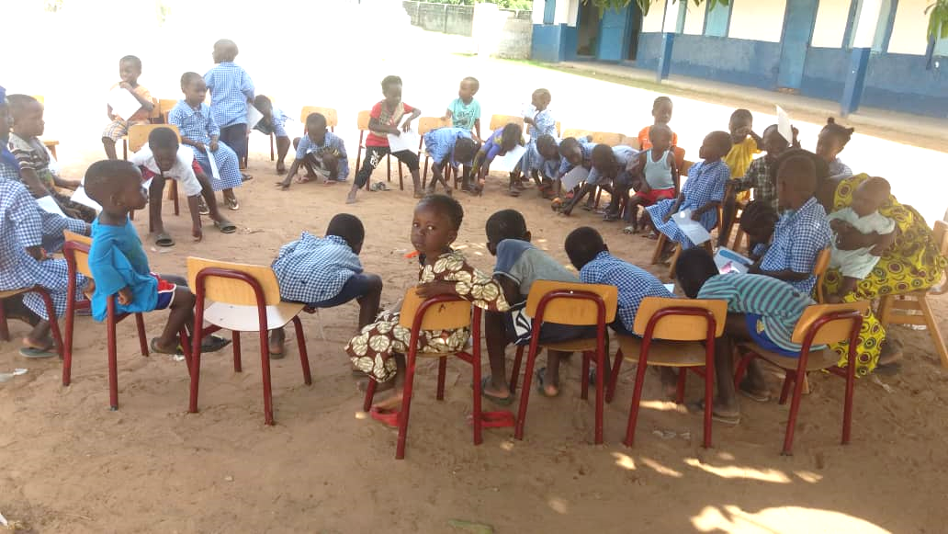
Two shutters for a window have been made, to add to those already done - there is so much dust especially when the winds come, so it is essential that all the windows have them. We have had some more individual blackboard slates made to replace some of the older ones, the remaining ones have all been repainted, there are plenty for every child to have one each, with some spare.

In April, we received a wonderful donation of tables and chairs for the Nursery school, also some learning materials, footballs and building blocks. To help with the school lunches we received 10 bags of rice and onions, 5 bags of potatoes, and a 5gal drum of cooking oil were also provided. This has all been a tremendous help and very generous - all this from a former Si-Kunda resident, who is the brother of one of our former students whom we sponsored throughout his education a few years ago.

The school garden is flourishing, including cassava, bananas, sorrel, ginger, cabbage and okra to supplement the school meals, Fadarbo is doing a tremendous job keeping the garden well-tended and productive. Any surplus cassava grown in the school garden will be sold to help school funds. Soon it will be time to have school uniforms made for the new school year, this costs approximately £400 to clothe all the students in the school, keeping a few spares for any pupils joining later in the year.

We have now raised enough funds to have some play equipment made for the playground, this will be ready for the new term in September. Apparently, this is the first school in the district to have swings in a playground, as expected the children are very excited to start using them in the new term!
NEW PROJECT – MEDINA FONKOI VILLAGE GARDEN
In January we visited The Gambia for a two week stay. We had a great trip as usual and were given a lovely welcome. During this time Sankung, our Project Manager, took us to see how all the Projects are managing. These are Projects that we have been involved with over the years. As always, we also look to see if there are any other ways that we can maybe help in the community. We often seem to come away with ideas for new Projects and so this trip was no exception.
While talking to Sankung, I asked him about a very remote village in the bush called Medina Fonkoi. I visited this particular village about 4 years ago, they are a most friendly people but have nothing and we have always wanted to help in some way. We have sent them clothing in the past but they really need something that will be of continuous use to them to improve their lives and that they can sustain themselves. So, I asked Sankung what he thought to the idea of a Ladies Allotment garden like the one we started in Si Kunda. He said this is something he had been thinking of as well, and he had found out that the women of the village have actually tried to start one themselves. They have one well and inadequate fencing. They need help to really get setup and started. After returning to the UK we have decided this is a project we would like to be involved with.
The plot will be extended to 50m x 50m, this size will enable the women to have a plot each. The area will need secure fencing so the goats will be kept out, it will also need another 2 wells, tools, watering cans, seed, fertiliser. The total cost is estimated to be £1,800.00. (dependent on the current exchange rate)
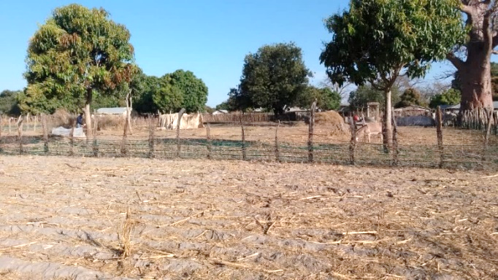
So now starts our campaign to raise funds, so if you would like to help this most worthwhile Project, with the goal of helping the whole village, we would be most grateful. Once finished it will be sustained by the villagers themselves.
One of our most successful Projects to date has been the Si Kunda Village Ladies Allotment Gardens, so we hope to repeat that success story in Medina Fonkoi!
Please Please contact any one of us if you think you are able to help us in any way with either a donation, raising funds or sponsoring. Marje
Chairperson’s Report
The six months since our last newsletter have been busy, concentrating on Sikunda School, along with Jabisa and Toniataba Schools. They have all benefited from the generous support so many of you provide, for that we are very grateful. We keep in close contact with our students, not just our current ones but also a lot of our past students as we like to know how they are progressing in their lives, and they too like to keep contact with us. We hope you enjoy the article written by Abdou, our “Gambian correspondent”! He will write something for us from time to time to include in the newsletter that may be of interest to our readers.
We are looking forward to finding out the exam results of our students who have just completed Grade 12, and to see where that leads them next in their education.
The women in Si-Kunda have for quite some time been discussing the possibility of having a market place in the village to sell produce grown from their allotments in the Women’s Friendship Gardens (a project we started in 2006). The village is on route to other rural villages so the opportunity is certainly there, and would benefit the whole community. We have some ideas now of how this may work, and so by the time the next newsletter is due we hope to bring some news of progress.
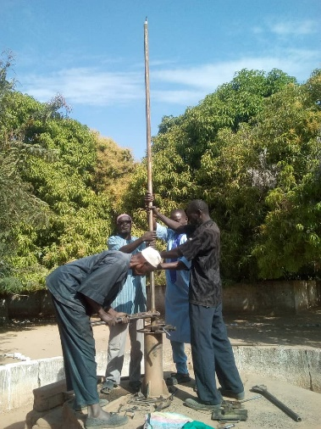
Many thanks to all of you who continue to support FoS, its very much appreciated by us all. With kind regards, Sue
Jabisa Lower Basic School
The broken pump at the well in Jabisa has now been replaced, and is in good working order. We also brought a wheelbarrow and some rakes for the Jabisa School garden. Jabisa school has very enthusiastic staff and pupils, and keep the school premises very tidy and organised. . The school is in a very remote area and receives little help from elsewhere, so we will continue to help where we can in supporting this school
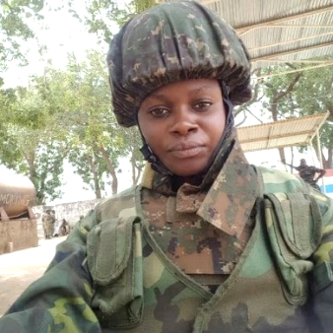
Sunkary One of our former students has been in the National Gambian Army for a few years now, and has worked her way up to now be part of the National State Guard, protecting the President when he stays in the capital, Banjul.

The Mandinka Naming Ceremony – by Abdou Jammeh
It is always interesting to learn from different cultures in the world. This small country (The Gambia) is famous for her ever-lasting and impressive cultural activities; which may be practiced in other parts of the world but differently structured in The Gambia and as such were said to have been inherited from our ancestors since their migration to the region in 14th century. The Mandinka tribe is the largest ethnic group in the Gambia which makes up 42% of the Population of The Gambia. In this article, we will see how a Naming ceremony is celebrated in Gambian Mandinka Society.
KULLIYOO is the original Mandinka word for Naming ceremony which basically means to shave/cut the hair of the new born baby. KULLIYOO is celebrated on the seventh day after the birth of the baby. The family is responsible for making this day a success since it's not just a day of entertainment, but most substantially, a cultural and religious requirement that every child deserves. The two most significant motives behind KULLIYOO (naming ceremony) in Mandinka society are offerings, and thanks-giving to God who blessed the family with a baby. This ceremony is accompanied with lots of joy, sharing and caring within the community.
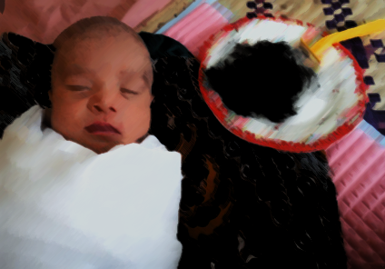
WHAT HAPPENS ON THE KULLIYOO DAY? Early in the morning of the seventh day of the baby is the actual time which the mother can go out of her house-of-delivery known as GIBA-BUNGHO. The members of the community are called to gather at the compound where the baby was born. The elders and religious leaders are welcomed to sit on the floor on a large mat in the middle of the compound. They hold the baby at the centre of the sitting mat, bring some cola-nuts and traditional rice cakes (Mungko), then start shaving the baby's hair A significant part of the KULLIYOO is the preparation of either a sheep or a goat. Otherwise the ceremony would be called NYANGBOO, which would be as a result of either financial constraints or poor timing system met by the family.
The father of the baby provides the sheep or goat for the meal to be shared with relatives, neighbours and the poor within or outside of the community, this is not only seen as the meal to be eaten, but shown as an appreciation to God also The only preserved part of the meat is the liver and the back of the animal. These two parts are adequately preserved for only the mother of the baby, and she will decide how to use them. This is a sign of respect to the mother.
NAMING THE BABY The next step is that everyone gets to the final compulsory section of KULLIYOO- the actual Naming of the baby. The carefully selected name, which has been kept a secret, is to be announced – nobody wants to miss this moment. This is everyone's favourite part; where traditional singers and melodious drums are set for entertainment. Elders on a large mat are with the baby waiting for this moment and other children present are given some food. GRIOTS (traditional singers and oral historians) start attracting everyone's attention by slowly and continuously pronouncing the name that everyone has being waiting for. The name is loudly announced as "... DEY-NA-NO TOOO..." by missing some parts in order to get the crowd's maximum attention. This translates as, 'The name of the baby is...' It is the time that you see people openly giving money to the griot in order to get the name fully announced. Revealing of the name is normally accompanied with soft and beautiful traditional dance which marks the end of the cultural and religious requirements of KULLIYOO. The afternoon is filled with fun and entertainment until late evening, the ladies colourful in their traditional dress. This rich culture still remains in Mandinka societies although reshaped and modernised, creating a lot of fun. Aside from that, Gambian Mandinka’s still observe culture which has been inherited from the earlier settlers in the region. Abdou Jammeh

Abdou is due to start his 3rd year at university. Apart from writing and poetry, other skills and accomplishments include Programme & Strategic Manager Inter-School Alliance for Change for The University of The Gambia, he is a brown belt in martial arts and the President of Gambia Shi Kung Fu Martial Art Training Centre. Abdou is also the Founder and President of The Si-Kunda Students Association – this is all very commendable, so many of our students have gone on to help others which just goes to prove how important the opportunity of education is and how much it is appreciated.
Donations… We are always very grateful for all donations we receive, and here are two that we think deserve a mention, one from Emmah,(aged 9) who lives in Canada and very generously donated her birthday money, also from Jemima (aged 11) who did a sponsored silence weekend – which I am sure wasn’t easy! We are very proud of them for being so generous. Their donations have been used by Si-Kunda Nursery school, buying footballs, balls, chalk, and then sweets for all the children on their last day of term – all of which were very much appreciated! Thank you Emmah and Jemima!
Another enthusiastic former student of FoS is Kaddy Sonko – she is now married, and works in her husband’s supermarket, assisting him to ensure they continue to have a thriving business.

