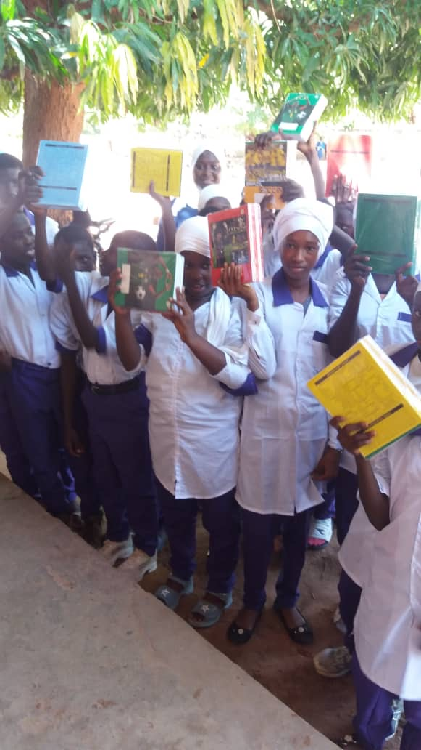
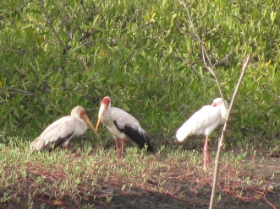
Toniataba School

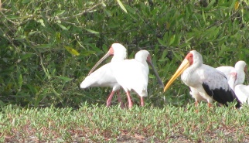
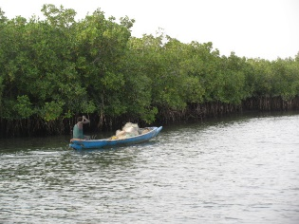
A link to this newsletter, and a few from the past can be downloaded from our website

For more Information about our charity, please contact anyone listed below:
Chairperson - Sue: 07717 821604 sjones@friendsofsikunda.org
Treasurer - Marje: 01933 387323 Marje.jones25@gmail.com
Sponsor Secretary - Gloz: 01844 274047 gkeen@btconnect.com
Secretary - Anne Seckington: anneseckington@btinternet.com
Fundraising – Kate Jones 07921 151711 & Danny Jones 07737 457431

Our Data Protection and Privacy Policies can be found on our website
www.friendsofsikunda.org Copyright: Friends of Si-Kunda January 2020
January 2020
Newsletter no.33
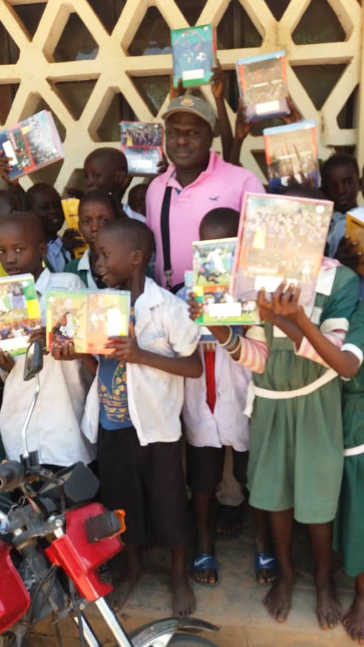

Fonkoi Kunda Lower Basic School
Charity UK Reg No.1097750 - Gambia Registration No. 581/2005

Chair’s Report
It has been a very busy six months in The Gambia for Sankung. There have been students to help with making decisions on their future; new schools, college and university arrangements to make; organising provisions of exercise books for the schools we continue to help – Toniataba, Jabisa and Fonkoi Kunda schools; school uniforms to order and then made by local tailors in Si-Kunda for Si-Kunda and Jabisa schools, further improvements made for Si-Kunda school and all on top of managing a new project which started a few months ago and now recently completed – The Women’s Garden project in Medina Fonkoi.. it is amazing how quickly this has progressed, and we look forward to seeing the results for ourselves very soon, there are some photographs are over the page.
Normally we would have visited again in November, but because Thomas Cook went to the wall, it has meant fewer flights are going to the country, and those that do mean considerably increased prices for us to get there. Currently the journey is much longer as there are two or three flights involved in getting there now. But we keep checking as we intend to get there in March. We are very fortunate to have the people we have working for the charity in Gambia whom we have been always able to trust, and we have such good communications these days that it is easy to keep very close contact and see all the progress the charity is making.
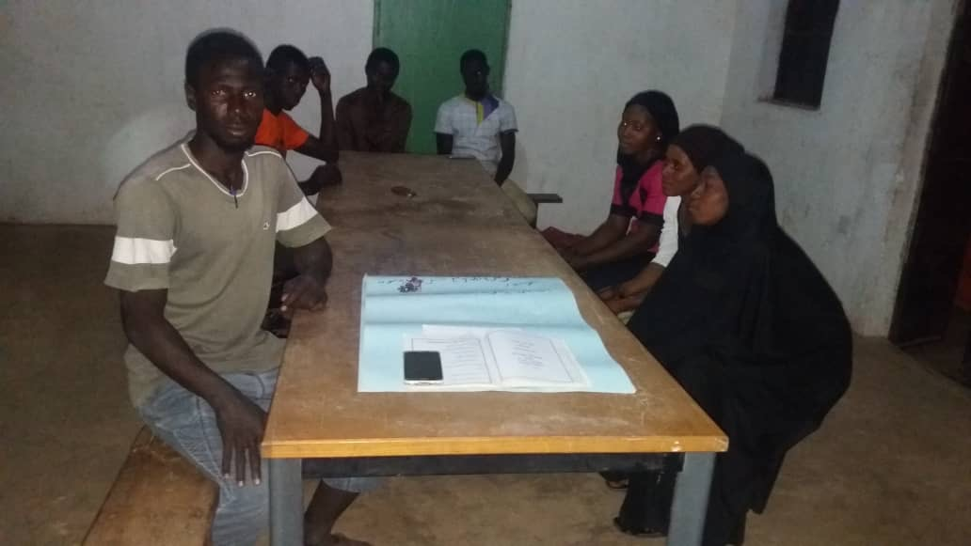
The Skills & Community Centre now includes a Koranic evening class for adults, and very soon we will start classes for soap making, with the intention of creating a soap making business in the centre also. And then tie and dye is a real possibility. We have a tutor who is going to take all this on, we just have to wait a little longer until he can start. The hair dressing salon is still in the side room of the building. And of course, other activities are ongoing.
All the photographs in this newsletter have been taken over the last two weeks of January.

Many thanks to all of you who continue to support FoS, it is very much appreciated by us all. With kind regards, Sue
Jabisa Lower Basic School
New uniforms and books for the start of the new school year..

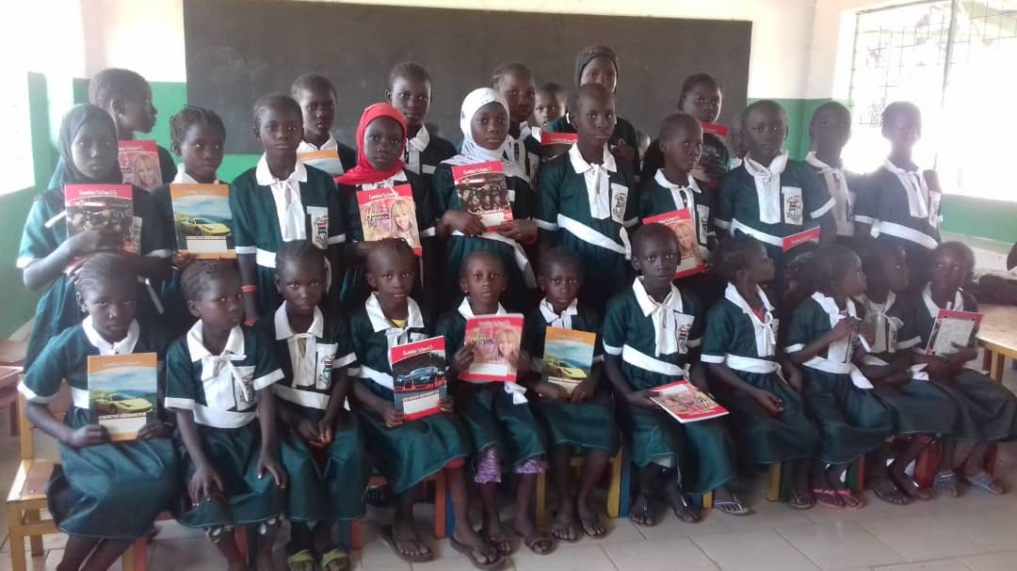
Si-Kunda Friendship Gardens
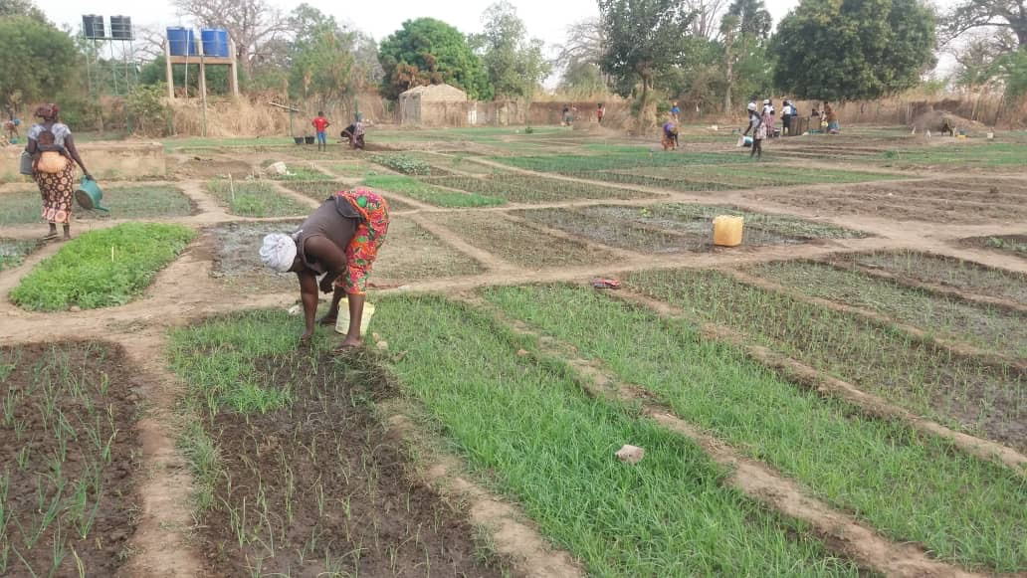
Friends of Si-Kunda try wherever possible to create projects that can be passed on to, and sustained by the community. We use local labour with all our projects
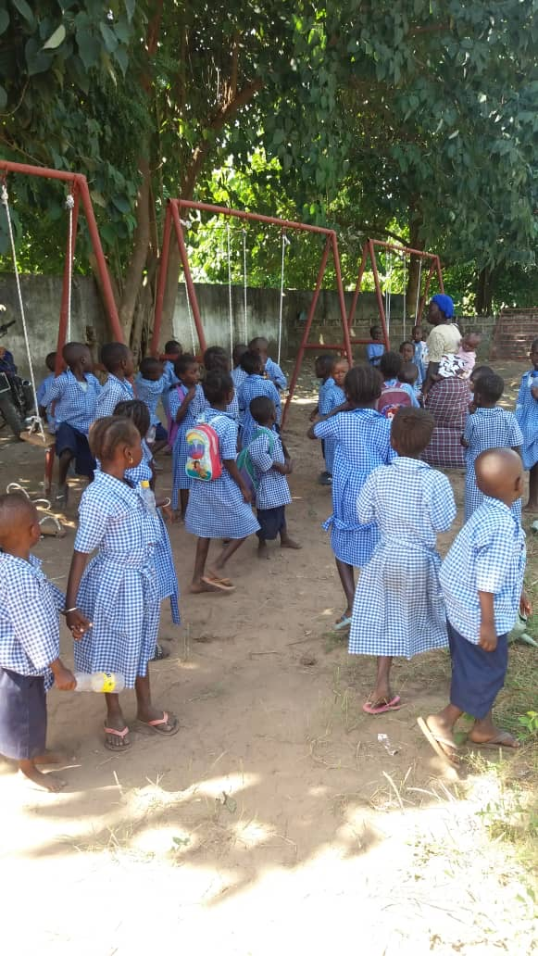
Si-Kunda Nursery School - There are now three sets of swings fixed in the School playground, and the children just love them! For safe keeping the swings are taken off the frames after school each day and locked away… otherwise the teachers are sure children will be trying to climb the school walls to get back in and use them out of hours! So, they are being well supervised and looked after.
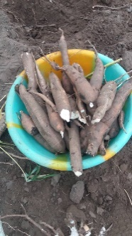
The school garden is flourishing, Fadarbo is doing a great job, and has created an area just for seedlings, he rotates the crops of vegetables and he has just harvested a lot of cassava, some is used to supplement the school lunches, and the rest sold to raise funds for the school.
Below is Fadarbo, teachers Anna and Modou and some of the students
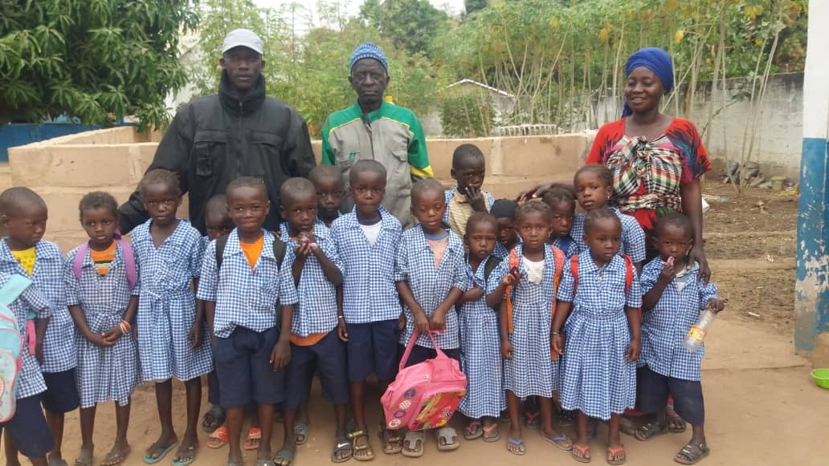
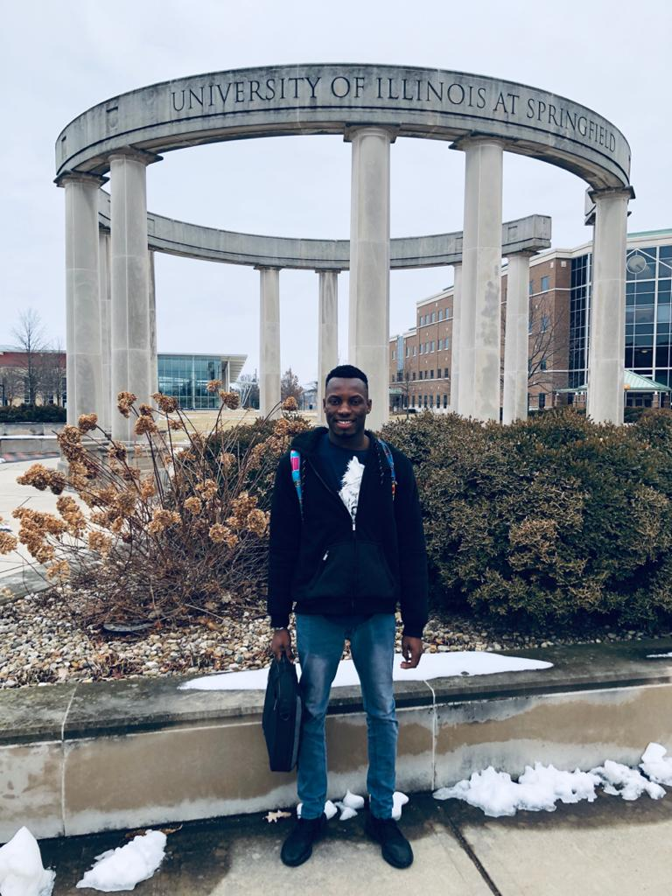
Student updates
Lamin Njie – Lamin has amazed us all with his continuing determination and hard work. After sponsoring Lamin through school and The Gambia University, he started work at Supersoniz Finance and worked his way up rapidly to acting Finance Manager. Then towards the end of 2019 taking full responsibility himself, he took the step to gain a place at Illinois University, Springfield, USA.
He started his first of two years doing his Masters in Accountancy on 13th January 2020. He is loving it, enjoying the course work, and getting to grips with a very different culture. The charity he created, and manages with his fellow committee members in The Gambia, is continuing to make a huge difference to sponsored young students and their families. Lamin is someone so many young people there aspire to.
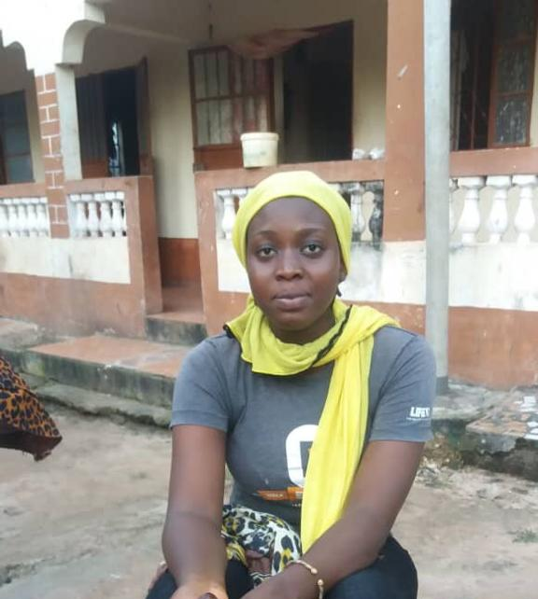
We have two students currently at University; Abdou, and also Paseedy who is now doing a degree in Public Health
FoS have just taken on another student to sponsor. This is Isatou, she needed funds to enable her to do the two year Primary Teaching Certificate course.
We have known Isatou for quite a few years, she is a lovely young woman who has always helped us feel so welcome. She is very hardworking and focused on what she wants to do and really deserves to be able to continue her education, and ultimately achieve her ambition of becoming a teacher.
Friends of Si-Kunda try wherever possible to create projects that can be passed on to, and sustained by the community. We use local labour with all our projects
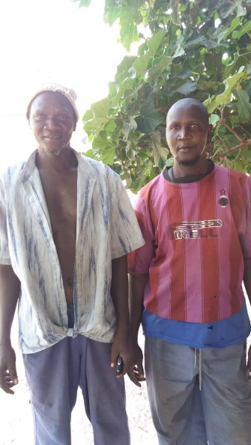
Medina Fonkoi women’s Fruit & Vegetable Gardens
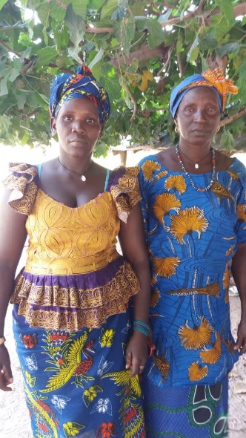
The village of Medina Fonkoi is far from the road running East to West on the south bank of the River Gambia, and over 200km from the coast.
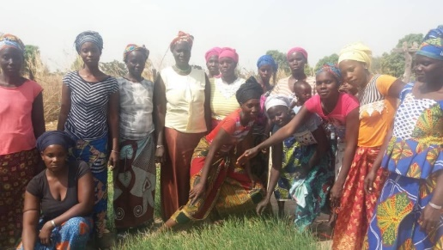
The people had appealed to us to help in creating a fruit and vegetable garden for the village, the same as we had done in Si-Kunda a few years ago.
These are the four committee members who are now managing the enterprise, as we were able to raise enough funds to complete the project much sooner than anticipated! A lot of hard work has been done over the last six months, Sankung managed the project, The villagers themselves provided labour, along with some employment for local expertise for fencing, dig the wells, etc., the gardens are now producing a large tomato crop, and lots of seedlings of different vegetables are being sown. This will help the community enormously, and we expect it to be as successful as the gardens created in Si-Kunda. Here are a few photographs of the starting of the process and where it is at now…..
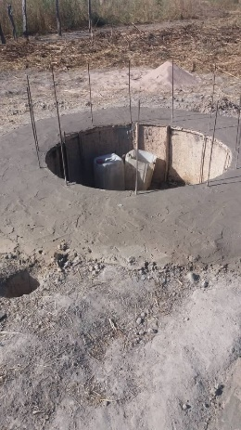
Initially clearing the grounds, start of the fencing and digging the wells.
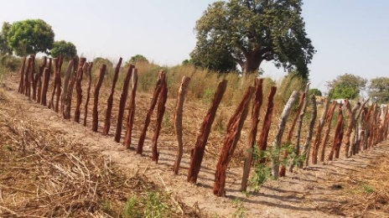
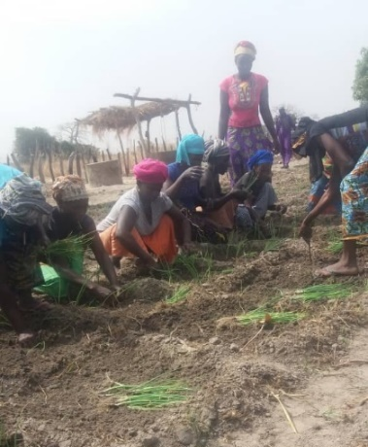
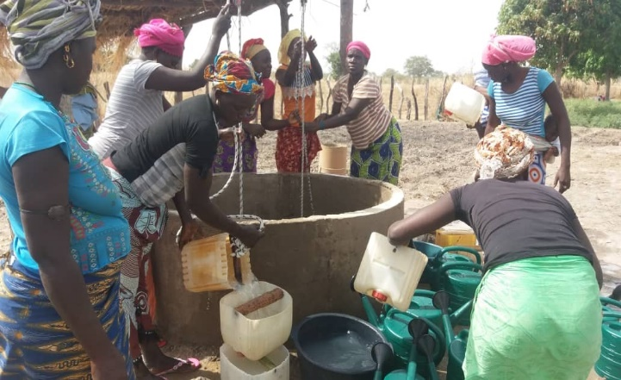
The first seedlings being transplanted
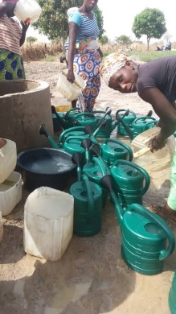
Seedlings, Tools, and watering cans

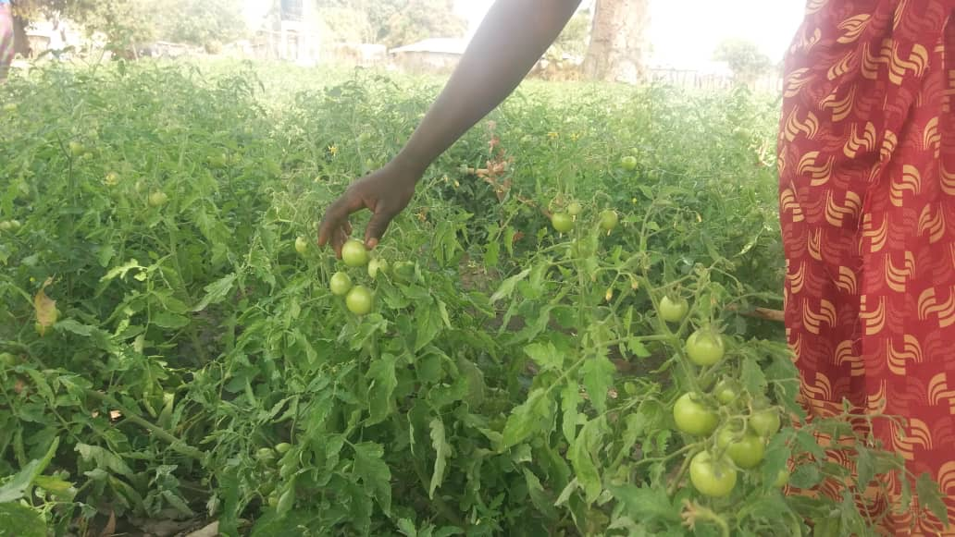
The women are working extremely hard now to make sure their first season is successful

