Newsletter no.35 - January 2021
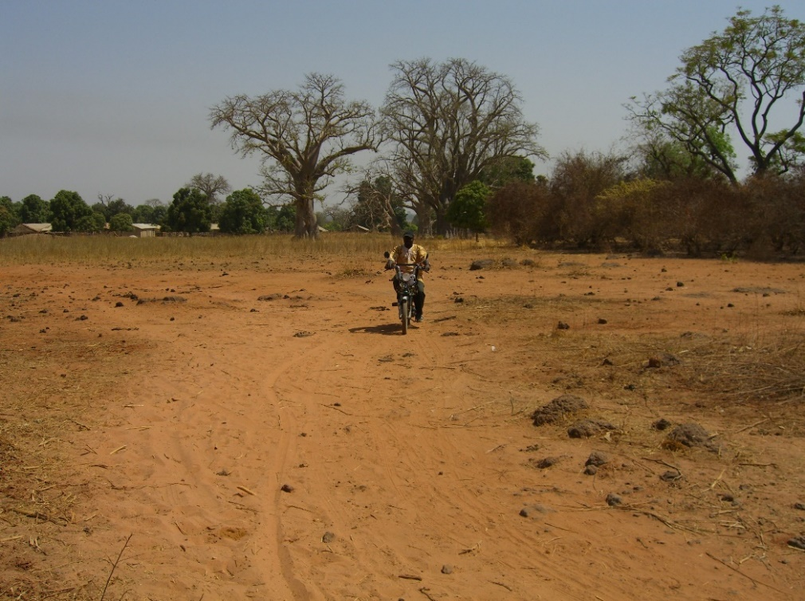
Sankung travelling between villages

For more Information about our charity, please contact anyone listed here:

Chairperson - Sue: 07717 821604 sjones@friendsofsikunda.org
Treasurer - Marje: 01933 387323 Marje.jones25@gmail.com
Sponsor Secretary - Gloz: 07748 774431 gkeen@btconnect.com
Secretary - Anne Seckington: anneseckington@btinternet.com
Fundraising – Kate Jones 07921 151711 & Danny Jones 07737 457431

Our Data Protection and Privacy Policies can be found on our website
www.friendsofsikunda.org Copyright: Friends of Si-Kunda January 2021
A link to this newsletter, and a few from the past can be downloaded from our website
Newsletter no.35 - January 2021

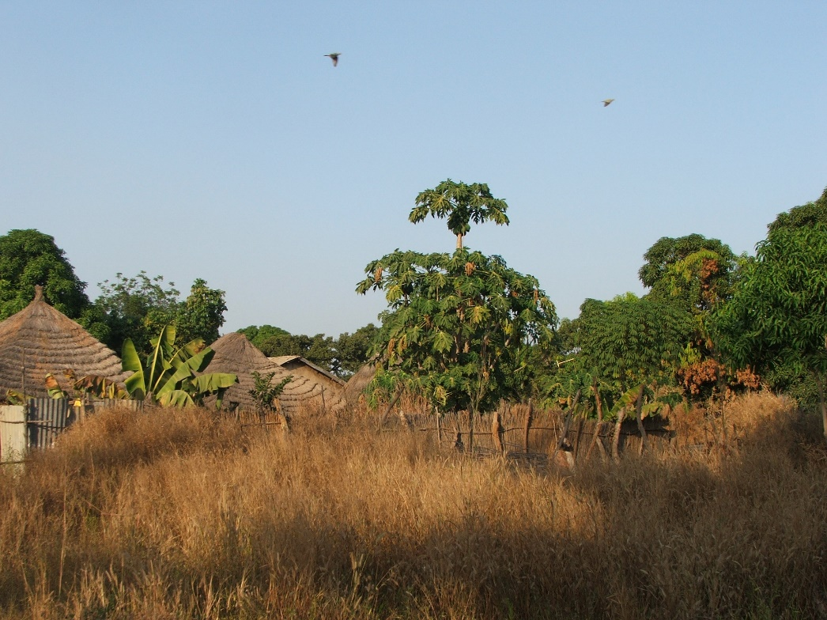
Medina Fonkoi
Charity UK Reg No.1097750 - Gambia Registration No. 581/2005
Please remember to use #easyfundraising when you do your shopping. www.easyfundraising.org – sign up and over 4,300 shops and sites will donate to Friends of Si Kunda for FREE. This means you can raise donations when you buy gifts, toys, jewellery, tech, experiences or anything else! Please support us!
You shop, Friends of Si-Kunda gets a donation… for free!
Paseedy – one of our students currently at university, has written this report for us
28th January, 2021 - The Gambia had recorded almost 4015 cases, with 3722 recoveries and 128 deaths of COVID-19 the cases recorded in the Gambia; this may seem a bit less dangerous when compared to other countries, e.g., Senegal and other countries around the world.
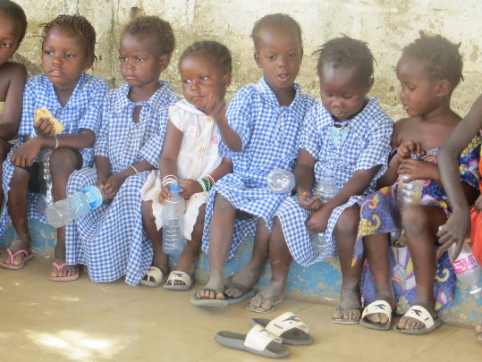
In this pandemic anyone who has contributed to help and prevent its deadliness and spread, has really played a huge role in preventing it in one's country and also preventing it from spreading to other countries. I am Paseedy Jammeh a public and environmental health student at the university of Gambia in my second year, second semester, and also a social worker. I have been sponsored by the Friends of Si-kunda since my nursery school. I have spent nothing less than 3 years in serving my community and nation even before the start of the virus, the major role I play in preventing the spread of diseases such as Coronavirus are: community sensitisation; community training (on personal health issues and hygiene); participating in social events cleaning exercises; organising events to talk about things affecting our community.
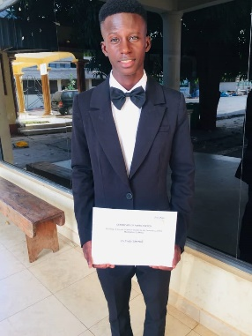
I have gone through the training and attended lectures on how covid-19 vaccination can be administered, organised by WHO (World Health Organisation), and I have completed exams after the lectures with a score of 91.2% and awarded with a certificate of achievement. I have also obtained certificates for participating in other activities from established organisations in the country with regard to health issues. – Paseedy Jammeh.
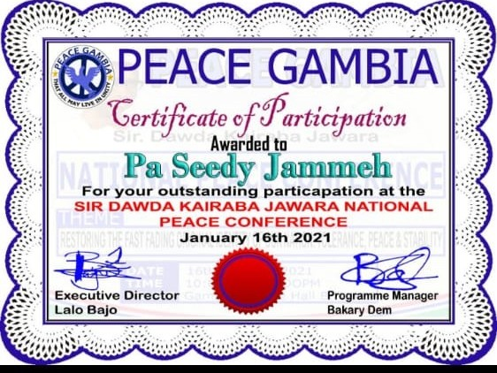
One of Paseedy’s recent awards
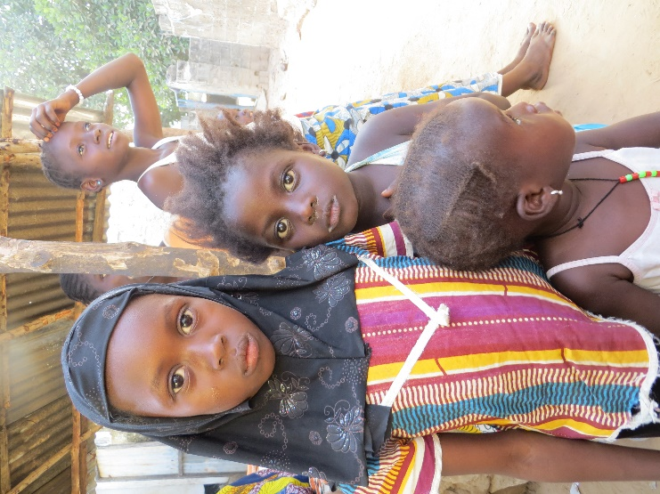
Jabisa, Fonkoi Kunda & Badumeh Lower Basic Schools
All these schools are receiving exercise books for this school term. Sankung purchases the books and then delivers them on our behalf. It is always a struggle for the parents to provide the exercise books themselves so without help, the children would have none. Text books are usually provided by the education dept.
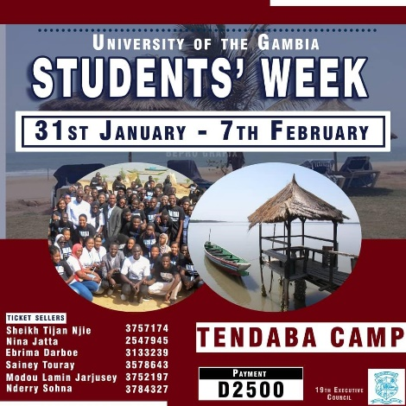
The school gardens have continued to produce fruit and vegetables to supplement the lunches.

This is an opportunity for the University Students to go on a week’s camp together where they have lectures, have fun, and get involved in many different activities.
Tendaba is by the River Gambia, about 120km from the coastal area.

Lamin Njie
Lamin was sponsored through FoS from 10yrs old, until he completed university in The Gambia. Lamin has achieved everything since by working and funding himself to continue “his journey”, here is the next chapter to his story…..
Lamin is pursuing his masters in accountancy at university of Illinois Springfield (UIS), currently in his third semester with a GPA 3.62 and he is hoping to graduate with honours with only one semester to complete his master’s program. Lamin is also a member GPSI (Graduate Public Service Internship), this is a very competitive program at UIS and thousands of graduate students apply for this program but only few outstanding ones are lucky to get this placement after numerous interviews. Graduate Intern Programs seek experiential learning opportunities at state and local government agencies of Illinois, that enhance the development of ethical, competent, and engaged graduate students. The program fosters the University’s commitment for academic excellence, enriching individual lives, making a difference in the world and lifelong learning.
Lamin has been working in this graduate program internship from August 16th 2020 to date, with Department of Commerce & Economic Opportunity (DCEO) at the department of accountability and compliance. According to him, the goals of his internship role is to protect the resources entrusted to DCEO by Federal and state citizens and protect the agency from risk by ensuring DCEO grant programs and grantees comply with requirements, identifying and mitigating risks.
He is so excited with these opportunities; his ambition is to gather quality experience from the United States of America and go back home to contribute to the development of his native county The Gambia.
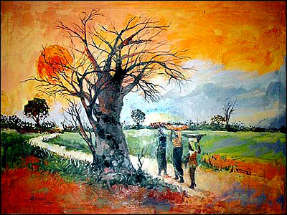
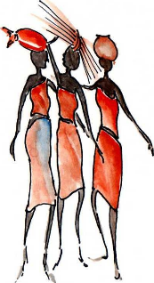
In Lamin’s own words. “Travelling to a developed country for the first time, has allowed me to see how far we are compared to developed countries and this broke my heart. On the other hand, it increases my desire to get in to politics one day in my home country and that will help me to be in a position to make that change I desire. Now I am in a journey of investing in myself to be ready for a greater future responsibility. ’’

Chair’s Report
We hope that you are all keeping well and managing as lockdown and Covid continue. A hard time for everyone, worldwide.
There may be Covid, but the charity is still managing to continue the work of sponsoring students, helping schools and projects in The Gambia. Sankung has been working hard to keep everything on course, along with the help of our teachers and the women in Si-Kunda and Medina Fonkoi are working very hard in the allotment gardens, as it is the time for planting.
Pupils have been back at school since September, but many are working on a rota basis and are incorporating the weekends into the school timetables. We keep in regular contact with Sankung and many of our past and present students… the benefits of Facebook messenger, Facetime and WhatsApp!
We were told that during lockdown, the government gave those living in the rural areas bags of rice and a small sum of money to each family; whilst those in the coastal area did not. The lack of tourists has obviously hit the country hard, and like everywhere else it is a problem for those who had work in the tourist industry, the craft markets, tourist taxis, etc.
We are hoping to bring back the Bonus Ball competition, so we will be contacting those of you who have participated in the past to see if it will be worth doing – just £1 a week. It has brought in a lot of funds for us over the years, and although we thought last year it would be a time for a break, due to the uncertainty of Covid, work, etc, we now think that perhaps we will give it another go! Of course, there is always the chance of winning £25 every week! If anyone else is interested, please email me or give me a call, contact details in this newsletter.
The Skills & Community Centre has been able to resume evening classes, and the veranda is used for selling wares. There was some storm damage to the roof recently which has had to be repaired. Soap making is going to resume soon. Juice making had started just before their lockdown, with Ansu doing the training, this should soon start again too.
Fonkoi Kunda School are using the staff homes we built to full capacity, married couples and singles are using them and the solar panels are providing light for them.
Keep safe everyone! Kind Regards, Sue
Si-Kunda and Medina Fonkoi
Women’s Fruit & Vegetable Gardens
The ladies in the village gardens of Si-Kunda asked the charity to help create a market area to sell their surplus produce from the gardens. At the moment, they carry their vegetables and fruit that they have for sale to Soma Town, a few miles away from Si-Kunda, and even further from Medina Fonkoi to Soma. The problem is not so much the journey, but that they have to compete with everyone else for sales. The reason is that if they had their own market places in their own villages, then they could sell from there and get better prices. Both villages would get ‘passing trade’, as they are routes that people from other villages use to go to Soma town. It makes sense and would be a good asset to increasing the use and value of the gardens. We established Si-Kunda gardens in 2006 and they continue to be very successful. So far, Medina Fonkoi seems to be emulating that.
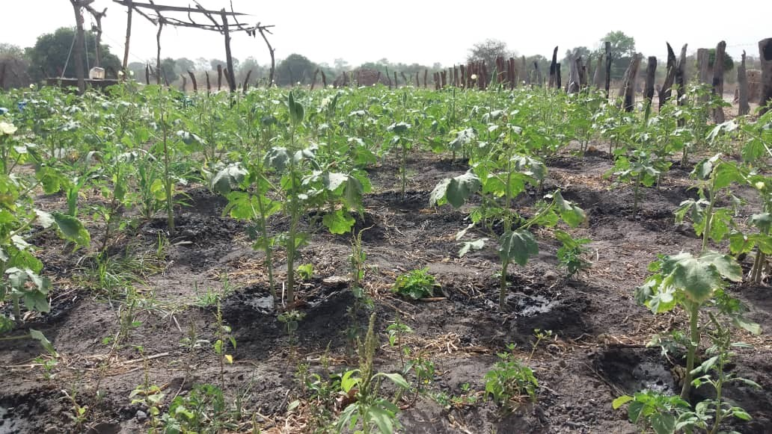
The estimates show that it would cost approx. £750 - £800 for each of the two villages, and labour from the villages would be used, so this is something we are aiming for in the near future, as we can really see the benefits this project would bring. Once built, the ladies will manage it themselves and ownership will be passed to them. They have a bank account for the gardens and manage that themselves very well, so we are confident that the organisation of the proposed market areas will be managed well too.
Friends of Si-Kunda try wherever possible to create projects that can be passed on to, and sustained by the community. We use local labour with all our projects
Updates of a few of our past students….
We like to keep up with as many of our past students as we can, to see how their lives have panned out: Sunkary is married with three children, she has been in the army for several years and has worked her way up to be a part of the National State Guard protecting the President when he is Banjul. Kaddy and her husband have a shop. Nyima works in a community garden in Soma. Bakary has been in the hotel sector for a few years now. Dembo qualified and worked as an electrician and is gaining working experience on a large farm enterprise and plans eventually to have his own business, which will help the village. Ousman J is an electrician. Seedy S is married with a baby and is doing well. Ismaila speaks fluent Italian and has worked as an interpreter. He has done very well, has brought a compound and helps his family. Fatou is married with a little boy and is working as a qualified teacher. Lamin B works in a builder’s merchants and advises customers. Baseiko is a plumber, he has bought a compound for his family. Abdoulie is also a plumber. Suwado is now a Business Women. Sanna is a plumber, his twin brother Sainey is an electrician. Palanding & Lamin M trained as tailors. Lamin J is an electrician. Duwada has work with a builder. Abdoulie J is another plumber. Lamarama helps out in the Lab at Soma hospital.
A few updates of some current students - We also have another up-and-coming young lady Isatou, who is on a teacher training course and has just begun her practical she has a placement at Yundum Lower Basic School, for two years. Opi is hoping to get into Agriculture and has applied for a course at agricultural school. Sulayman, who is still a student, has always loved football with a passion. In November, he was called up for the Gambia Youth U17’s for training and just last week (Jan 27th) been signed up by a 3rd division club. He is pleased as the opportunity is there for him if he does well. Fanseedy is in Grade 11 and does very well in his school exams and loves football. We have lost touch with some of our students’ of course – inevitable as they move on. Many of the girls are married with children its always harder for them, though many of them have small business to help with their families, so an education is never wasted! It’s great that Lamin Njie and Paseedy have contributed to the News Letter. Lamin from his University in Illinois, USA and Paseedy from his Uni in The Gambia. Abdou is now in his final semester. He aims to achieve two degrees a Major in Political Science and a Minor in English Language. His ambition is to then go on to gain a Master’s in Public Administration, as that will give him a really wide scope of opportunity. Abdou will be at the Tendaba Camp for the first week in February.
As always, we wish them well in their chosen paths and it’s great that so many want to stay in touch with us and of course they are so grateful for the opportunity they have received, thanks to their generous sponsors. Gloz

