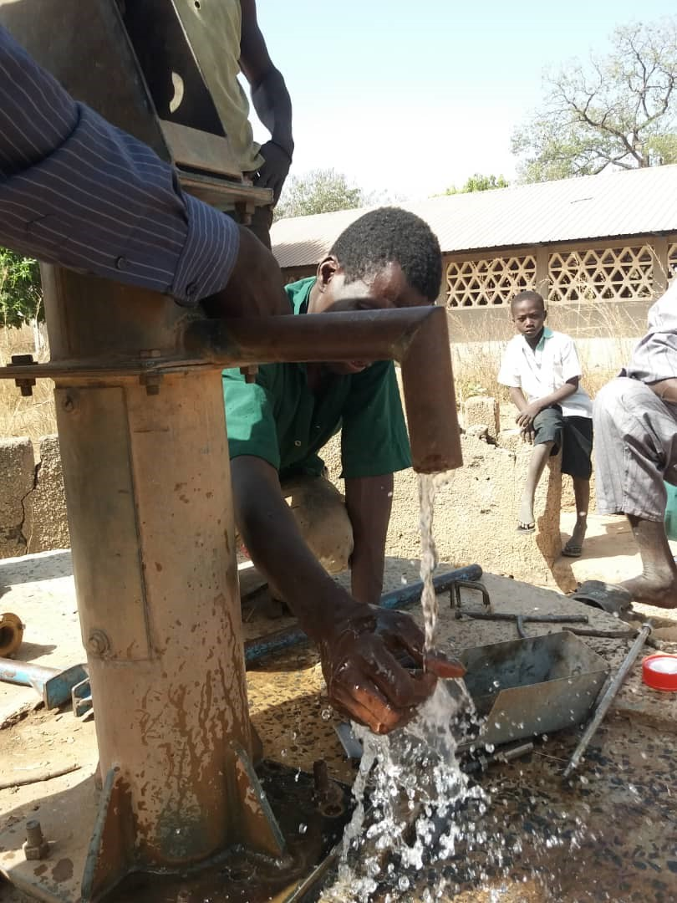

Fonkoi Kunda School
Water pump now working!

For more Information about our charity, please contact anyone listed here:
Chairperson - Sue: 07717 821604 sjones@friendsofsikunda.org
Treasurer - Marje: 01933 387323 Marje.jones25@gmail.com
Sponsor Secretary - Gloz: 07748 774431 gkeen@btconnect.com
Secretary - Anne Seckington: anneseckington@btinternet.com
Bonus Ball – Daisy: daisy@friendsofsikunda.org
Fundraising – Kate Jones 07921 151711 & Danny Jones 07737 457431

Our Data Protection and Privacy Policies can be found on our website
www.friendsofsikunda.org Copyright: Friends of Si-Kunda June 2021

Newsletter no.36 - June 2021

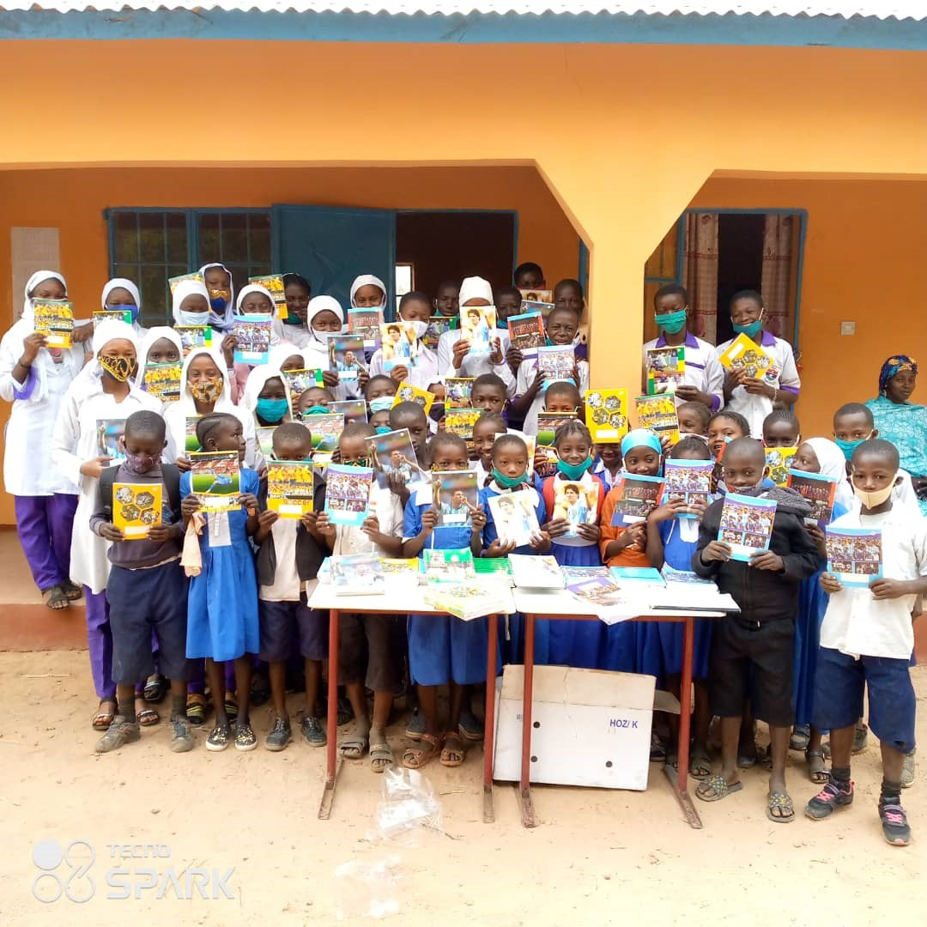
Toniataba School

Charity UK Reg No.1097750 - Gambia Registration No. 581/2005

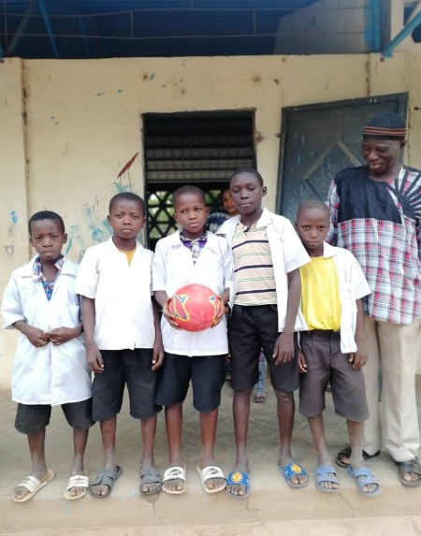
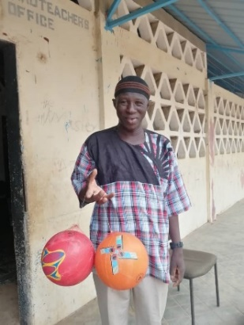
Fonkoi Kunda Village School
The young boy in the middle of this photo appealed to our Project Manager Sankung for a football for his school, as they had none. Consequently, we have purchased some for the school, as we have for others.
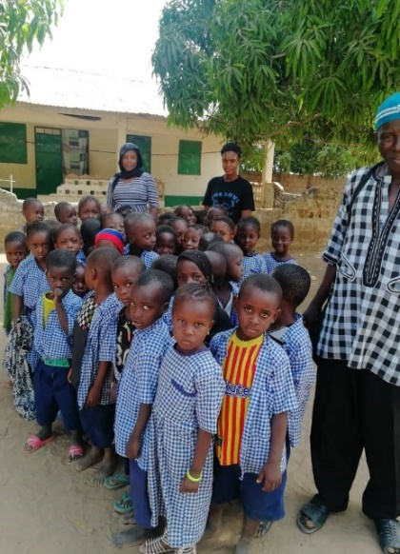
When we are able to visit, we will take as many footballs as we can from UK as always, meanwhile we have to get what we can in the local towns.
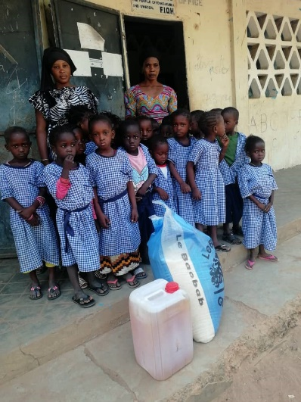
The school has been struggling to provide lunches for the children, their supplies are unreliable which means they are often hungry and ultimately fewer will attend, so we have purchased rice and oil to help for the moment and Sankung will keep a check to see what happens going forward. Also, quite a few of the children had nothing to wear on their feet, so flip flops/sandals have been purchased to make sure they all have footwear.
Some general maintenance is currently taking place at the Teaching Staff homes we built a few years ago in the school grounds, it will be completed this month.
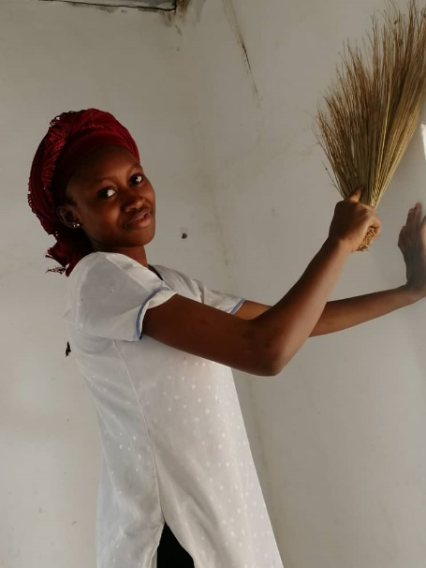
Hairdressing - These young ladies asked if they could setup their own hairdressing salon in the Skills and Community Centre, it has been agreed and they will be paying a small rent monthly to go towards the rice and oil used by Si-Kunda nursery school for student lunches.
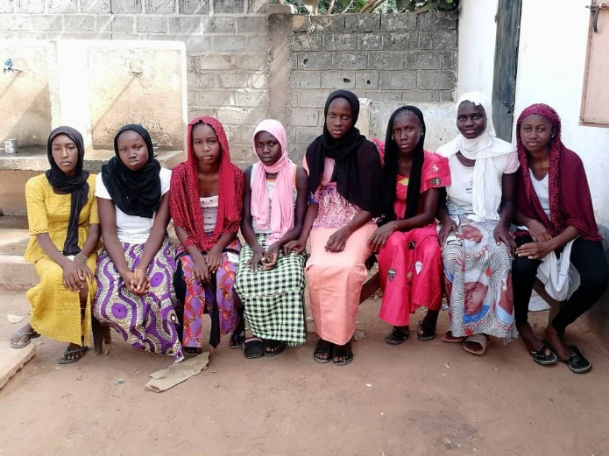
They have been busy cleaning and preparing one of the rooms in the Centre, and getting themselves organised. We wish them luck and will encourage them in making it a success!
A link to this newsletter, and some from the past can be downloaded from our website www.friendsofsikunda.org which also gives the history of our projects and more.
Please remember if you do any online shopping, please use Easy Fundraising! Enter www.easyfundraising.org to sign up and choose Friends of Si Kunda as your chosen charity, over 4,300 shops and sites will donate to Friends of Si Kunda for FREE. This means you can raise donations when you buy gifts, toys, jewellery, tech, furniture, experiences or anything else! Please support us!

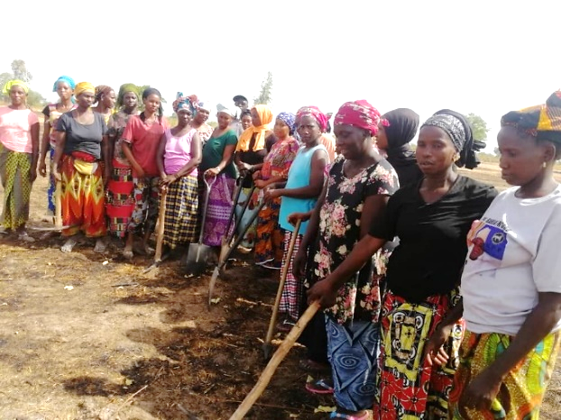
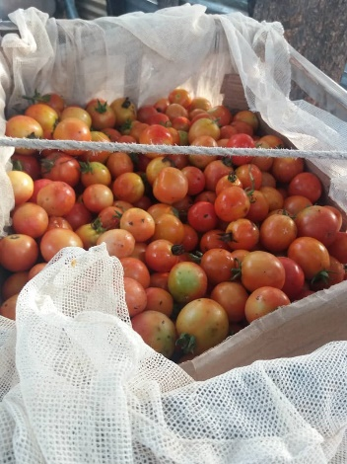
Medina Fonkoi Garden Project – Bumper crops, and going strong! Medina has become a centre for tomatoes in the area growing two crops of them a year, along with many other varieties of produce. We should be able to start their Market Place Project very soon.

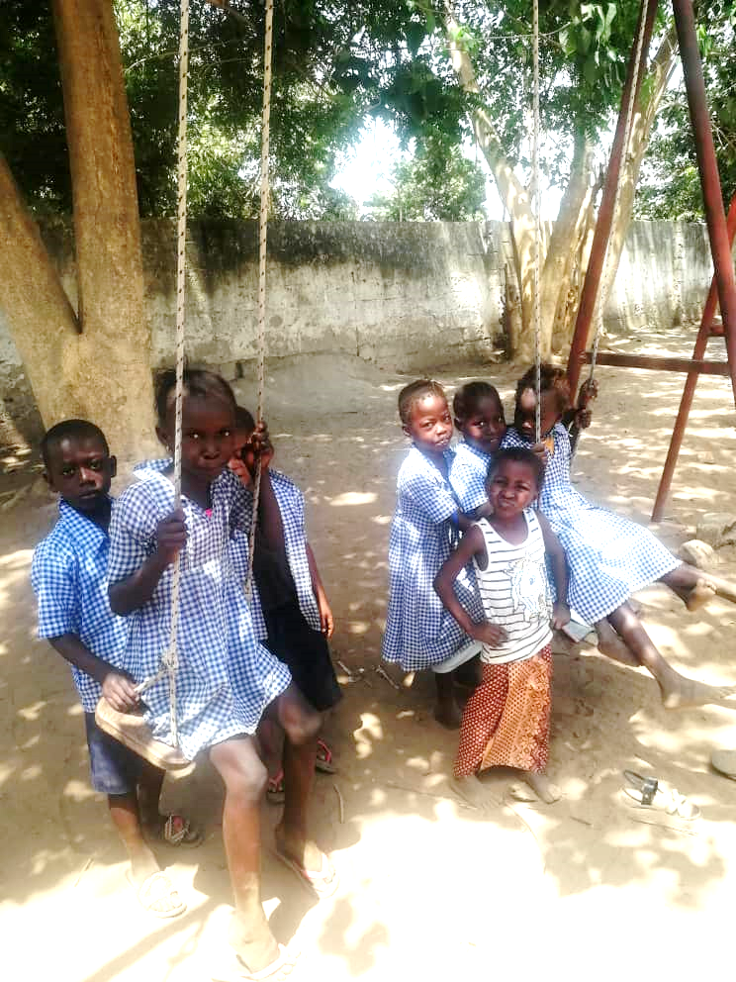
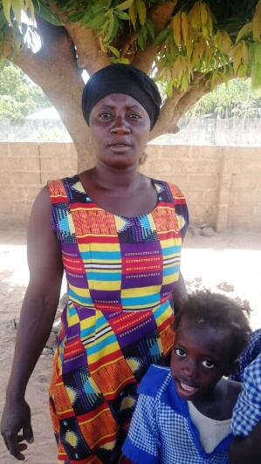
Si-Kunda Nursery School
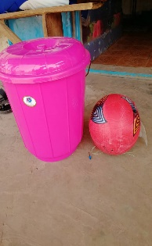
Here is Anna, one of our teachers at the Nursery School Some of the recent supplies, and a few of the children enjoying themselves in the playground!

Soma Medical Centre - We are helping the local hospital in Soma with some admin supplies, there is so much more they need so we will be considering this in the coming months.
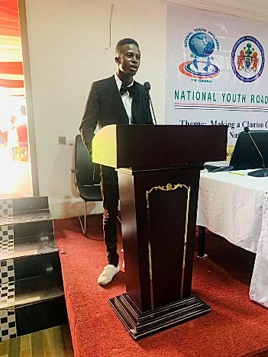
Chair’s Report - How time flies, another six months since our last newsletter and it’s the middle of the year already! A lot of progress has been made, and we have included as much as we can in this June version.
One of our students, Pa Seedy, is going from strength to strength at The Gambia University and has now just been appointed as Health Minister of the 9th Executive Council of UTG- SAPEH for the next 12 months (University of Gambia, Sapeh Students Association of Public and Environmental Health). He is getting well used to public speaking, and is representing his department in an upcoming National Debate and Public Speaking competition. As Lamin Njie has before him, Pa Seedy is a mentor to some of the younger students.
We have completed the first Bonus Ball 16-week series for 2021, This raised £444.00 including a few extra ££’s given to go with it, so a great result for us along with a lot of happy winners! This goes such a long way to help with the schools we support. We have now started the 2nd series, with a great response from so many of you. There are just a few numbers left available - For just £1 a week it gives you the opportunity to win £25 each week so if anyone who hasn’t taken part before and would like to, please send an email to Daisy@friendsofsikunda.org and Daisy will send on details of how to join in.
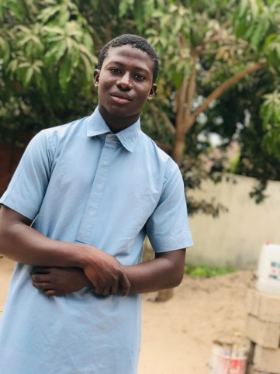
We have replaced the pumps and cylinders at two school wells, these are in constant use so it is vital to keep them in good working order to provide their water.
Omar one of our students, is in Grade 10 and has ambitions to do accounting and work in a bank. His last school report shows he is getting excellent results and well on track.
Many thanks to all our supporters as always. You enable us to continue creating projects, supporting schools and of course our students, all of which is so much appreciated! Kind Regards, Sue
Si-Kunda Market Project
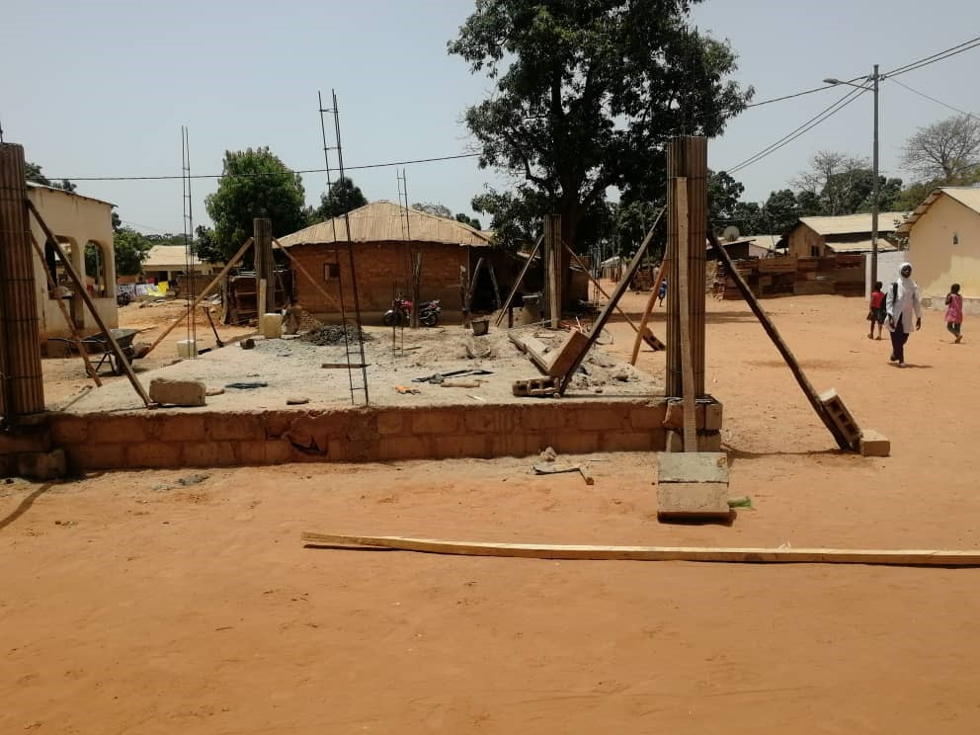
As proposed in the last newsletter, we are now well underway in building the first of two village market places. This one is in Si-Kunda, there was a short holdup trying to source cement, but it is now progressing well.
The foundations and raised floor are completed, the pillars have been erected and the low walls are currently being built. The roof will have to be done, and places for the selling to be constructed inside the building. This is being constructed in the centre of the village, with the thoroughfare right in front of it, so they will get a lot of footfall from other villages, so potentially lots of customers!
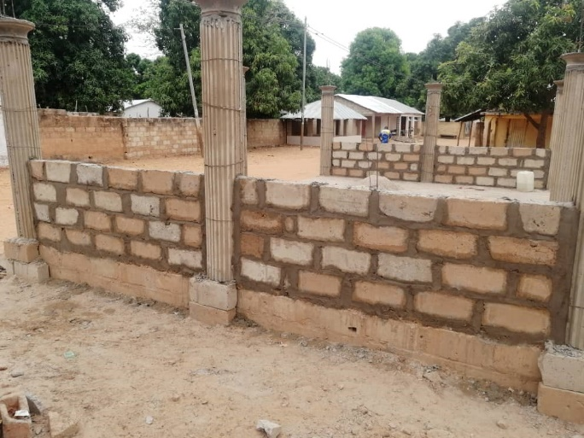
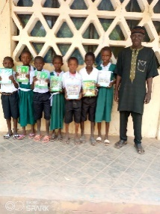
On the facing page are some of the ladies who have allotments in the Sikunda Gardens, they are looking forward to being able to sell produce from their allotments at the market once it has been completed. Of course, soap made in the Skills Centre and any other wares will be on sale there too.
The original estimated cost has gone up, as like everywhere else the cost of building materials has risen, but Sankung has done all he can to keep the costs down as much as possible at the same time making sure the construction will be fit for purpose!
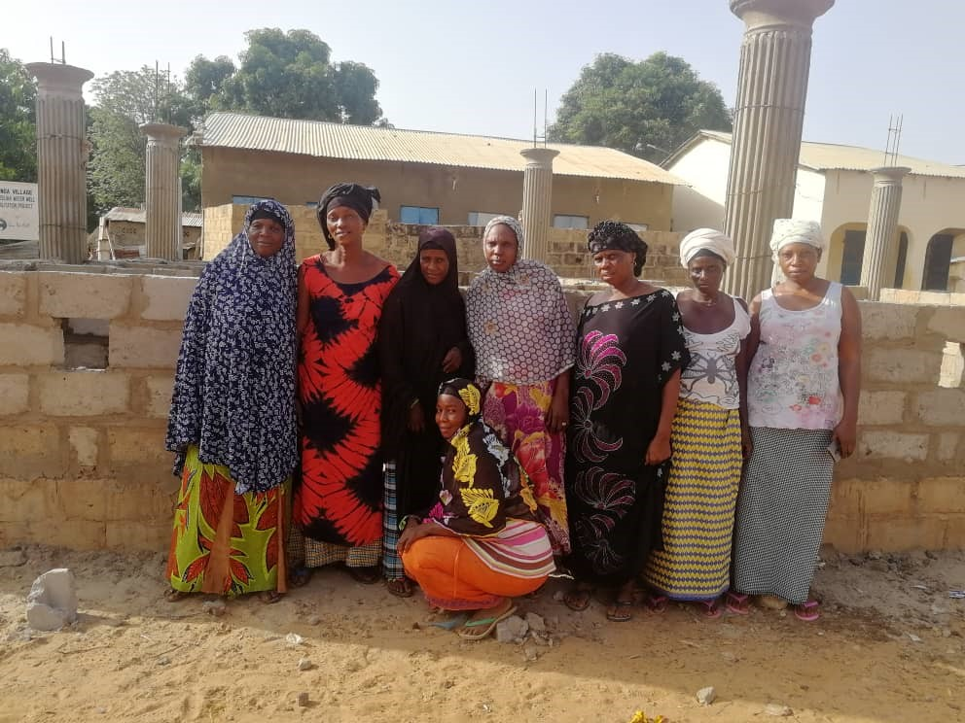

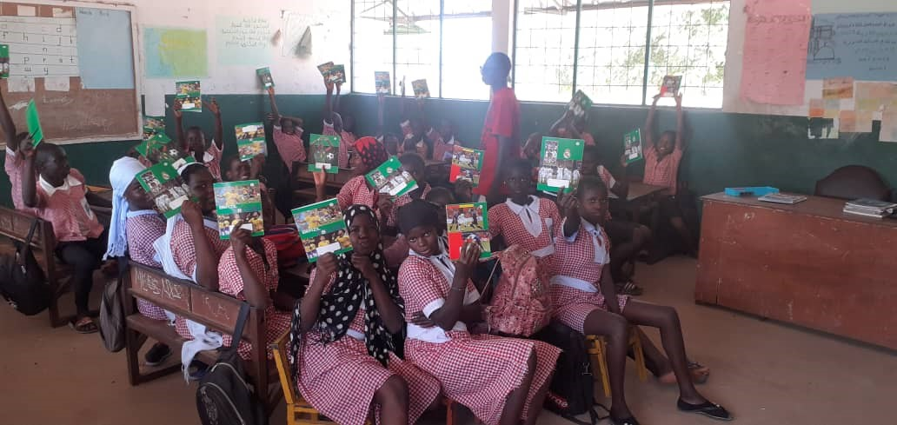
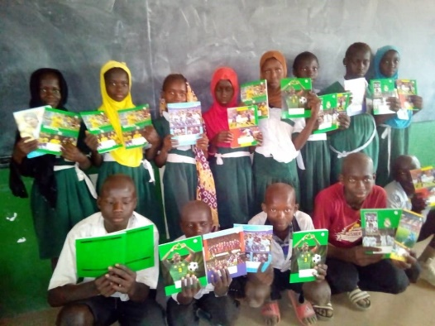
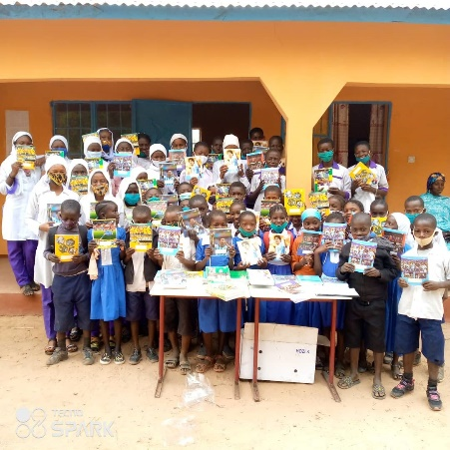
Schools - We have been helping the following village schools with exercise books Toniataba, Jabissa, Fonkoi Kunda and Badumeh

