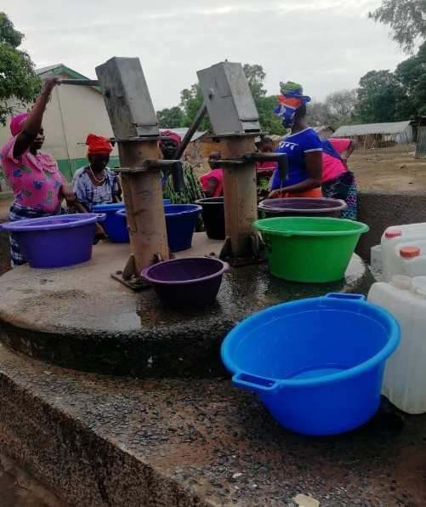

Fonkoi Kunda Village water pumps

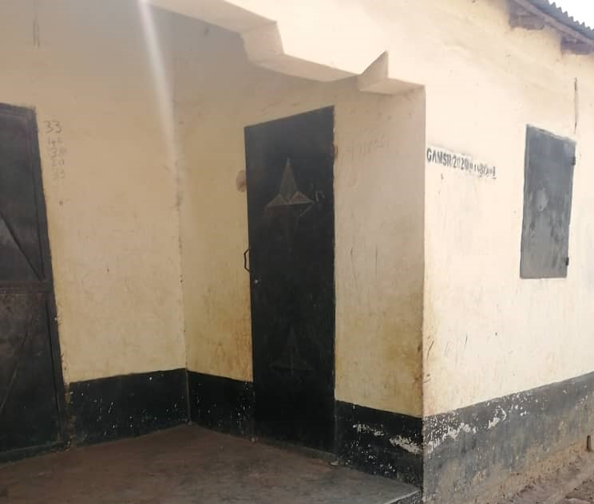

Community & Skills Centre

A shop is being created in this small room at the front of the Community and Skills centre, it will be to sell milk. It is quite close to the new market place, so another useful amenity for the villagers

For more Information about our charity, please contact anyone listed here:

Chairperson - Sue: 07717 821604 sjones@friendsofsikunda.org
Treasurer - Marje: 01933 387323 Marje.jones25@gmail.com
Sponsor Secretary - Gloz: 07748 774431 gkeen@btconnect.com
Secretary - Anne Seckington: anneseckington@btinternet.com
Bonus Ball – Daisy: daisy@friendsofsikunda.org
Fundraising – Kate Jones 07921 151711 & Danny Jones 07737 457431
Sankung Jammeh – Project Manager
Our Data Protection and Privacy Policies can be found on our website
www.friendsofsikunda.org Copyright: Friends of Si-Kunda January 2022

Newsletter no.37 – January 2022

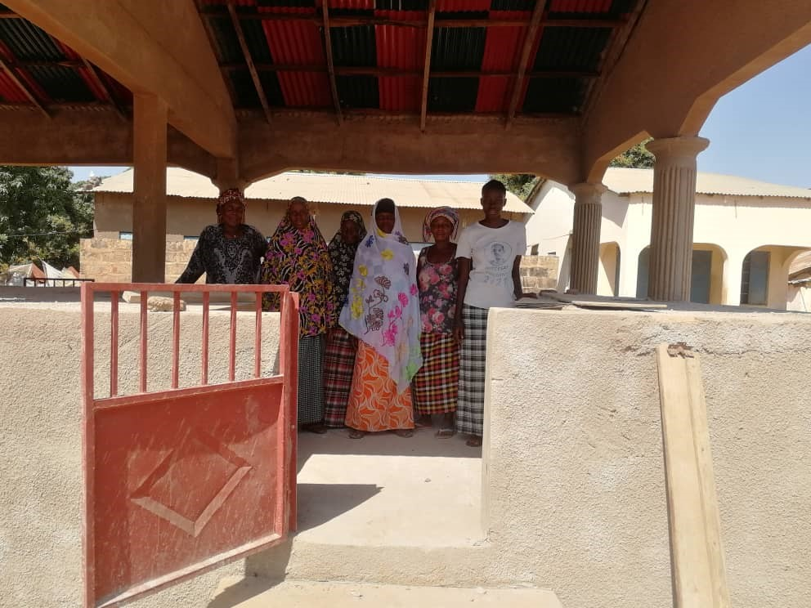
Si-Kunda Village Marketplace

Charity UK Reg No.1097750
Gambia Registration No. 581/2005

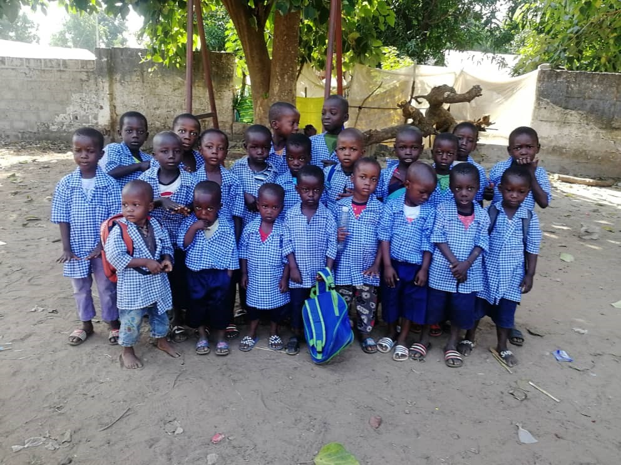
Si-Kunda Nursery School
Start of the Autumn Term !!2021!

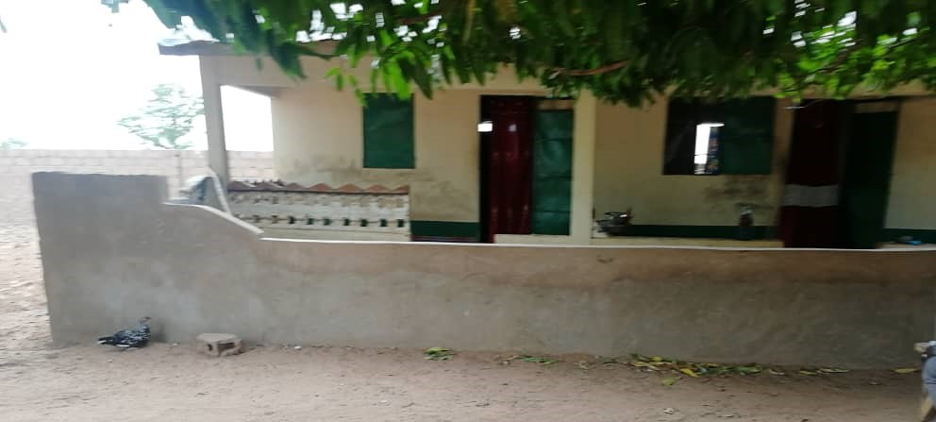
Fonkoi Kunda School - The maintenance has been completed for the staff homes. There are four and all needed a bit of work to bring them up to scratch. We originally built these within the school grounds in 2015.
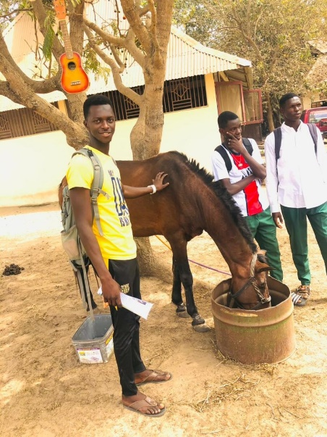
Student Ousman Ceesay - Or Opi as he is known, didn’t have the best start in life his father was an older man and struggled with poor eye sight, however this did not stop him from doing his best to educate his son which he felt was so important for him. But it became evident, despite his best efforts that he could not afford it and we were happy to sponsor him. Sadly, Opi’s father passed away in 2015. Opi tried so hard at school but did struggle a bit with results, he did year 12 again and did better this time before leaving education.
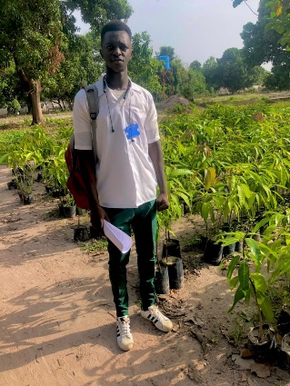
In January 2021, Opi on his own, applied to join an Agriculture School, his uncle paid a little of the fees but not easily; Sankung approached us to see if we could help. We have known Opi since he was seven years old and are fully aware that he would always try and better himself so felt this could be a real opportunity for him and found him a sponsor. It was agreed that we would see how he progressed after the first year. In July 2021 Opi was in Basse on an Agriculture Practical – he sent this message: “We started in Makasuto Horse and Donkey known as Animal Welfare Advocate and then moved to one of the big gardens in Basse for Crop Practical”, and he sent us several pictures. He is really enjoying this course and doing well. He is now at the beginning of his second year and Opi is continuing with Practical, Study Class and Field Work. It’s great to see that this lovely lad seems to have found his strengths and hopefully a better future. - Gloz
We complete the current Bonus Ball 16-week series at end of this month and start the new series in February. Thankyou!! to all of you who support this fundraiser, it is so worthwhile and helps so much in helping to support educational needs. There are just a few numbers left available - For just £1 a week it gives you the opportunity to win £25 each week so if anyone who hasn’t taken part before and would like to, please send an email to Daisy@friendsofsikunda.org and Daisy will send on details of how to join in.

Medina Fonkoi Village Garden Project
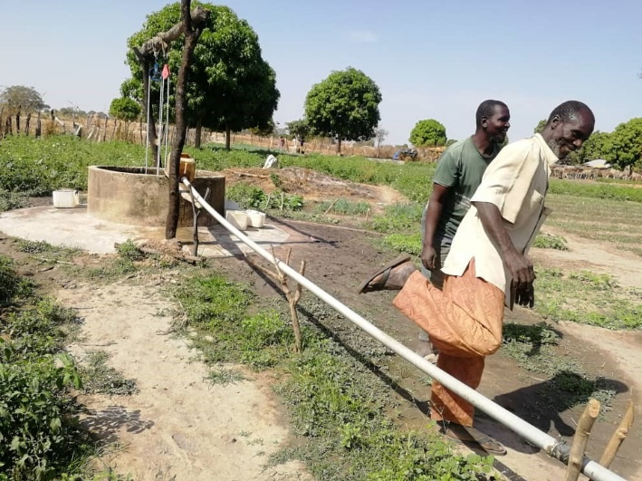
The allotments are flourishing and continue to improve all the time. The people in the village have constructed a way to make it a little easier to water their allotments, saving them time and to save carrying the plastic buckets so far. They have a bucket (made from a large canister) on the side of the well, a pipe is attached to that which then runs to a holding tank. So, they fill the canister from a bucket which runs on a pulley in the well, the water then runs through the pipe to the holding tank - it works really well. It also helps the older ladies that may otherwise struggle to draw the water from the well.
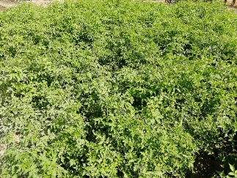
Tomatoes....

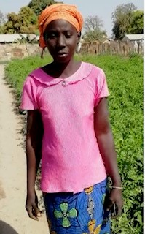
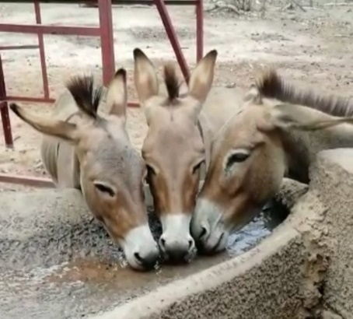
A site has been agreed to build a market place in the village

Chair’s Report – The start of another year! We continue to support our projects with the help of all our supporters, which is wonderful considering how difficult these past couple of years have been for so many. Many thanks to you all!
We have had some great results from our students over the past year, Gloz is giving you an update on two of them in this edition; we will give more in the next.
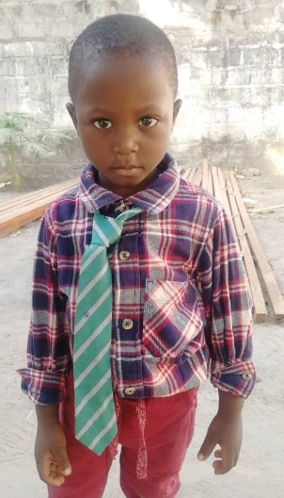
This little boy is Sankung’s first grandchild, who is named after him. Then just four months ago Sankung’s daughter Fatou (a schoolteacher) had her second child, a daughter called Nyara.
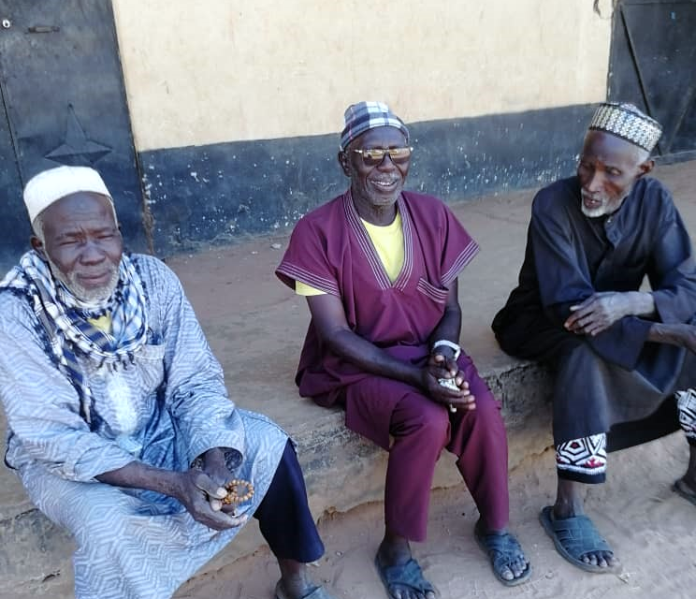
We have had 50 more uniforms made for Si-Kunda Nursery School. This school has no other funding and is totally dependent on our charity. Our teachers and caretaker have been with us for many years now and continue to do a great job ensuring the children are ready to move on to Toniataba Lower Basic school when they are old enough. Exercise books are being delivered to four schools in the area that desperately need them.
The taxi business being managed by Sankung is making good profit. The purpose for this is to eventually help support the charity, at the moment the funds from it are being kept safe in a bank account.
We have known these three gentlemen since the late 1990’s! All play an important part in their village and surrounding area. They make us so welcome every time we visit, we have had many discussions over the years!
Si--Kunda village elders, sitting outside the Community Centre discussing village matters
We hope you enjoy the updates and photographs in this newsletter, we wish you a Happy and Healthy New Year! Kind Regards, Sue

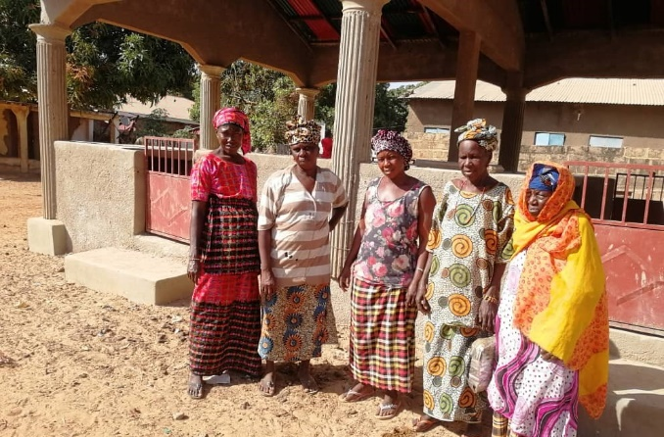
Si-Kunda Market Project - Now completed!!!
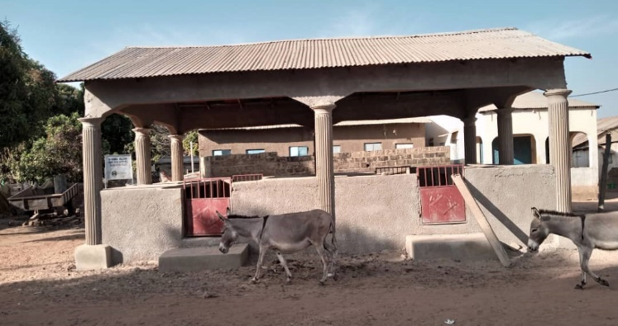
In addition to the front cover here are more pictures of the new covered market, completed this month and now ready to use. It will be used to sell produce grown in the Women’s Gardens and fish caught from the river. Gates have been put on the entrances to stop the donkeys and goats from intruding and causing havoc! This will be a huge benefit to the village, so now we plan to create another in Medina Fonkoi village – we hope to start building it this year.
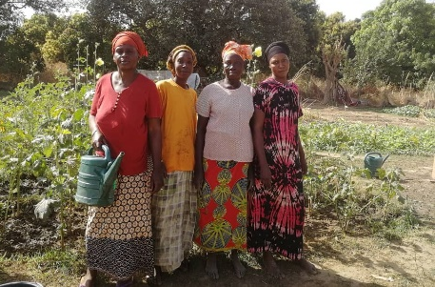
Si-Kunda Gardens – Some essential fencing repairs have been done. Lots of produce is being grown – as always
Student Abdou Jammeh graduates from University in February, more about him in the next newsletter!
Student Paseedy Jammeh - Paseedy did very well at school and is a very good athlete. In 2018 he attended a four-day sports camp, having come first in all of his races at his school. He then went on to represent his school Mingdaw Senior High in Brikama and won all of those races too which led him to compete at National Level at the Independence Stadium. He took part in two relay races and thoroughly enjoyed it all, it was televised on Gambia TV. 2019 saw him still competing in athletics and doing well, he just missed out on going to Nigeria to compete, he was told the wrong time for his final heat and missed out – he said he would have definitely won it if he had raced! He attended Mingdaw Senior High and was a lively enthusiastic student. After graduating in 2019 Paseedy was accepted by The University of the Gambia, to study Public & Environmental Health. During the coronavirus pandemic, he did on-line classes for study. April 2020 found him back at university, his second year and he achieved very good results. During this time, he also did his bit for Covid by going out with a loud speaker advising and encouraging people to get vaccinated wherever possible and has been/is actively involved in vaccination programmes - he received a certificate for his efforts and managed to get onto radio FMB to centralize on Covid 19.
In June 2021 Paseedy was elected as Health Minister of the 9th Executive Council of The University Student Association of Public Environmental Health.
September 2021, he entered an international literary competition addressing his project about the pollution of plastics and the effect on health. We were very proud to learn that Paseedy won this competition – hearing the results live ourselves via the InfoNile Facebook page! This is what he sent to Sue – “I have seen love, inspiration and motivation, it’s a profound pleasure for me to thank you all, my heart got melting to receive such splendid support. I don’t have much words to express my delight and gladness but still I believe thanks to you all, I will do better - we are victorious, Friends of Si-Kunda worth to be awarded with great praise and congratulation for me the means and support to take part in this competition.” - Gloz

