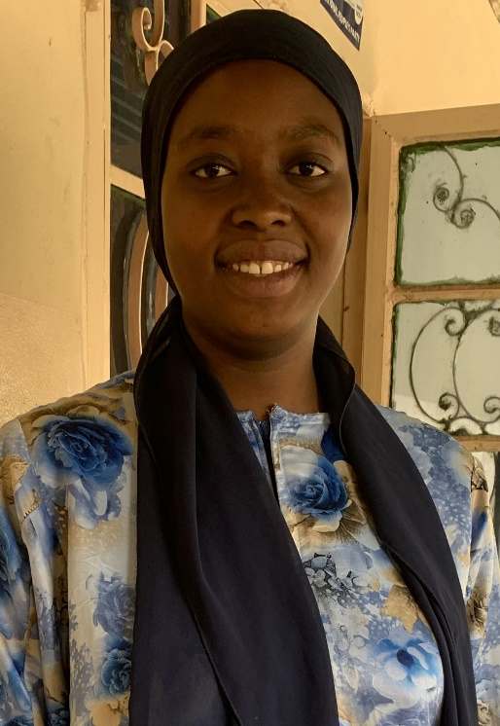
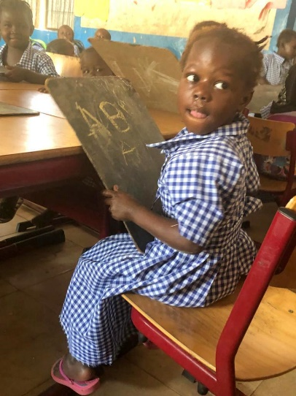
Isatou, having completed her teacher training is currently on her first practical teacher placement, which is at Soma Lower Basic School
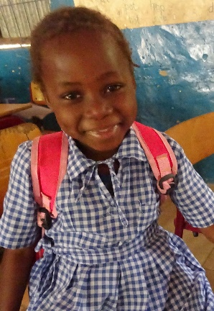

Two pupils from Si-Kunda Nursery School

For more Information about our charity, please contact anyone listed here:
Chairperson - Sue: 07717 821604 sjones@friendsofsikunda.org
Treasurer - Marje: 01933 387323 Marje.jones25@gmail.com
Sponsor Secretary - Gloz: 07748 774431 gkeen@btconnect.com
Secretary - Anne Seckington: anneseckington@btinternet.com
Fundraising – Kate Jones 07921 151711 & Danny Jones 07737 457431
Bonus Ball Admin – Daisy: daisy@friendsofsikunda.org
Sankung Jammeh – Project Manager
Our Data Protection and Privacy Policies can be found on our website www.friendsofsikunda.org
Copyright: Friends of Si-Kunda July 2022

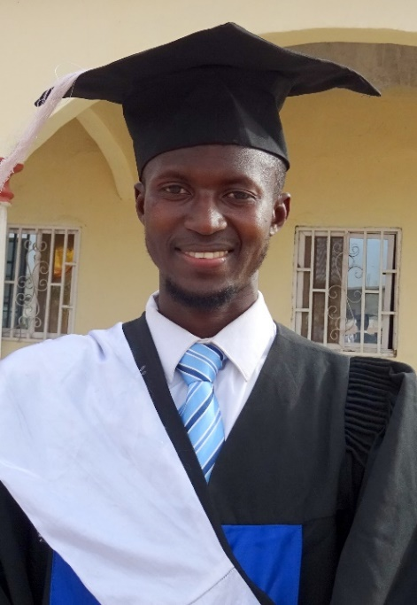
Many Congratulations to
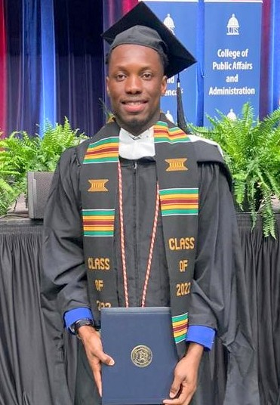
Lamin Njie and Abdou Jammeh!!
Two remarkable young men who have taken an opportunity, then through sheer hard work and determination have turned that into achieving so much

Charity UK Reg No.1097750
Gambia Registration No. 581/2005
Newsletter no.38 - July 2022

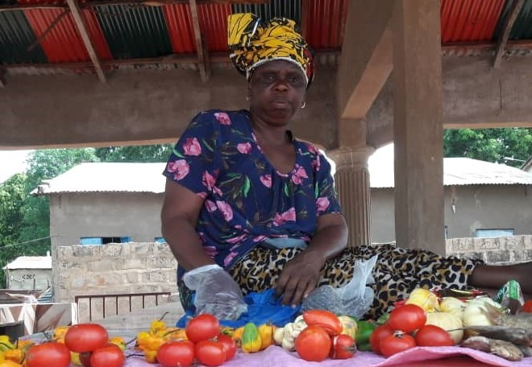
Si-Kunda Market Project – The market is open!!!!
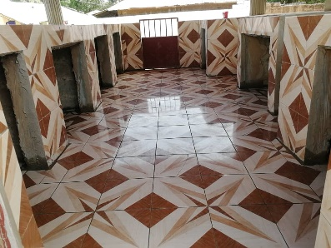
The market place is well used and very popular in the village, it is great to see the enthusiasm of the ladies who are using it! Above is Pawpaw getting in early to set up her stall. Since we visited in February it has all been tiled to make it easy to keep tidy and clean.

For Sale! We do have quite a selection of African crafts; wooden hand carvings, cloth bags of various types and sizes, some jewellery, and various other items. If anyone is interested in purchasing any for gifts (or something for yourself!) then please contact me and I will send photos, details etc., All proceeds will go towards our support for the schools we continue to help. sjones@friendsofsikunda.org or 07717 821604
And of course, there is our Bonus Ball fundraiser that continues to do very well for us, there are a few spare numbers of you would like to take part for £1 a week, giving the chance of winning £25! Contact Daisy daisy@friendsofsikunda.org
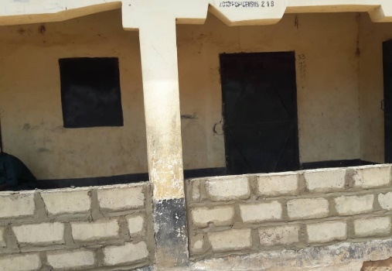
Si-Kunda Community & Skills Centre - The veranda has had some minor repairs, and a wall is currently being constructed along the front of the veranda. The centre is getting a lot of use for various programmes, including the recent elections

Fonkoi Kunda Lower Basic School
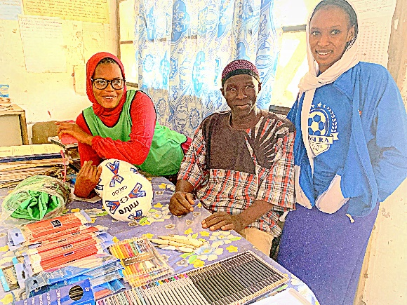
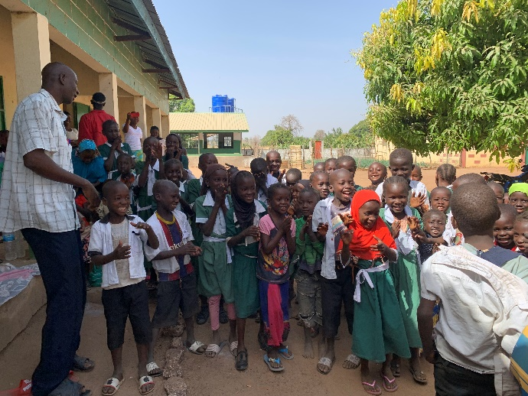
Mr Sanneh the headmaster, his five teachers and lady caretaker made us most welcome. The staff all seem so energetic, fun and friendly, just the sort of teachers you would like yourself! They really do struggle, as other than the exercise books we provide, they get none and always need more pencils and biros. This time we also provided some tools for the garden and a wheelbarrow. The school needed a new 12v battery for the solar power so this has now been purchased and installed.
Jabisa Lower Basic School – This small village school so far from any road or town, manages to create a very happy environment for the children. As with the other schools we help, they receive exercise books from us, pencils, etc., and recently a garden hose and garden tools. The garden fence posts gradually being eaten by termites so they will need some help with creating a new fence and extending the school garden. They have created a small chicken farm, providing eggs and meat to supplement the school lunch.
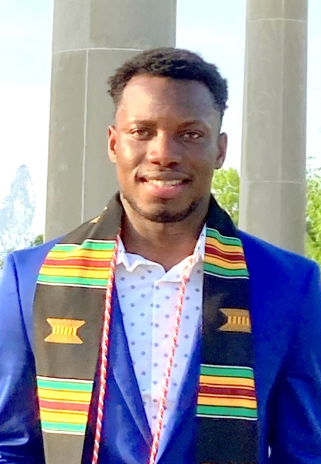
Lamin Njie
Lamin was sponsored through FoS from 10yrs old, until he completed his degree in Accountancy at The University of Gambia. Lamin has achieved everything since then by working and funding himself to continue “his journey”. After giving an update on his progress in the January 2021 newsletter, here is the next chapter to his story…..
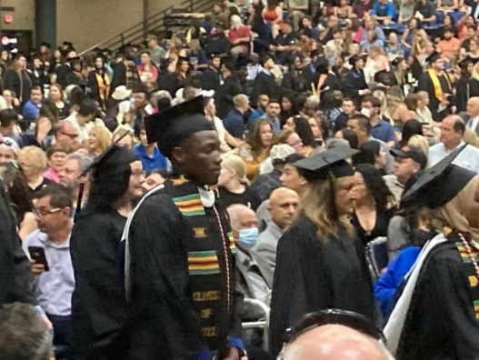
Lamin has achieved what he set out to do, and that is to gain his Masters in Accountancy, graduating from the Springfield University, Illinois, USA on May 14th this year. It was an emotional day, for him in particular, and for us, it has been his dream for so long, and now at last he has achieved it. Lamin has had to work extremely hard in having to support himself (so determined to do this without help) and study in a foreign country overcoming many difficulties, while adapting to a totally different culture and lifestyle to his own. His employer and the University directors all spoke so highly of him to us, and recognise just how far he has come as did the many friends he has made. Lamin has been offered (and accepted) a contract with the state department with whom he had his internship, the Illinois Department of Commerce & Economic Opportunity (DCEO) in the Office of Accountability and Compliance. We are assured that he has a very bright future in front of him and will go far. In time, it is Lamin’s firm intention once he has gained a lot more experience to return to The Gambia to “make a difference”. We are confident that is exactly what he will do. He still manages his charity that he set up in The Gambia sponsoring children’s education, which is continuing to do really well.
Lamin has made his family, and us, very proud.
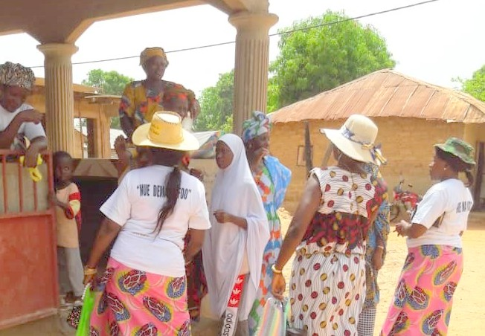
Chair’s Report - Well it has been a busy and exciting few months since our last newsletter! In March Gloz, Gwyn and I had our first visit to The Gambia since before the Covid pandemic, so we were very excited to see all the progress of the projects for ourselves, and also of course to catch up with past and present sponsored students, we keep constant contact by mobiles and social media as much as possible but it was so good to actually meet and spend time with them all again. It was great to see the completed Market place in Si-Kunda, and the Garden project in Medina Fonkoi. It was wonderful to see the pleasure and opportunities these projects have given to the women in these two villages. This photograph shows women arriving to buy from the market in Si-Kunda.
The highlight of our Gambian trip this time had to be attending the graduation ceremony of Abdou Jammeh in Banjul, we are so proud of him, it was a wonderful day and you can read more on the next page. As indeed you can of Lamin Njie; we were aware of his upcoming Masters graduation in America in May. So as this was an event we could not pass up on, Gloz and I took this opportunity to plan a holiday to coincide with it, ensuring that we would be there to support him, such an amazing experience for all of us. While in Gambia we visited Badumeh and Toniataba schools in addition to the schools mentioned in this newsletter, also we had a meeting with the Regional Education Director to discuss amongst other things the future of Sikunda Nursery School, and our concern about the lack of any rice and cooking oil supplies to Fonkoi Kunda School (this has been rectified, for the moment anyway). The cost of living, as everywhere it seems, has risen dramatically in the country, which for these people is incredibly hard and a real problem, this makes a school lunch even more important and parents rely on it for their children. Some also have to walk far, and if they are not given food, they just fall asleep at their desks, most schools have vegetable gardens to help supplement, but need to have rice as that is their staple diet and their main meal, and sometimes only meal of the day. We are pleased that the Peace Corp have Sikunda School on their radar now, and have helped in recent months with washing materials, footballs, and at times have their new volunteers visiting the school providing help and demonstrating extra teaching skills for the staff. We hope you enjoy reading our latest news, and many thanks for your support! Sue
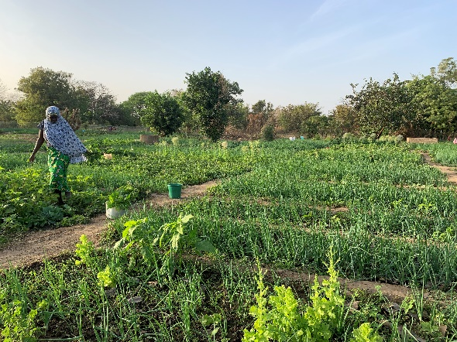
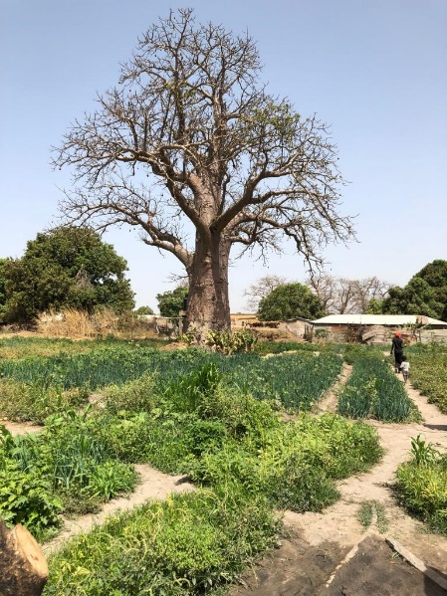
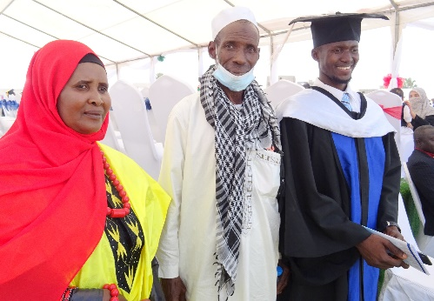
Abdou’s Graduation!
When planning our trip to The Gambia in March, we hoped it might be possible to be there when our student Abdou Jammeh Graduated from The University of the Gambia with his Batchelor of Science and English degree, but we could not be sure as no definite date was known at the time, but with sheer luck and co-incidence, the timing was good and to our delight invited to attend. The day began by choosing our outfits and ploughing our way through heavy traffic to the QCity Stadium in Banjul. Abdou was waiting for us dressed in his Mortar and Gown and handed us our tickets, his parents were also in attendance and were already seated. To our surprise, Sankung and Gwyn were directed one way, and Sue and I were told to follow a lady to a Marquee in the opposite direction. We selected seats to the left which was next to the V.I.P Marquee which would seat the President of The Gambia Adama Barrow and his entourage who arrived via a cavalcade just behind us. The ceremony began with a man singing and playing an instrument called a Kora followed by the university choir, one of the songs was ‘I had a Dream’ sung beautifully. Later a speech of welcome by the President of the University, followed by several more, after which the students arrived in their respective groups to receive acknowledgement of their degrees. Bottled water, a programme and a meal were provided in our marquee. It was all very entertaining and lengthy and incredibly moving for us. When it was over, we were joined by Sankung and Gwyn, who had not had the V.I.P treatment that Sue and I had enjoyed, they were apparently sent to the opposite side of the stadium to a small marquee, with no posh covers on their seats, Gwyn told us that no one kept still or quiet during the proceedings! We are not sure why we were chosen but true to say we were very honoured and relieved that we were!! Soon Katakily and Muhamed Boma, Abdou’s mum and dad joined us, Katakily looked resplendent in her African dress of beautiful bright colours, they were so proud of their son and so they should be, and indeed as are we. Lots of photographs were taken after which we made our way out of the stadium. Other members of the family were waiting outside and we were invited back to their compound for a celebration meal, but even by Gambian standards there were just too many of us to pile into one vehicle, so our driver was summoned to take us back to Busumbala where we had time to freshen up and cool down before joining them. Abdou lived alone in this compound for a couple of years when leaving Si-Kunda to go to uni, but was later joined by his uncle Embraham who sadly has lost a leg due to diabetes, Abdou was able to help with his care alongside his studies, soon after Katakily joined them leaving his father in Si-Kunda to work. We were welcomed to a lovely Gambian meal and the usual hospitality we know so well. We had a tour of the compound and met Abdou’s pet goat Alfalfa whom he has reared since it was a tiny kid, this is so rare here, but no surprise, Abdou has always had empathy for his animals, Alfalfa is now too big to play the game of ‘butting’ they enjoyed when he was small unless Abdou is well prepared! His other goats and chickens enjoy a lovely life. Later we asked Abdou to put his cap and gown back on for more photo’s, it was during this he asked if we would video him as he had something to say. In this speech he wanted to thank our charity for the help and chance he has received to get him where he is, and in particular to thank Janet, his sponsor who took over from her mum Phylis, after she sadly passed away, they were both so supportive and kind to him. His words were so moving and Sue and I had tears falling down our cheeks as we listened. His hopes for the future: He applied for a three-month internship to do practical work, he was refused but was offered instead a permanent role for the National Disaster Management Agency because they were so impressed with him and all he has achieved, Abdou said he would like to accept the role, but only if they would allow him to pursue his Masters as well. So, it has been agreed that he works for them on a contract basis while he pursues his options of studying for his Masters.
Medina Fonkoi Garden Project- On our visit we were so pleased to see how well the crops were growing, all the allotments were being used. After discussions with the Head of the village and the women, it was decided that we would extend the gardens further taking priority before planning the construction of a market place. So, this work was started soon after we had returned home, and has now just been completed, providing a much bigger area. That extra space is now being used for planting maize and pumpkins.

