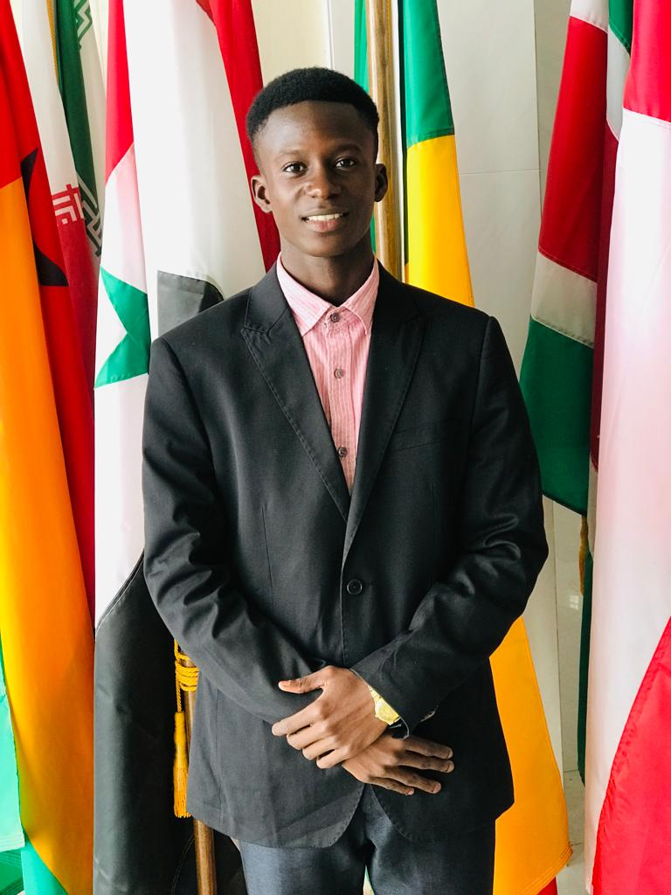

**PaSeedy**

For more Information about our charity, please contact anyone listed here:

Chairperson - Sue: 07717 821604 [sjones@friendsofsikunda.org](mailto:sjones@friendsofsikunda.org)

Treasurer - Marje: 01933 387323 Marje.jones25@gmail.com

Sponsor Secretary - Gloz: 07748 774431 [gkeen@btconnect.com](mailto:gkeen@btconnect.com)

Secretary - Anne Seckington: [anneseckington@btinternet.com](mailto:anneseckington@btinternet.com)

Fundraising – Kate Jones 07921 151711 & Danny Jones 07737 457431

Bonus Ball Admin – Daisy: [daisyj@friendsofsikunda.org](mailto:daisyj@friendsofsikunda.org)

**Sankung Jammeh – Project Manager** 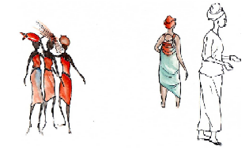

*Our Data Protection and Privacy Policies can be found on our website* [**www.friendsofsikunda.org**](http://www.friendsofsikunda.org)

**Copyright: Friends of Si-Kunda January 2023**



Newsletter no.39 – January 2023

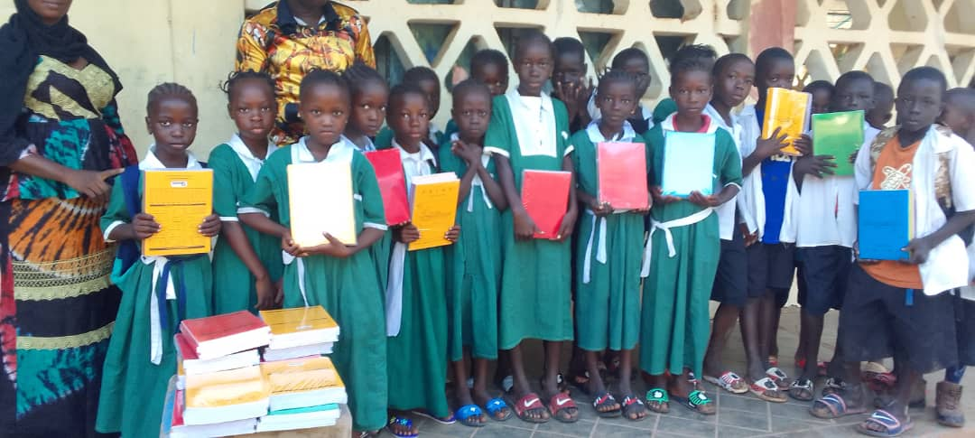

Fonkoi Kunda and Jabisa Schools

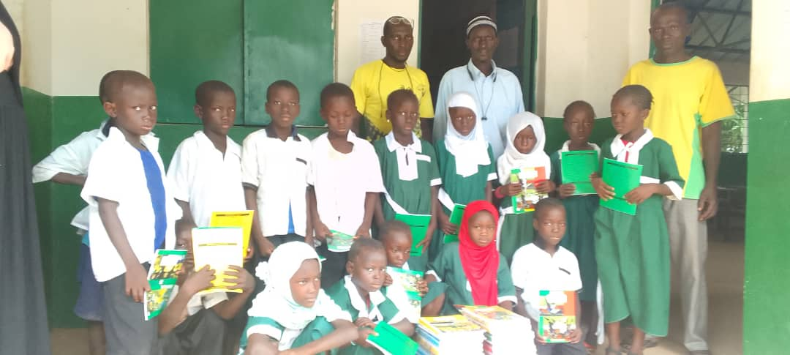

***Charity UK Reg No.1097750 (2003) Gambia Registration No. 581/2005***

**Updates on a few of our sponsored students –**

**Ousmann (Opi) -** Opi’s Assessment in his 2nd year at Agricultural school for his Field Attachment gave him a score of 19 out of a possible 20. He has now been enrolled for a two year Advanced Diploma in Agriculture and will be going on another field trip with IAAS (International Association of Students in Agriculture and Related Sciences) in the north bank region. Opi is so determined to do well, it is rewarding to know that he has found something he loves and will hopefully give him a bright future. His dream is to become an agricultural engineer.

**Pa Seedy -** It’s a challenge keeping up with Paseedy! A more ambitious person would be hard to find. The Uni he attends chose him to help with the first aid training for UTG (University of the Gambia) students in collaboration with UTG and the Red Cross. He was nominated to take part in the organizing of the Task Force. He gets invited to speak at many functions, both for the university and other educational institutions on various environmental and health topics which include - The Pollution of Plastics and its effects on the environment; Smoking and the effects on health; The Dangers on the road due to poor tyres, brakes etc; Female Mutilation and the effects on young girls and women. He is also passionate about politics and thinks that the youth should be listened to. He put himself on an on-line course with a University in Taiwan – The study area is close to Public Health. He also completed another course with them on Hospital and Industrial Management, he has now received his certificates. He just keeps going. He appeared on Starlight T.V. a live show, as Vice President of the Student Union for the Uni, to deliver on the topic of Contribution of Public Health of UTG students in National Development. Then amazing news – Paseedy was selected as one of two from 3,600 applicants to go to Rwanda to give a talk on Public Health matters, but sadly he did not get to go as there were last minute flight issues and was unable to get there. A disappointment but he is as ever optimistic and looks forward to more opportunities. Paseedy will be completing University in July, his graduation will take place in January 2024. As this is his final semester, the department has organized a nationwide tour for the students to familiarise themselves with communities and functions of Public Health across the country.

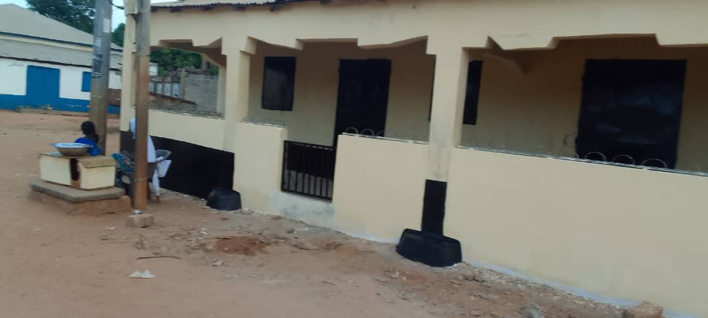**Community & Skills Centre**

A veranda has recently been completed in front of the centre, and secured with a gate to stop marauding goats! The outside of the centre has also had a new coat of paint. This building which we had built in 2007, has had some changes of use along the way and is still a very important part of village life, which includes being used as a centre for Health and vaccination programmes, Voting in local and national Elections, training programmes, village meetings, etc., etc.,

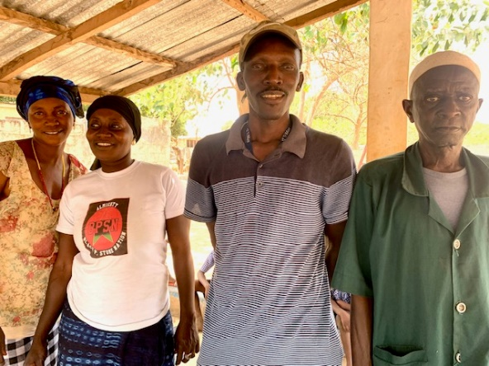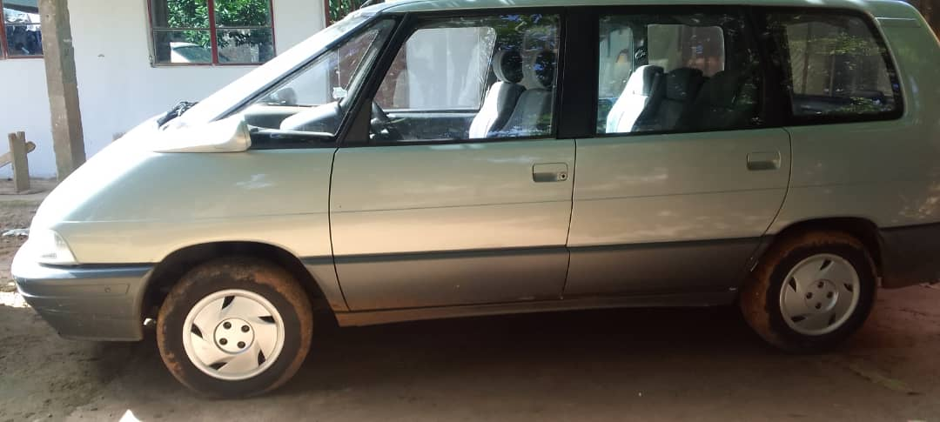**Taxi Project -** In 2018 we received donations specifically to purchase a car in The Gambia to be used as a taxi to raise funds. All the profits have been saved and there has been enough available for Sankung to purchase a 7-seater to add to the “fleet”. By adding a 7-seater it will increase the revenue, which will help towards the charity’s funds. An added bonus is that it also provides jobs for drivers.

**Fundraiser**! – our Bonus Ball fundraiser continues to do very well for us raising funds for our projects. There are a few spare numbers if you would like to take part, for details please email [daisyj@friendsofsikunda.org](mailto:daisy@friendsofsikunda.org) …….. just £1 a week to give you the chance of winning £25 each week**! *Tumbulu, Anna, Modou & Fadarbo – Si-Kunda School staff***

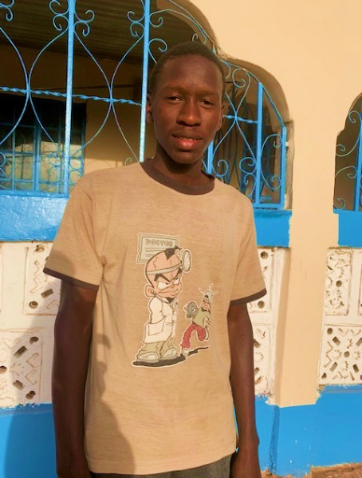**Student Afanseedy –**

We visited AfanSeedy on our trip in 2022 at his family’s compound in Soma, a town a few kilometres from Si-Kunda from where he was born. We were made very welcome, and he told us he was going on a field trip with his classmates and was excited to be going. He is a very pleasant young man and strives to learn to fulfil his ambitions. He loves football and plays when he can, he is a supporter of Real Madrid. He left year 12 with good results including four credits, but it was not quite enough to gain a place at Uni, where he hoped to study Journalism and was very disappointed, though still very determined. He has enrolled into a school which will allow him to study and retake his missing subjects this year and hopefully he will get the results he needs; we all wish him every success.

**Chicken Yassa**

**A Gambian recipe** tried and tested – very tasty!

8 skinless chicken breasts

For the marinade: 2/3 cup of oil, 1 cup red wine vinegar

1 cup freshly squeezed lime juice, 3 chicken stock cubes (magi cubes if you can get them)

6 garlic cloves, mashed, 6 tsp fresh grated ginger

2 tsp salt (or to taste), A lot of black pepper, 1 large chopped red chilli

## Method

**The night before**:

1. Make the marinade by combining all the ingredients (except the chicken)
2. Clean the chicken breasts. Place the chicken in a large glass baking dish. Put about 1/3 to ½ of the marinade over the chicken, and let it marinate overnight. Reserve the rest of the marinade. At some point, turn the chicken over.

**On the day**:

1. Bake the chicken in the oven, basting and turning over periodically; gradually add the rest of the marinade
2. Sauté a lot of thinly sliced onions slowly over a medium-low heat till golden
3. Once cooked, heap the onions over the chicken, and serve with warm crusty bread and salad

**Chair’s Report -** We wish you all a very Happy and Healthy New Year!

It has been a busy few months in The Gambia, renovating the school in Si-Kunda, and also the Community/Skills centre. Both projects are now completed, as you will see from the photographs in this our 39th edition of the newsletter. Hard to believe it will be our 40th edition in July and also our 20 year anniversary coming up of registering Friends of Si-Kunda as a charity. We are extremely grateful to all of you that have been supporting us for so long now, many of you since we first started, and together we have achieved a lot and helped many with the help of Sankung as our project manager – but more of that in the July edition. Times are hard in Gambia, as everywhere else. The rice and groundnut harvests were very poor in 2022, the rainy season came very late, then there were torrential rains causing lots of flooding and many homes were destroyed leaving many homeless. In just a year the cost of buying rice has increased 65% and oil is even more at 130%, two of the most important purchases for a Gambian family. Many students are leaving education early as their parents are unable to afford the increasing fees, which in turn means that some schools are struggling to keep going. There have even been children turning up at Si-Kunda school just for food, all of which means that the vegetable gardens are more important than ever. A sack of rice is used every month at Si_Kunda school, Tumbulu our lovely cook does a wonderful job making a lunch for them all Monday to Thursday, currently there are 85 regular pupils.

We have three new projects which are about to start -

1. The Friendship Gardens in Si-Kunda needs a new pump for the solar system to enable easier watering, the current one is not running efficiently and is in need of either urgent repair or replacement… it has been investigated and we have decided to replace it. The original one was provided by the agricultural department, for which everyone was very grateful, but it has got problems now which means water is reduced to a trickle and takes a very long time to water the crops. These gardens cover a large area, and are so important for the whole village.
2. Jabisa School has a flourishing vegetable garden, but it is not big enough to produce enough for all the children. So, we are going to extend it to ensure they can produce the amount they need.
3. **A group of people in clothing

   Description automatically generated with low confidence**Medina Fonkoi village – The gardens are now big enough for all the women in the village, but an extra well is needed to ensure there is plenty of water all of the time in all areas of the allotments.

If any of you would like to help with fundraising, or have some ideas for fundraising we would always be pleased to hear from you! More news on these projects next time, plus more I am sure!

Meanwhile we thank you again so much for your support! ***Sue***

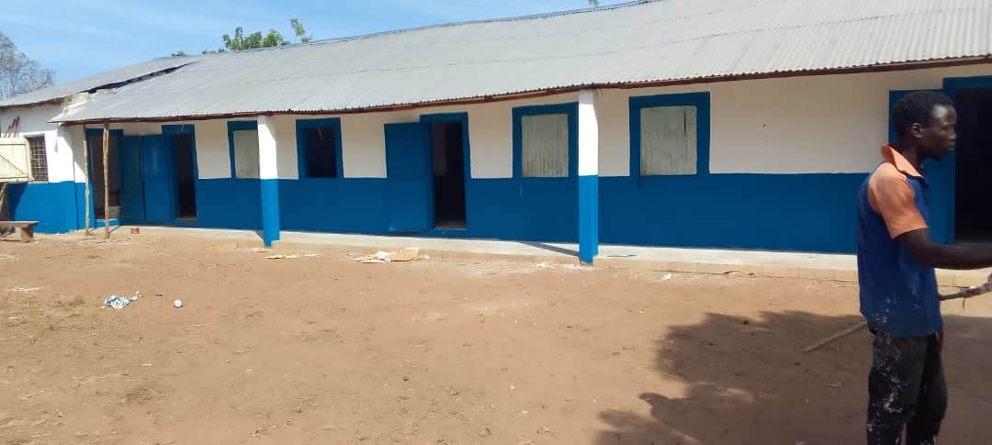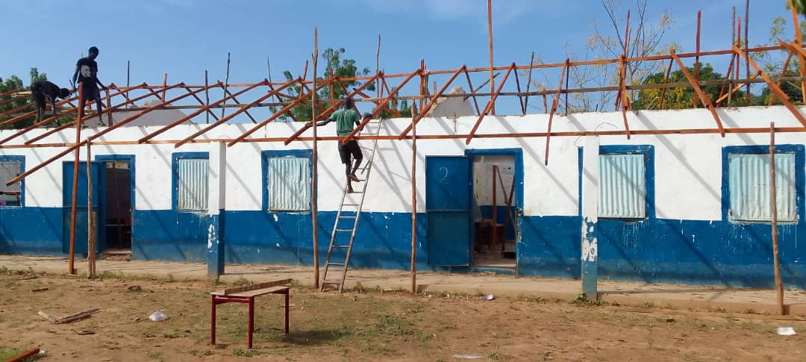**Si-Kunda Nursery School**

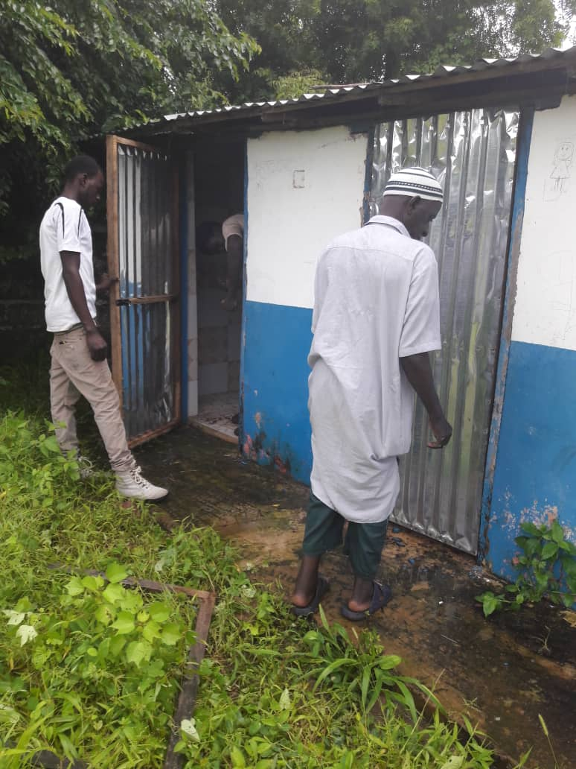The Nursery school roof had to be replaced, including all the rafters, a big job but it had to be done and has now been completed. Some of the corrugated sheets from the old roof were able to be re-cycled and used to replace the roof on the pavilion in the play area. The kitchen door and window have been replaced, the school gates have been repaired, and the doors replaced on the toilet block. The classrooms have been painted, and also the outside of the school. So all in all quite a busy few months! The Peace Corps have installed some extra outdoor play equipment, it is great to have their support for the school. We have been managing the school for many years, and was initially the reason for forming the charity. Our hope in the future is to secure help from the education department with whom we have had some encouraging meetings.

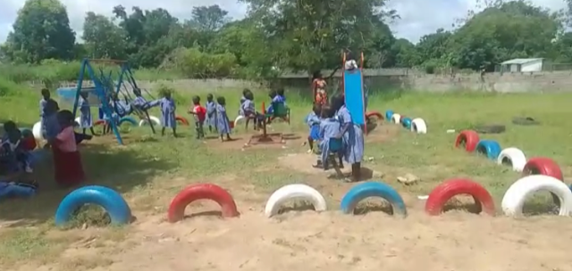

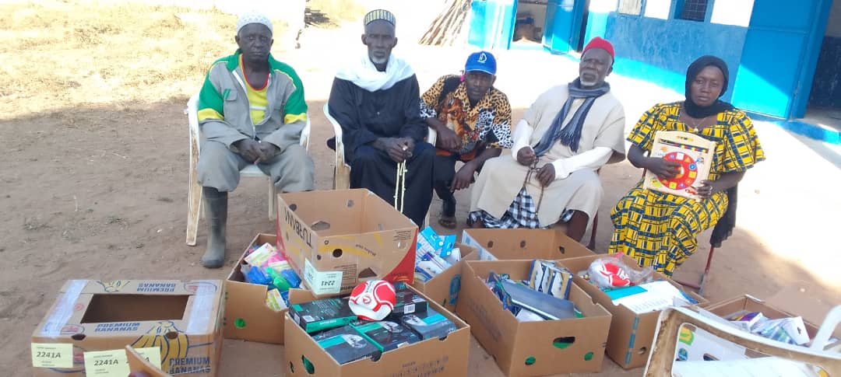

Here are some supplies given by an ex-resident of the village. It was wonderful to receive this help from someone who grew up in the village and wanted to return with all these very welcome materials.

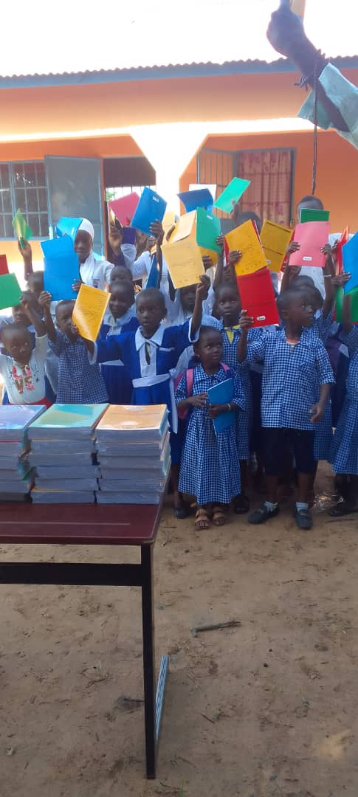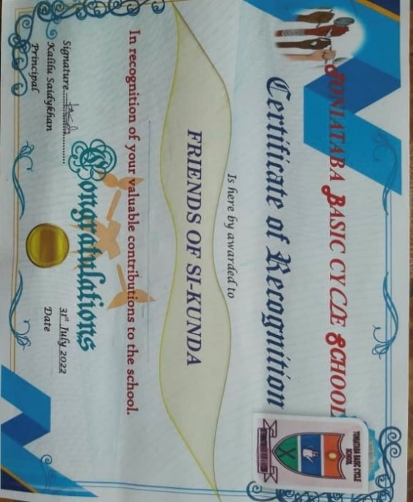**Toniataba, Fonkoi Kunda and Jabisa schools** – These schools all received exercise books at the beginning of the school year.