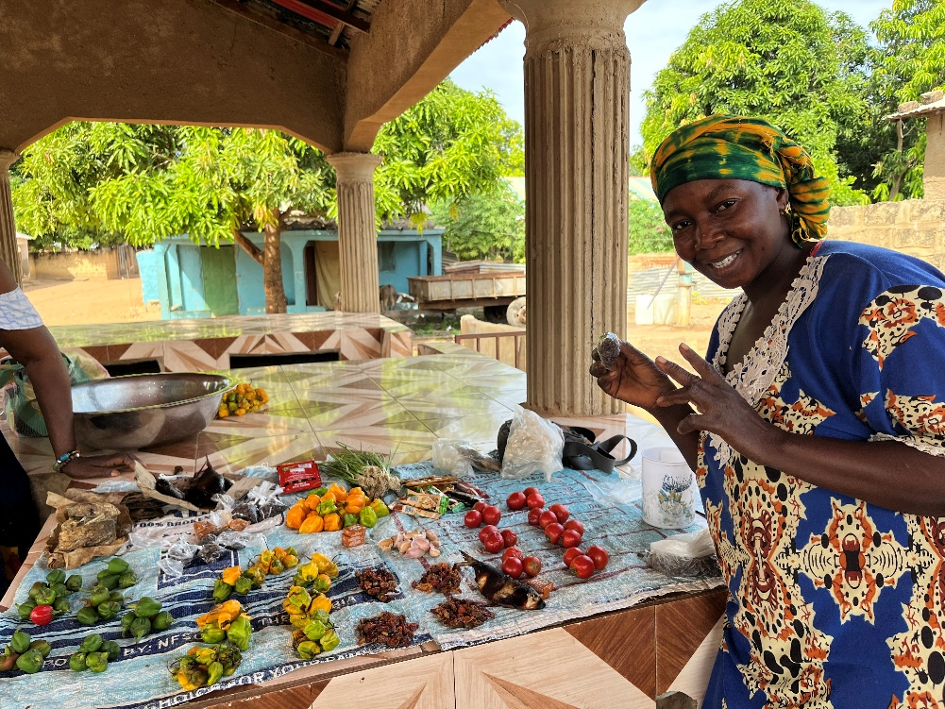
Si-Kunda Marketplace

For more Information about our charity, please contact anyone listed here:
Chairperson - Sue: 07717 821604 sjones@friendsofsikunda.org
Treasurer - Marje: 01933 387323 Marje.jones25@gmail.com
Sponsor Secretary - Gloz: 07748 774431 gkeen@btconnect.com
Secretary - Anne Seckington: anneseckington@btinternet.com
Fundraising – Kate Jones 07921 151711 & Danny Jones 07737 457431
Bonus Ball Admin – Daisy: daisyj@friendsofsikunda.org
Sankung Jammeh – Project Manager
www.friendsofsikunda.org

Copyright: Friends of Si-Kunda January 2024

Newsletter no.41
January 2024

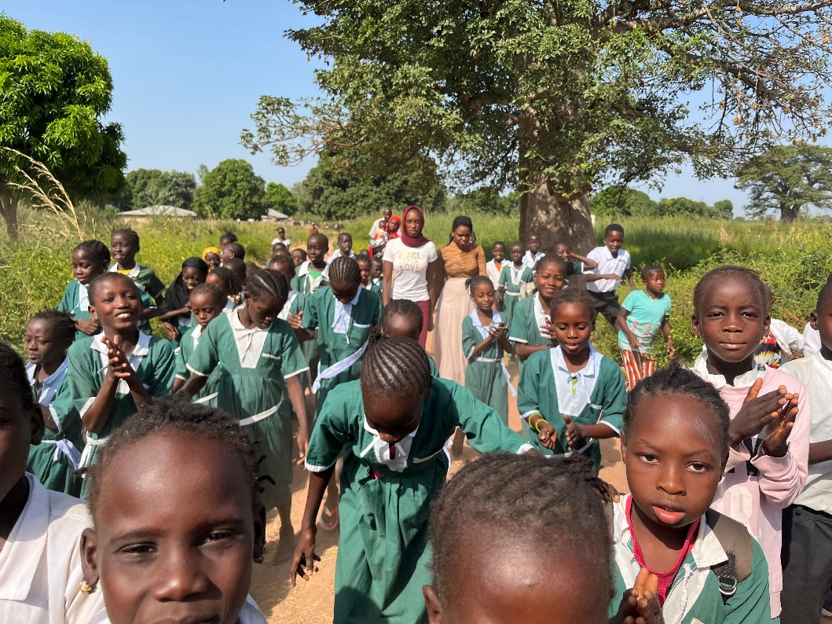
Fonkoi Kunda Lower Basic School

Charity UK Reg No.1097750 (2003) Gambia Registration No. 581/2005
Abdou Jammeh

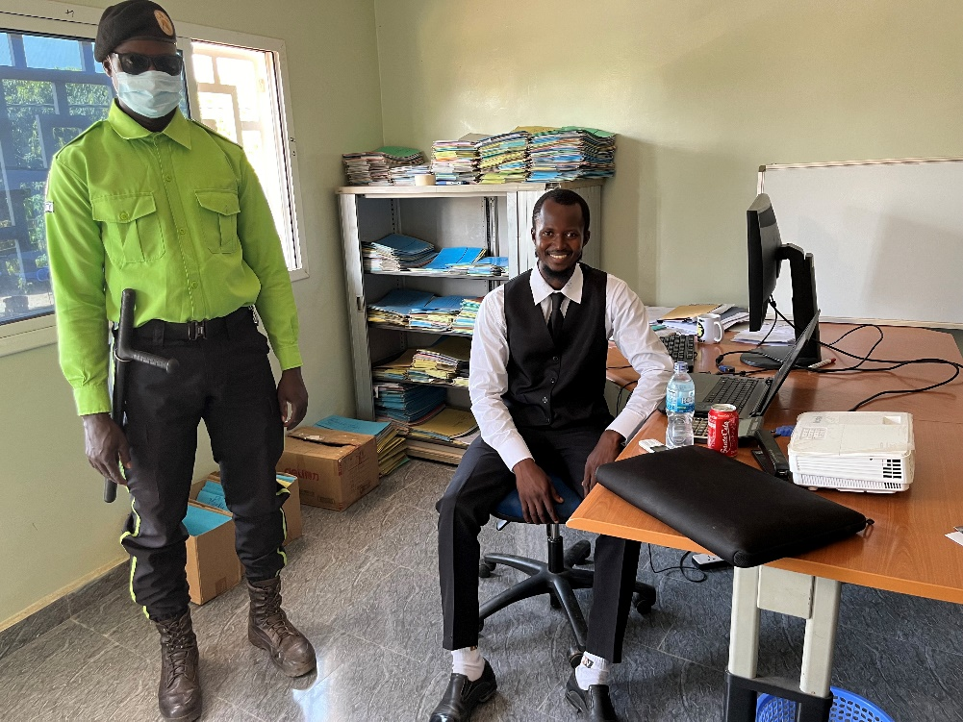
Since gaining his degree and then working for the National Disaster Management Agency, Abdou is currently working as Head of HR for the Five Star Security Company in Sukuto, and we went to meet him in his office.

Abdou was waiting outside for us when we arrived, we were introduced to various members of staff then taken two floors up to Abdou’s office. He is the only employee to have an office to himself, everyone else is in open plan. Abdou had created a presentation for us and had a projector set up, but unfortunately the electricity went off just as we arrived! However, he explained the history of the company and his role with great enthusiasm.

There are 400+ staff, and it was obvious that Abdou loves his work. Abdou has created an MS Access database for the company to save having everything on hardcopy, he also created the company website and designed the company calendar. Abdou is a very talented and hardworking young man who loves his work. It is a company that allows and encourages him to study to further his education and qualifications. We are very proud of him!
Toniataba School

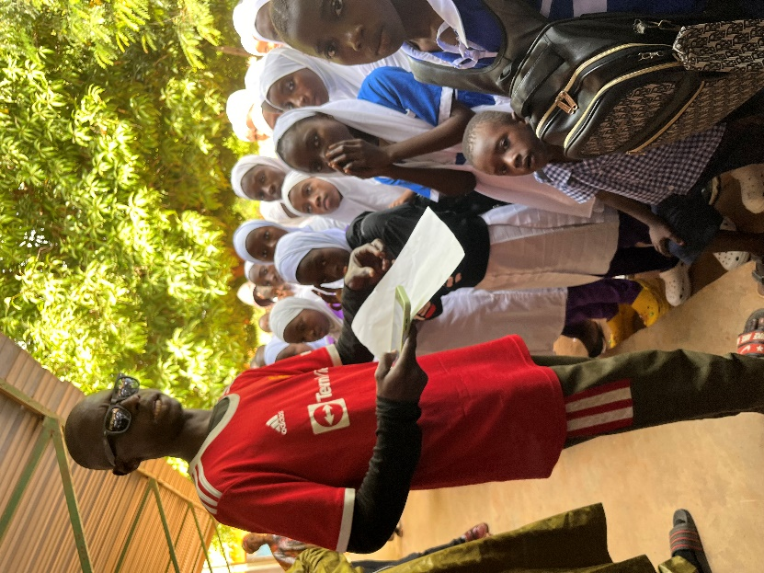

We received a lovely welcome by the new headmaster Mr Colley, who remembered us from when we were at Pakalinding School in 2013, he was a teacher there at the time. We remembered that time particularly well, as the motorbike we travelled on through sandy tracks broke down when it was Dan’s turn to go with Sankung (I had arrived safely before him!) They ended up pushing it about 7km to get there in 40+ degree heat!
The teacher in this picture was once a pupil at Toniataba school years ago when we first met him, he was so pleased to see us and gave a wonderful speech to the whole school assembled outside. It was great to see him return to teach at the school where he had received his early education. The French teacher gave a particularly inspiring speech to the school, all the teachers seemed very enthusiastic and the school very well organised. The school has come on so far since we first visited many years ago, and it is always such a pleasure to return. We gave stationary on this occasion, and they had recently received the exercise books. .
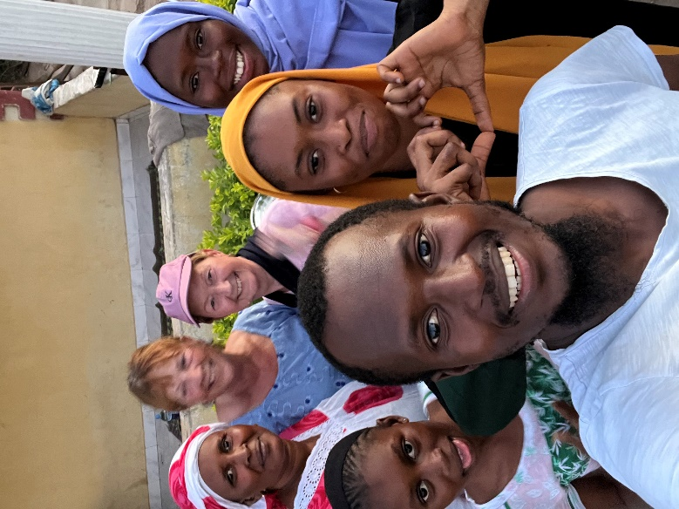
Over the past couple of months, we have provided some extra long garden hoses; watering cans; taps for wells and wheelbarrows. Drinking buckets with cups for each classroom at Fonkoi Kunda school. Vegetable seeds and seedlings for the school gardens and Medina Fonkoi ladies’ allotments. Text and exercise books, school stamp and ink, registers and some stationary for Si-Kunda nursery school.
The picture to the left is of Abdou and some of his family with Gloz and I last November.
Below left is the “Milk” shop which has opened at the front of the Community Centre in Si-Kunda…. another very useful addition for the village!! Below right is Aimee, Sankung’s youngest daughter.
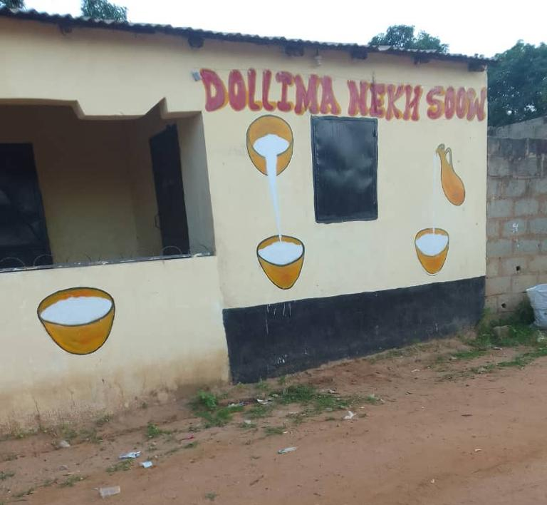
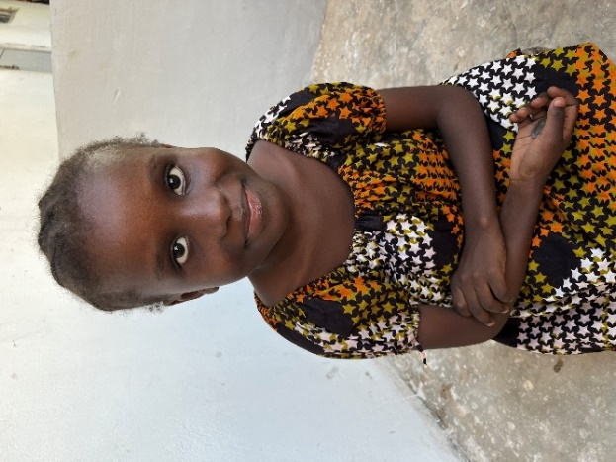

Chair’s Report
A Happy New Year to you all!

It has been quite a year for the charity, apart from our both past and present students’ achievements over the past 12 months, it has been great for Si-Kunda Nursery School – as you will see on the next pages…… something we have been hoping for, has finally happened! We have been so privileged to have been able along with the help of all of our supporters, to keep this school going for all these years since 2003. It has been hard work at times and sometimes a little frustrating but has always been so worthwhile. So many children have benefited from it, with a constant number of approximately 80 – 90 children at any one time. We will still be involved with the school for the foreseeable future but will no longer be taking overall responsibility for the running of and costs, the future of the school is secured.
Some news on three past students….. First of all – Fatou, who qualified as a schoolteacher a few years ago, has a young family of two children. She is now doing a two-year higher diploma course, and once qualified it will enable her to apply for head teachers posts in The Gambia. We are more than happy to sponsor her again as she is a very determined young lady, so we feel sure she will achieve what she is aiming for. Lamin Njie, who is now a financial auditor for the Wisconsin State Bureau of Investigation, fulfilled one of his dreams to come and stay in the UK for Christmas! We had a wonderful two weeks, and he really is a remarkable young man, he gives so much back to his country and not just by helping his family, but with providing sponsorship and helping so many others to have an education. While here, Lamin accompanied me to a presentation I was giving for Hanslope WI, he spoke on account of what his childhood was like in Africa and how an education has changed his and his family’s lives. Everyone enjoyed it, and it certainly gave the presentation reality of what can be achieved. I must mention Paseedy! He graduated from Gambia University last year and now he is travelling this month to the USA, to attend Springfield University for two years to do his Master’s in Public Health. A huge opportunity for him and well deserved, he will be going from a hot 35C to a possible minus-20C in one day so that will be a challenge in itself! We know he will embrace everything and has a great future in front of him… what an adventure his is on!
With many thanks for your continued support, Kind regards, Sue
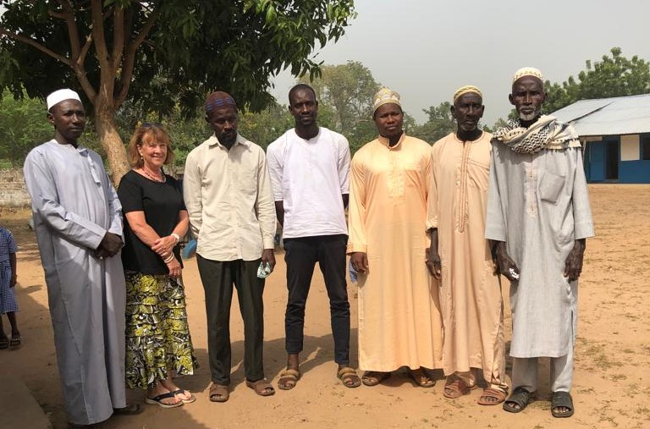
Si-Kunda Nursery School
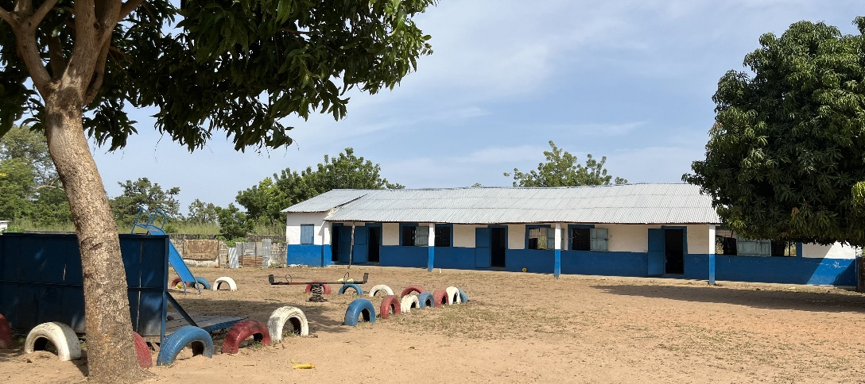
As from 25th September 2023 - A new beginning for this school, the school that was the reason for starting our charity back in 2003!

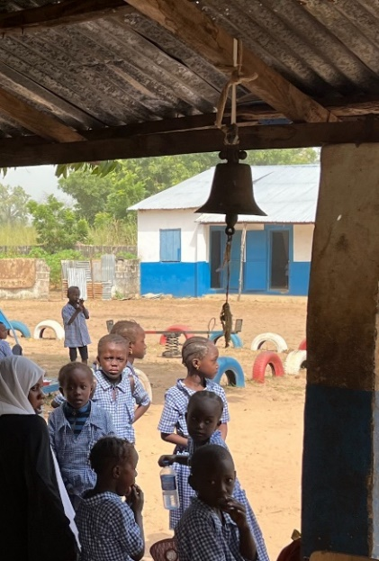
We are really pleased to now have the future of this school secured. We have been trying for a few years to have the responsibility of this school to be taken over by the Education department, and now we can happily say that this has indeed happened! With many thanks to Sankung along with the Director of Education, his deputy and planning officer in Mansa Konko for ensuring the final agreements & arrangements were made with the village and ourselves. We will still be involved with the school, as some needs will be ongoing, but now the responsibility of the staff, salaries and the running of the school will be taken care of. It means we can concentrate more on funding the materials it will continue to need and currently we are still funding the school lunches…. which has increased two-fold, as the school is now not just a nursery, but a Lower Basic school for Grade 1, increasing each year until it will eventually go up to Grade 6. Already there are 165 pupils… Grade 1 has about 75, and the nursery continues with 90.

There is now a new headmaster, 4 teachers and extra cooks to help Tombulu. The kitchen had its roof raised, as this was a specification to enable help with the supply of rice and oil… the supply hasn’t arrived yet, but we are hopeful it will soon! This is a great improvement for the village to have its own Lower Basic School, and has

been welcomed by all, although they are very keen that we are still involved. There is the School Committee and VDC (Village Development Committee) who together along with the Education office will monitor how the school is run, so we will meet with them on our visits to Si-Kunda. We are so pleased that the handover has happened at a time that the school is in good repair, with enough supplies to ensure the teachers and pupils have what they needed to start the new school year. It feels the right time.

Our longest serving teachers have been Modou and Anna. Modou was there when we first arrived, working unpaid until we stepped in to help. He has been working there ever since until a few months ago when he started working fulltime in the nearby town Soma, he is very happy in his new job and has been given a new motorbike to use. Anna has been a teacher at the school for many years and is also happy to go onto new things, she had the option to stay but preferred to go onto pastures new, so the time has been right for them both too. They have both become friends to us over the years so we will continue contact with them. Fadarbo is finally retiring as Caretaker, he had a few years ago but continued working! So a new caretaker and nightwatchman have been taken on. Tombulu remains as head cook!

This school would not have existed at all if it hadn’t been for this man, Sarjo Jammeh. He was the original founder and teacher at the school in the 1990’s. Sadly he died after five years, it was then that Modou took on the teaching (unpaid) to keep the school open. This is where we came in two years later.

